# **Java String:**

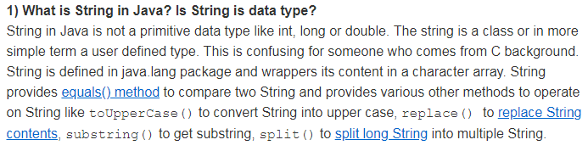

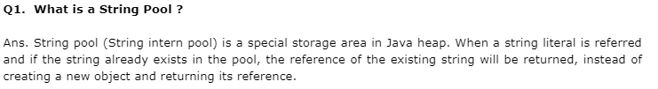

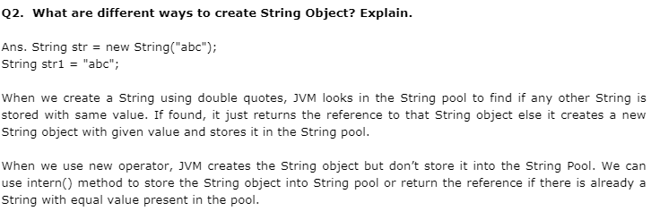

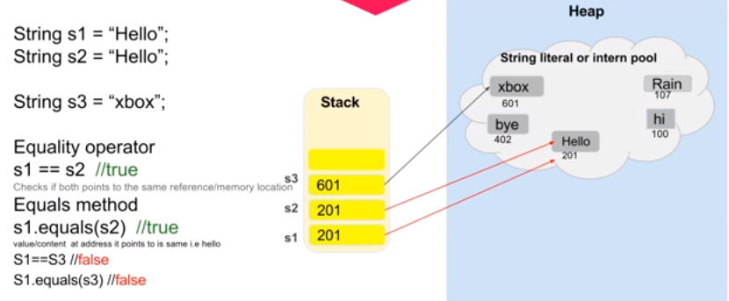

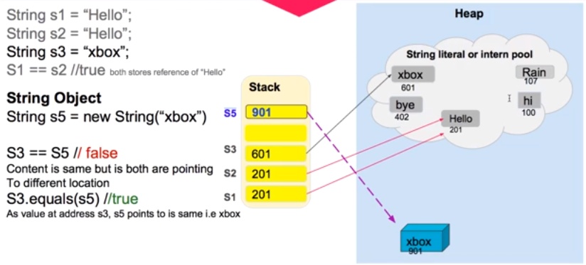

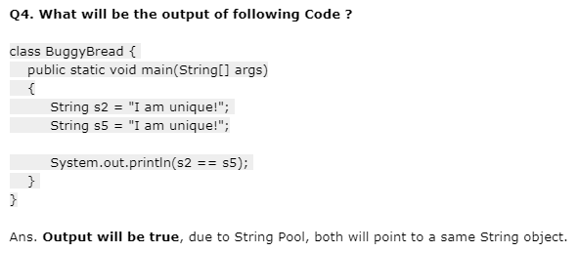

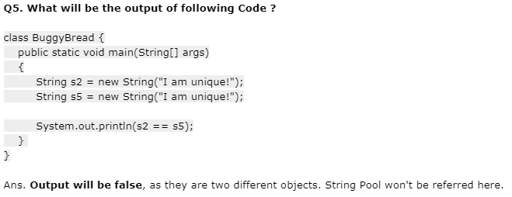

**StringTokenizer:** The java.util.StringTokenizer class allows you to break a string into tokens. It is simple way to break string.

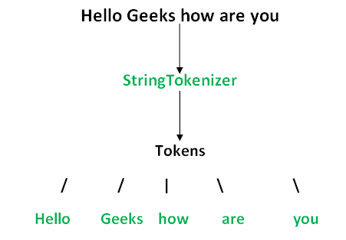

# [Why is String immutable in Java?](https://stackoverflow.com/questions/22397861/why-is-string-immutable-in-java)

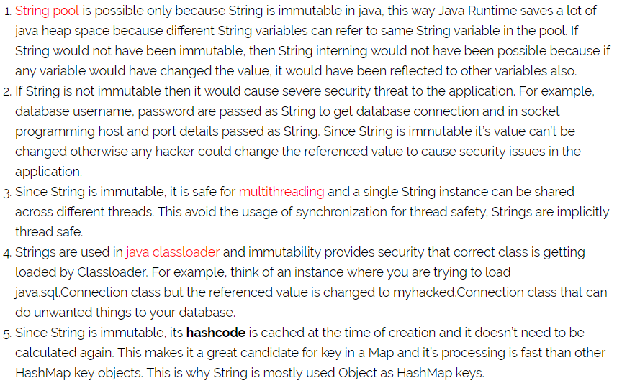

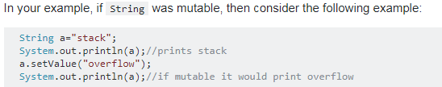

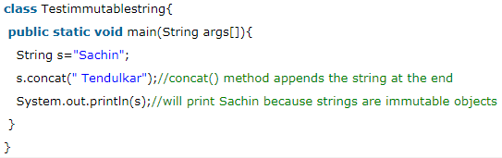

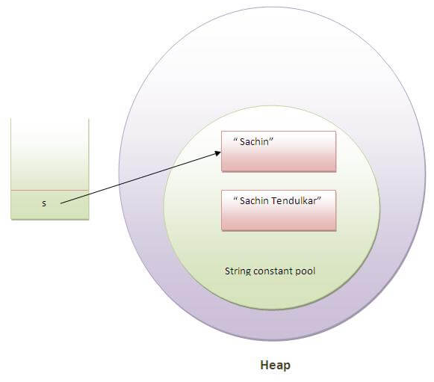

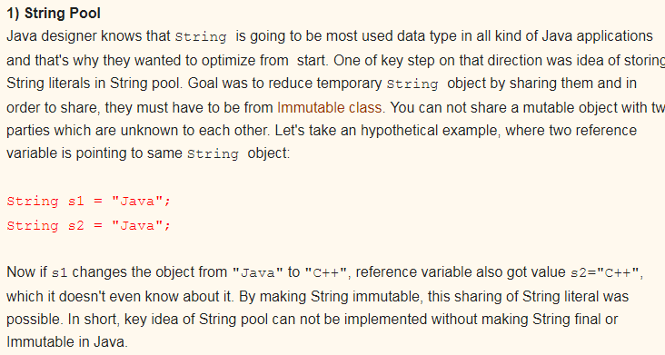

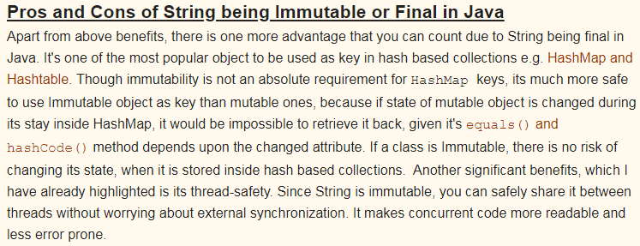

# Custom Immutable Class:

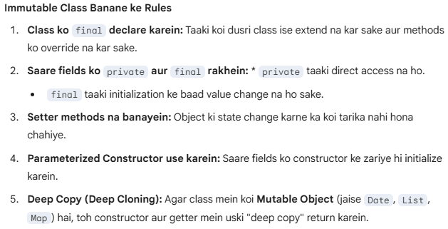

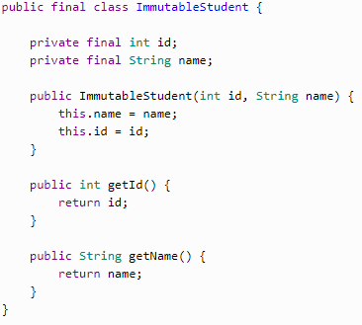

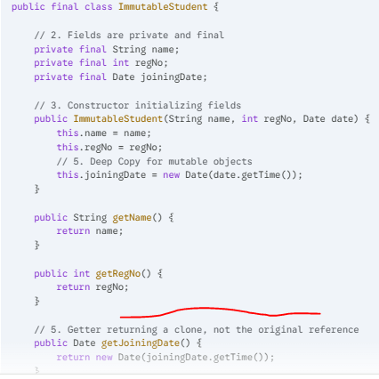

# StringBuffer:

In Java, **StringBuffer** is a peer class of String that provides much of the same functionality, but with one critical difference: **it is mutable**.

While a standard String is fixed in size and content once created, a StringBuffer can be modified—you can append, insert, or delete characters without creating a new object every time.

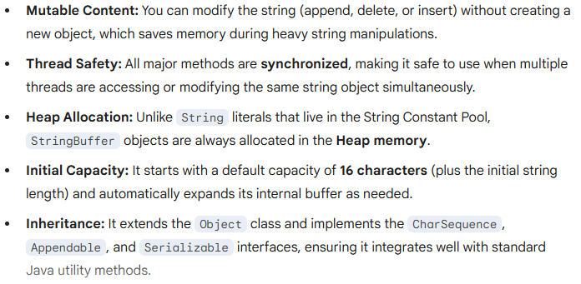

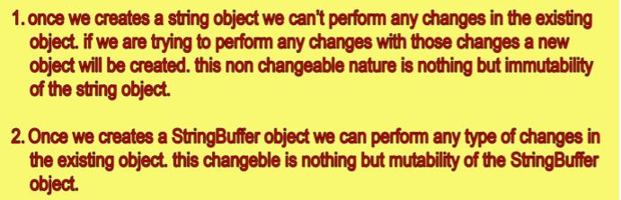

# StringBuilder:

In Java, **StringBuilder** is a helper class used to create and manipulate mutable (changeable) sequences of characters.

If you use a standard String, every time you "change" it (like adding a word), Java actually creates a brand-new object in memory because Strings are **immutable**. For loops or heavy text processing, this is very slow and wastes memory. StringBuilder solves this by modifying the same object in place.

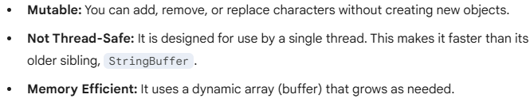

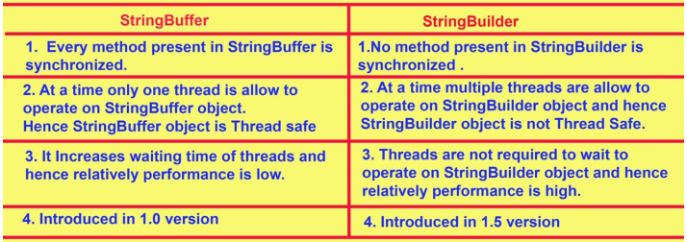

# Object Class:

In Java, the **Object** class is the "mother of all classes." It sits at the very top of the class hierarchy in the java.lang package.

Every single class you create—or that is built into Java—implicitly inherits from Object. If you don't use the extends keyword, Java automatically adds extends Object for you.

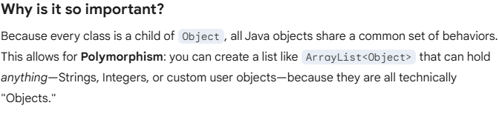 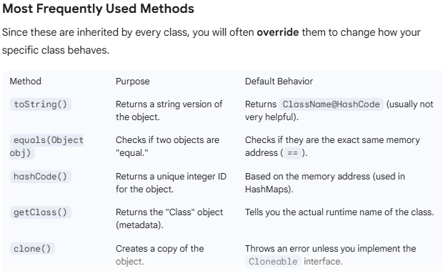

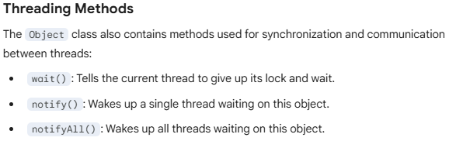

# Singleton class:

Java mein ek aisi class hoti hai jiska poore program mein sirf **ek hi object (instance)** ban sakta hai.

Agar aap dusri baar object banane ki koshish karenge, toh wahi pehla wala object hi wapas mil jayega. Naya object nahi banega.

The Singleton's purpose is to control object creation, limiting the number of objects to only one. Since there is only one Singleton instance, any instance fields of a Singleton will occur only once per class, just like static fields. Singletons often control access to resources, such as database connections or sockets.

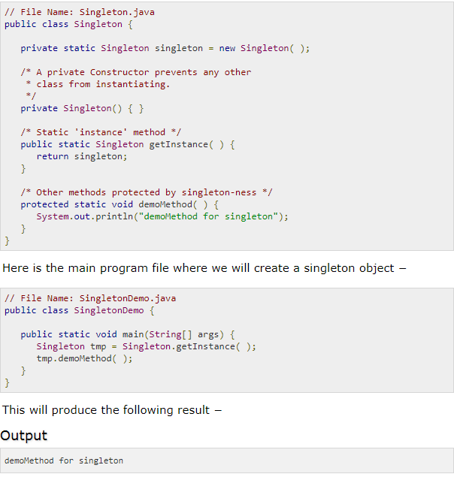

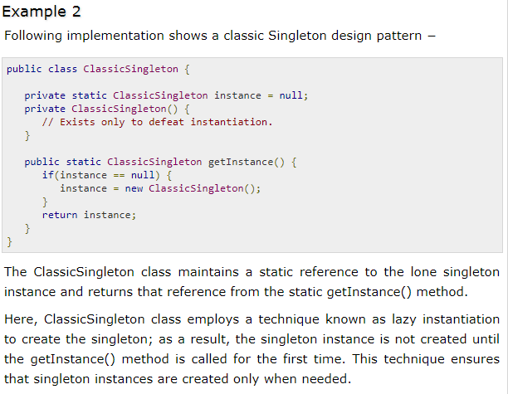

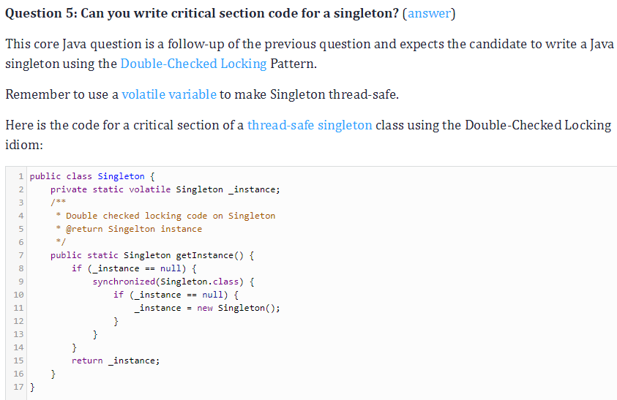

# Interface:

**Interface** is a reference type, similar to a class, that is used to specify a set of behaviors that a class must implement. Think of it as a **contract** or a **blueprint** for a class.

It tells a class *what* to do, but not *how* to do it.

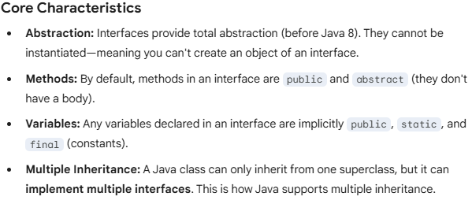

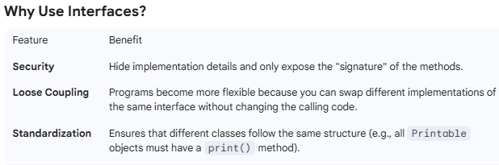 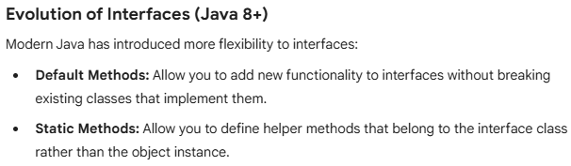

# Marker Interface:

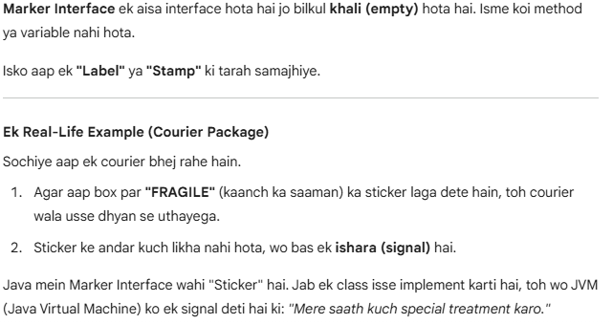

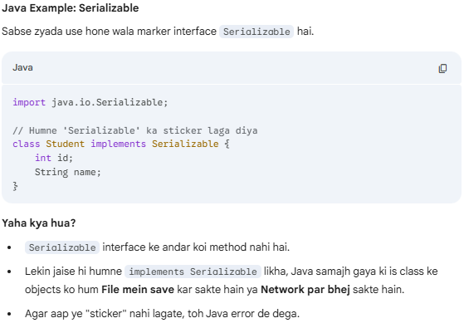 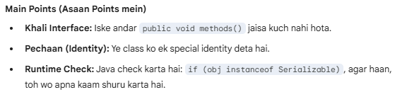

# **Interface** & **Abstract Class**

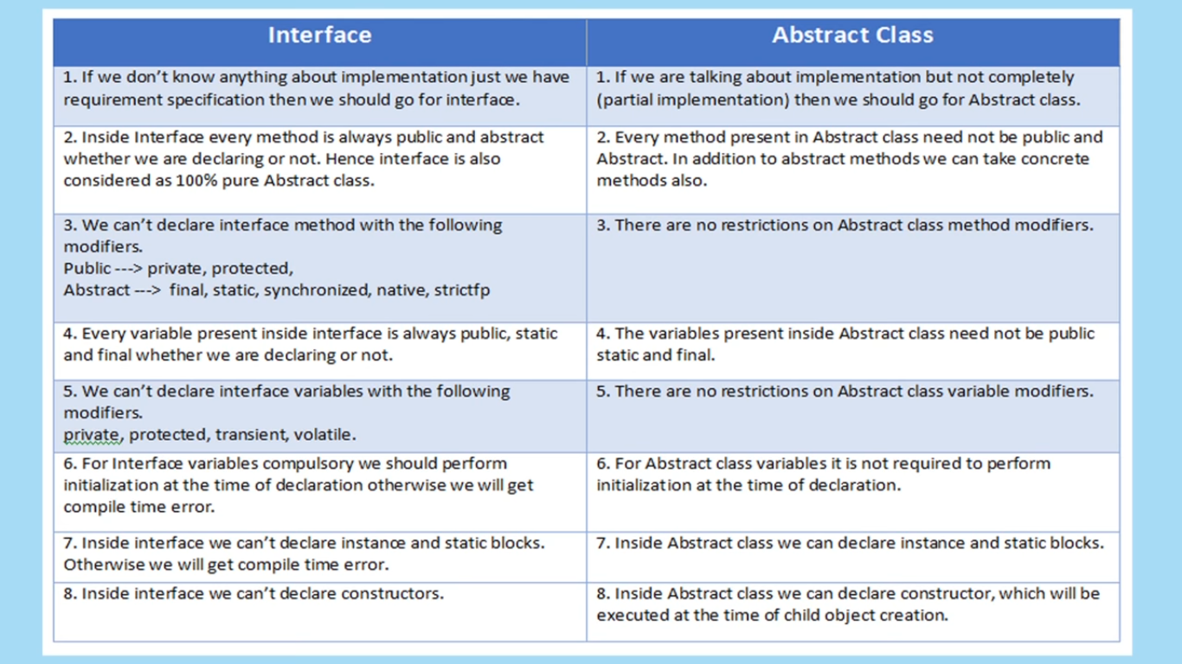

# **Overloading** & **Overriding**:

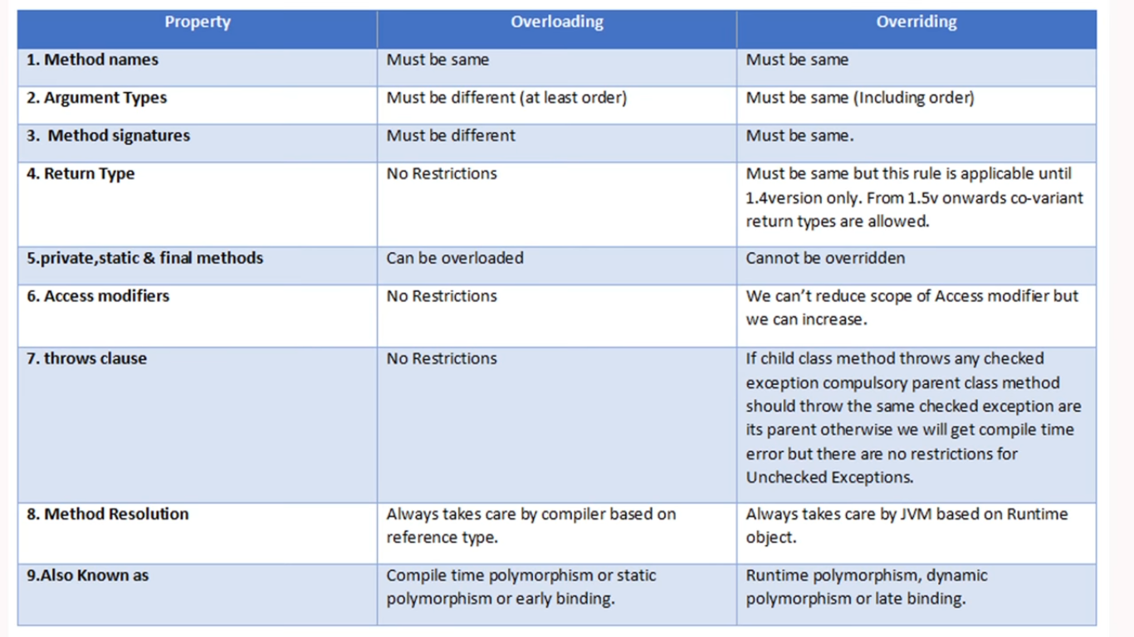

# **new operator** and **newInstance()** Method:

|  |  |  |
| --- | --- | --- |
| **Difference** | **new operator** | **newInstance()** |
| Object Creation | Test t=new Test() | Obtject obj=Class.forName(“className”).newInstance() |
| Argument Constructor() | Test t=new Test();  Test t=new Test(10,10);  If you use no-argument constructor compiler call no-argument constructor | .newInstance()  {  no-argument constructor() only  }  **We can’t pass parameterized contractor**  **If we pass parameter then we will get “InstantiationException”** |
| Exception Difference : If class is **not** there | Test t=new Test();  If Test class is not there then we will get “**NoClassDefFountExcption**”  Note: NoClassDefFoundException is the UncheckedException. | Obtject obj=Class.forName(“Test”).newInstance();  If Test class is not there then we will get  “**ClassNotFoundException**”  Note: ClassNotFoundExption is the Checked Exception. |

# **“==” & “.equals()”** method.

|  |  |  |
| --- | --- | --- |
| **Difference** | **Double equals operator(==)** | **equals() method** |
| Definition | Double equals operator(==) is for “**Reference Comparison**” | Equals method is for “**content comparison**” |
| Example | String s1=new String(“Rahul”);  String s2=new String(“Rahul”);  **System.out.println(s1==s2) - >False** | String s1=new String(“Rahul”);  String s2=new String(“Rahul”);  **System.out.println(s1.equals(s2))->True** |

# Object Cloning:

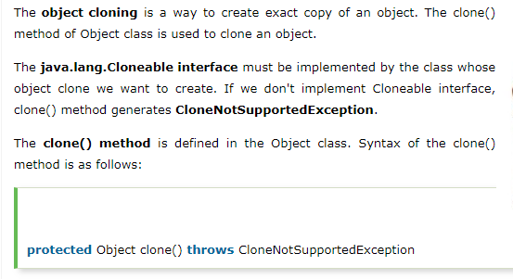

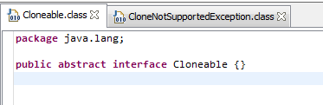

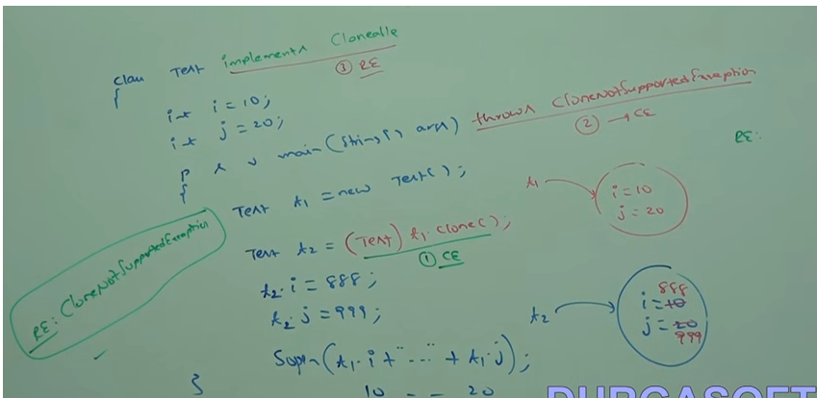

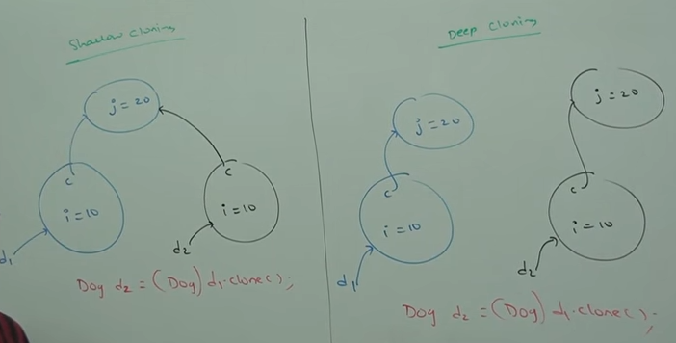

Note : Shallow cloning uses Object class clone() method.

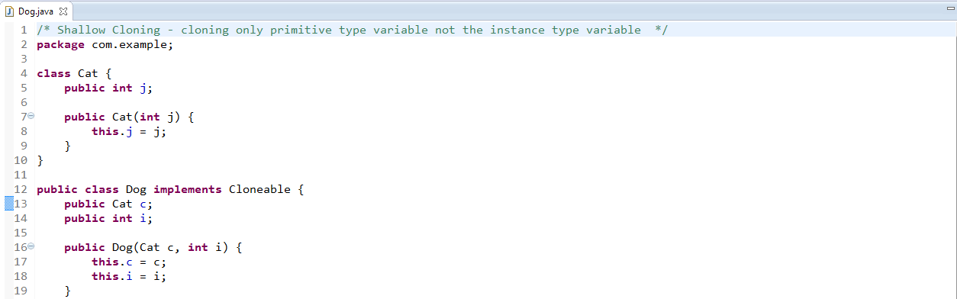

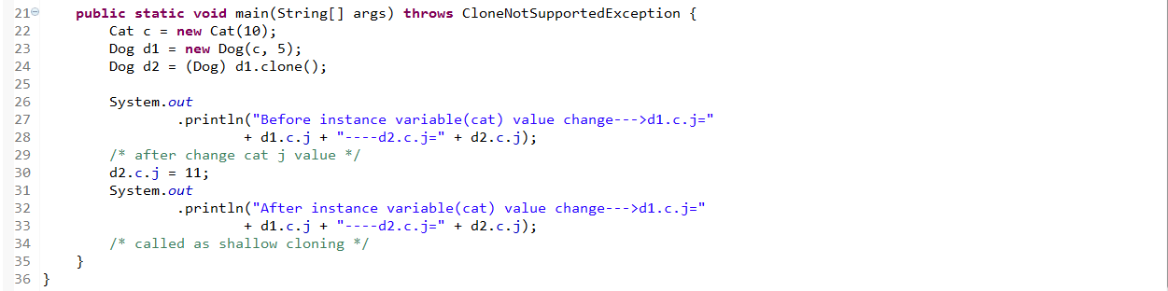

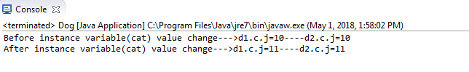

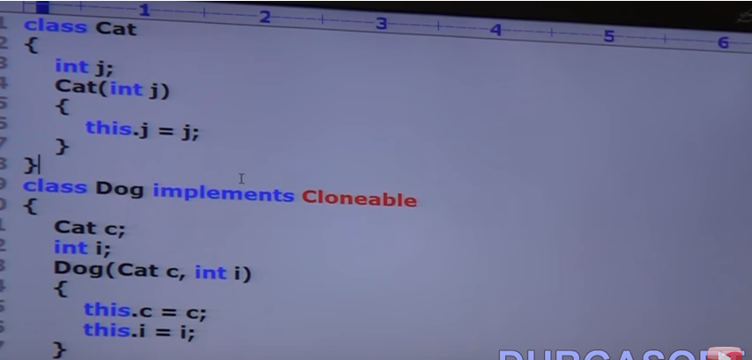

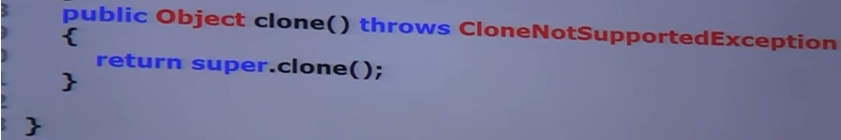

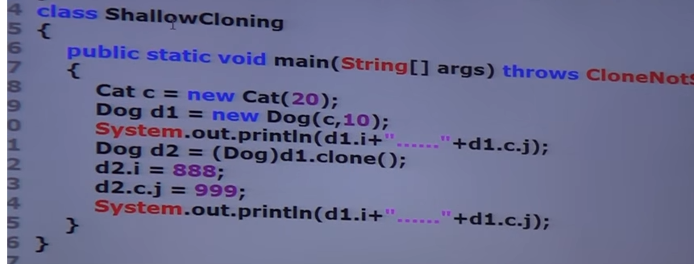

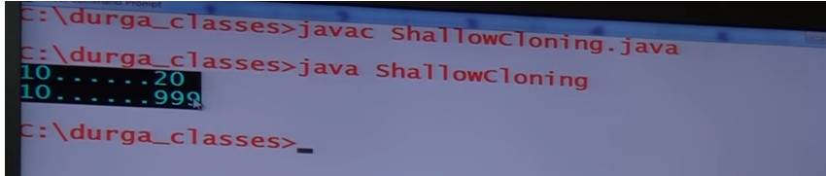

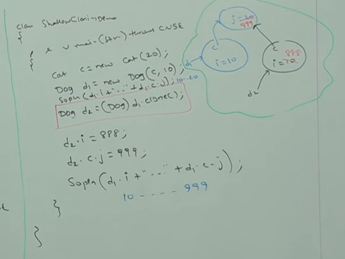

**In Shallow cloning** – By using cloned object reference if we perform any change to the content object then those changes will be reflected to the main object.

To overcome this problem we should go for “Deep Cloning”.

**Deep Cloning**: The process of creating exactly duplicate independent copy including “contend object” is called deep cloning.

In deep cloning if the main object contend any primitive variables then in the cloned object duplicate copy will be created.

If the main object contend any reference variable then corresponding contend object will be created in the cloned copy.

By default object class clone() method mint for shallow cloning, but we can implement deep cloning explicitly by overriding clone() method in over class.

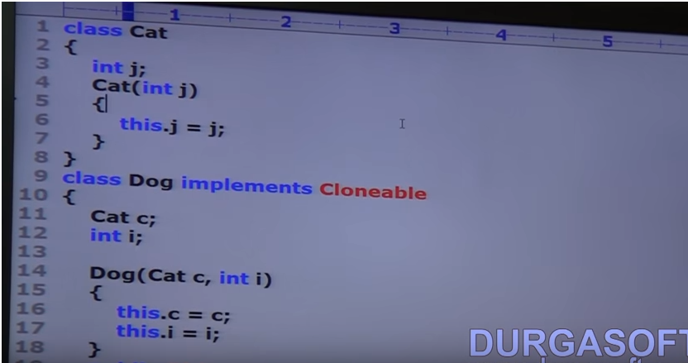

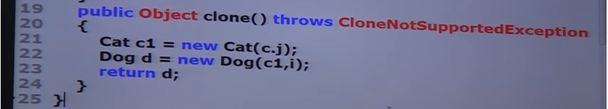

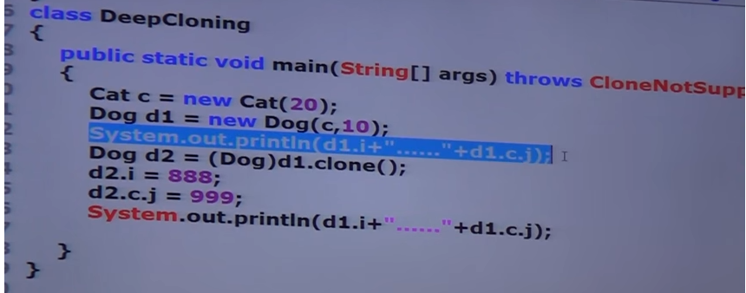

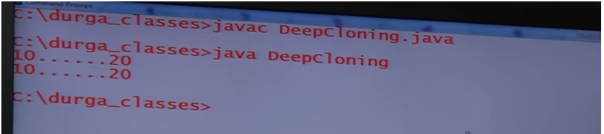

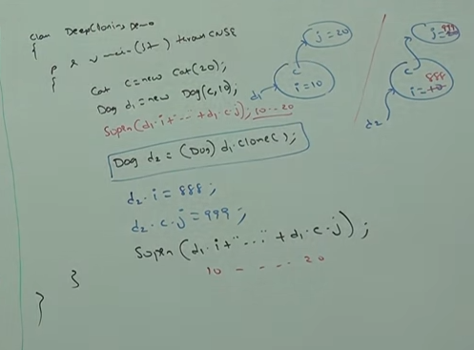

# Generics:

**Generics** Java ka ek bahut powerful feature hai jo aapko **Type-safe** code likhne mein madad karta hai.

Asaan shabdon mein, Generics ka matlab hai ki aap ek hi class, interface, ya method ko alag-alag data types (Integer, String, User-defined) ke saath use kar sakte hain, bina baar-baar naya code likhe.

**Type Parameters** tab use hote hain jab hum koi cheez **define** kar rahe hote hain, aur **Wildcards** tab use hote hain jab hum kisi cheez ko **use** kar rahe hote hain.

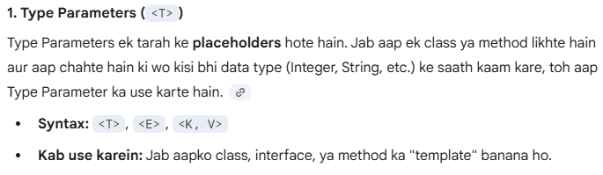

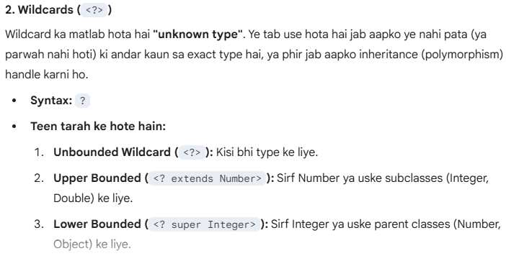

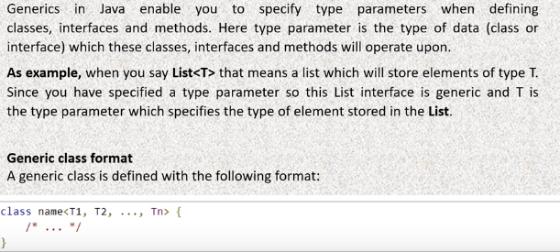

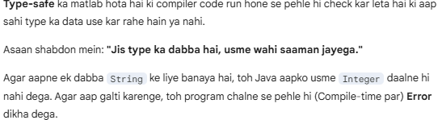

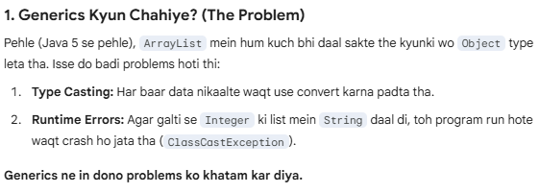

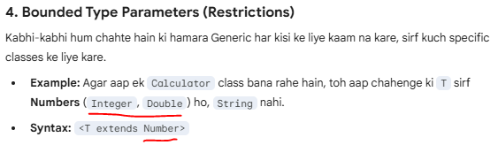

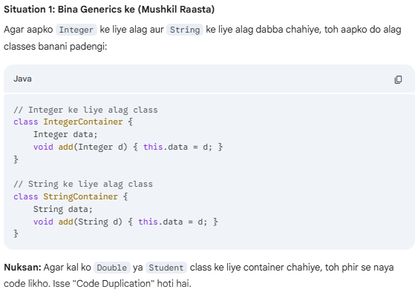 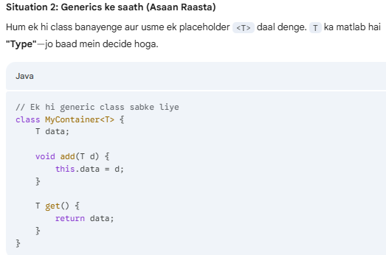 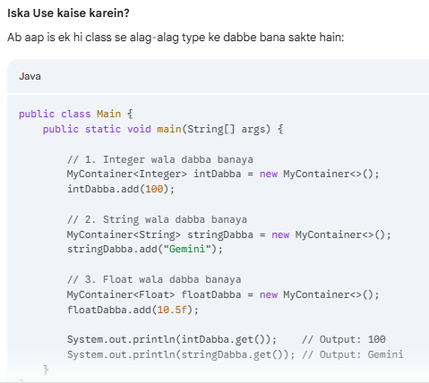 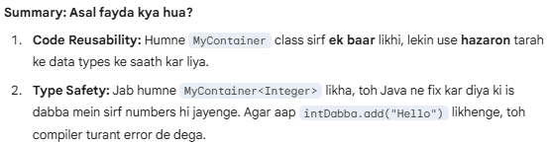

## Wildcards in Generics (?):

Java mein **Wildcard (?)** ka matlab hota hai **"Anjaan Type" (Unknown Type)**.

Jab aap code likhte hain aur aapko ye nahi pata (ya farq nahi padta) ki samne wala kaunsa data bhejega, tab aap ? ka use karte hain.

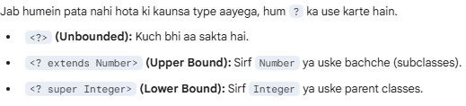

PECS(**P**roducer **E**xtends, **C**onsumer **S**uper.) Rule

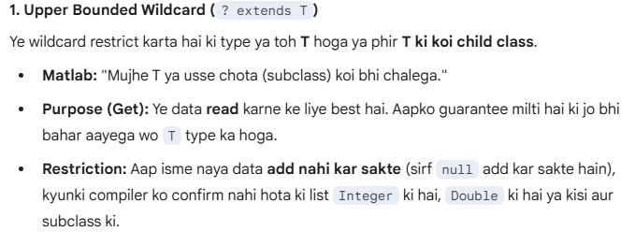

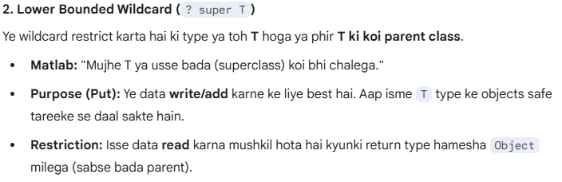

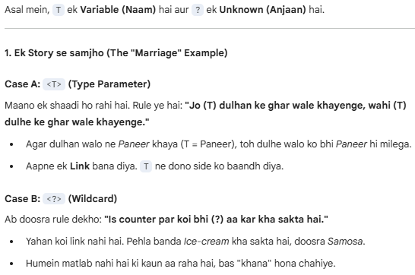

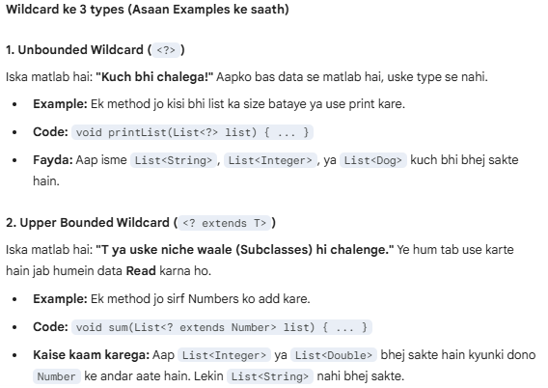 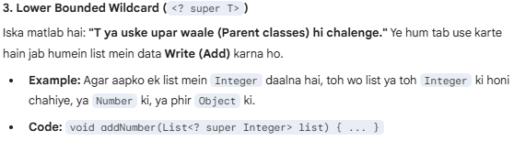

**Example:**

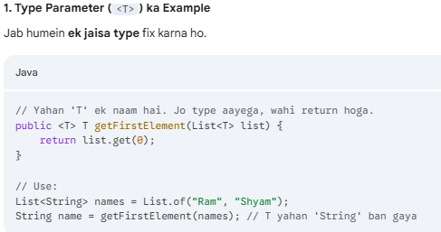

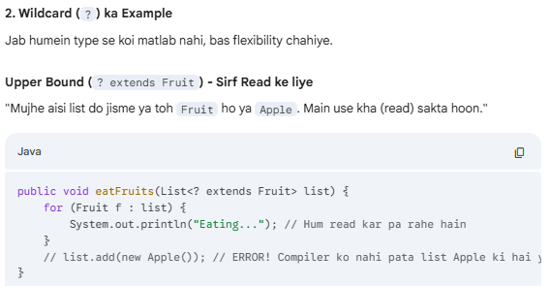 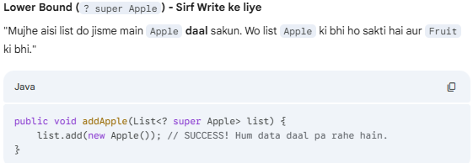

# **Inner class and nested Static Class in Java:**

Where should you use nested class in Java? This is one of the tricky Java question, If a class can only be useful to one particular class, it make sense to keep that inside the class itself  otherwise declare it as top level class. Nested class improves Encapsulation and help in maintenance. I actually look JDK itself for examples and if you look HashMap class, you will find that Map.Entry is a good example of nested class in Java.

## **Inner Class:**

Any class which is not a top level or declared inside another class is known as nested class and out of those nested classes, class which are declared [non static](http://javarevisited.blogspot.sg/2012/02/why-non-static-variable-cannot-be.html) are known as Inner class in Java. there are three kinds of Inner class in Java:

1. Local inner class
2. Anonymous inner class
3. Member inner class

Local inner class is declared inside a code block or method. Anonymous inner class is a class which doesn't have name to reference and initialized at same place where it gets created. Member inner class is declared as non static member of outer class.

**Here are some important properties of Inner classes in Java:**

1) In order to create instance of Inner class, an instance of outer class is required. Every instance of inner class is bounded to one instance of Outer class.

2) Member inner class can be make [private, protected or public](http://javarevisited.blogspot.sg/2012/10/difference-between-private-protected-public-package-access-java.html). its just like any other member of class.

3) Local inner class can not be private, protected or public because they exist only inside of local block or method. You can only use [final modifier](http://javarevisited.blogspot.sg/2011/12/final-variable-method-class-java.html) with local inner class.

4) Anonymous Inner class are common to implement [Runnable](http://javarevisited.blogspot.sg/2012/01/difference-thread-vs-runnable-interface.html) or CommandListener where you just need to implement one method. They are created and initialized at same line.

5) You can access current instance of Outer class, inside inner class as Outer.this variable.

# **Serializable:**

If you want a class object to be serializable, all you need to do it implement the java.io.Serializable interface. Serializable in java is a marker interface and has no fields or methods to implement. It’s like an Opt-In process through which we make our classes serializable.

Serialization in java is implemented by ObjectInputStream and ObjectOutputStream, so all we need is a wrapper over them to either save it to file or send it over the network.

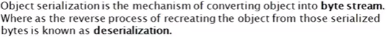

**Example**:

Address.java:

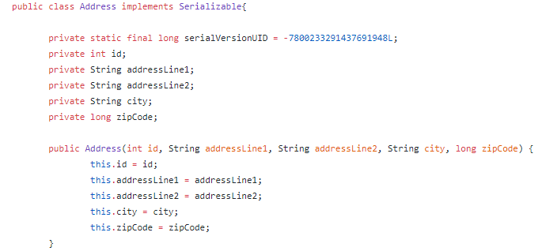

//Setter and getters

**Employee Class:**

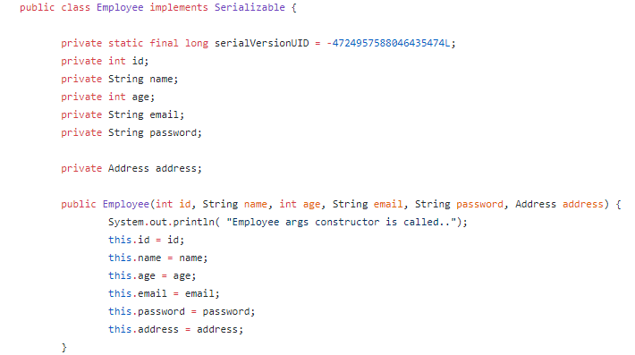

**Mail Class:**

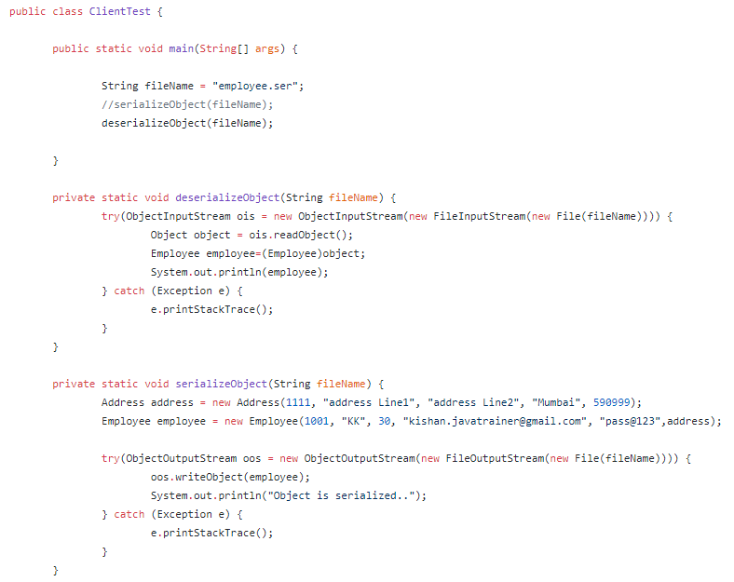

Example #2:

Write method -> writeObject() and readObject()

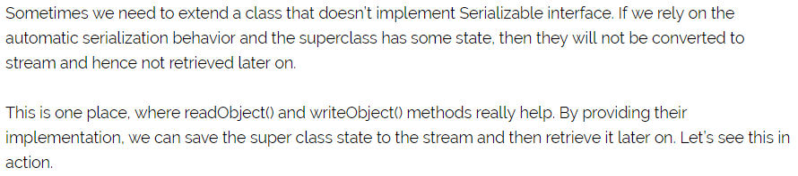

Model class Person with setter getter and Main class like below:  
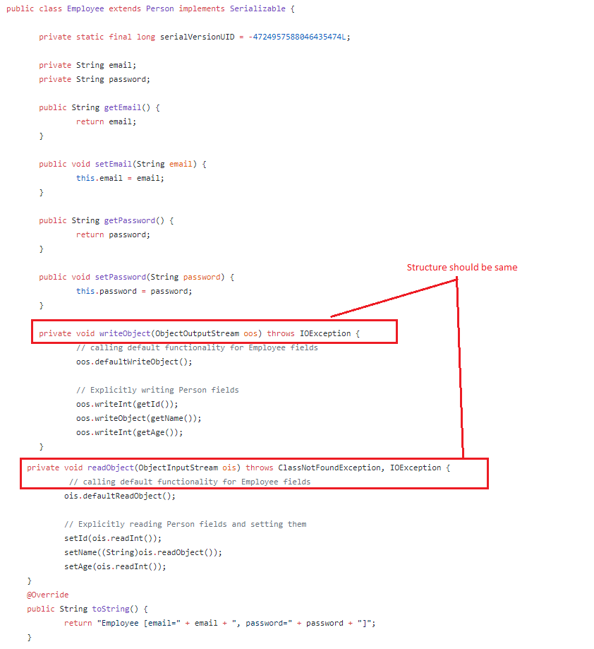

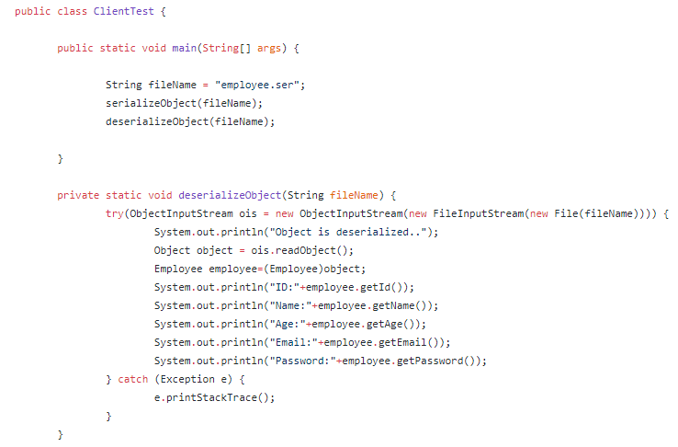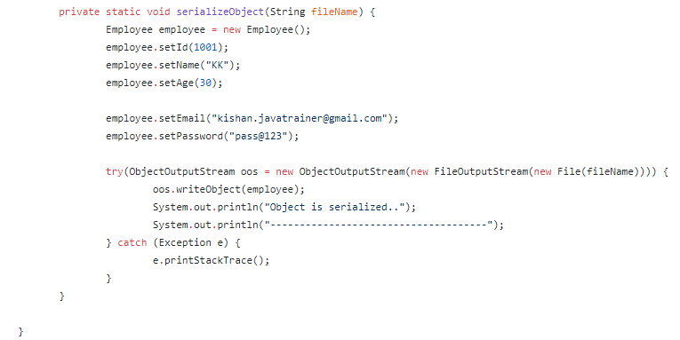

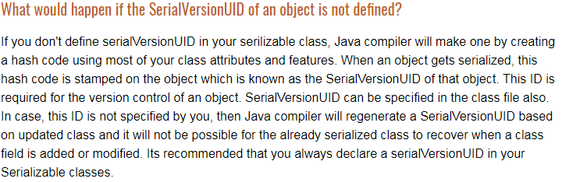

# **Externalizable:**

**Externalizable** interface, Serializable ka hi ek advanced version hai. Ye aapko serialization process par **poora control** deta hai.

Jab aap Serializable use karte hain, toh Java khud hi objects ko save aur restore karta hai (automatic). Lekin Externalizable mein **aapko** batana padta hai ki kaun sa data save karna hai aur kaun sa nahi.

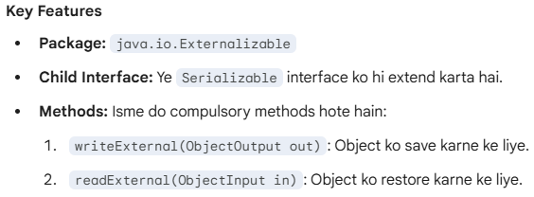 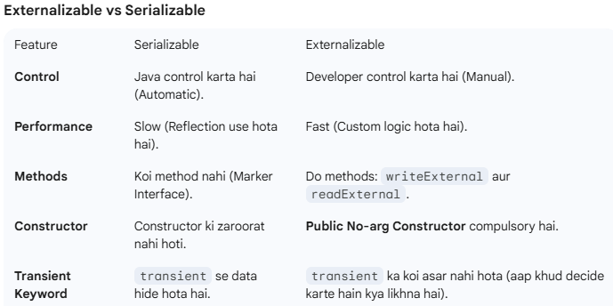



**Example**: **Person class not implementing externalization.**

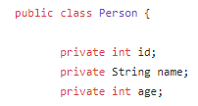

**Setter and Getter**

**Employee Class:**

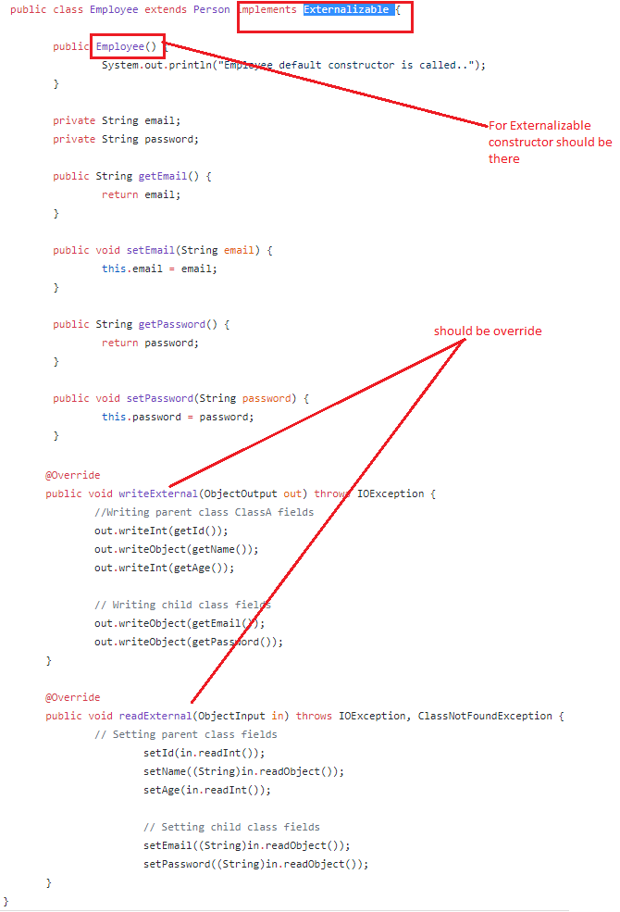

# **SerialVersionUID:**

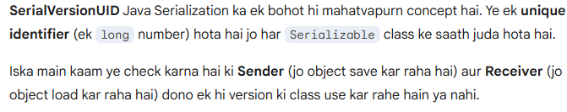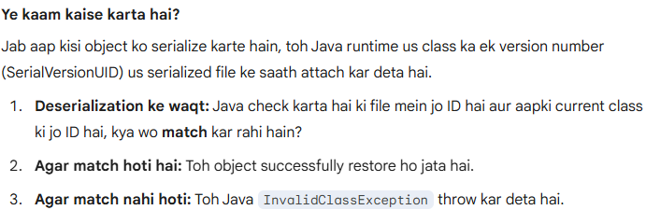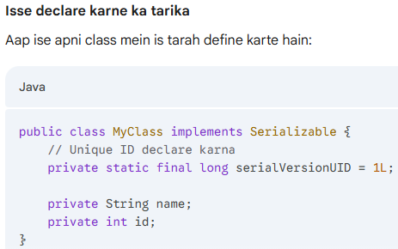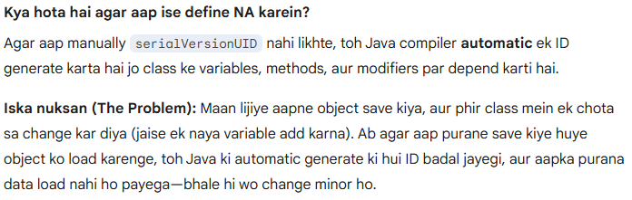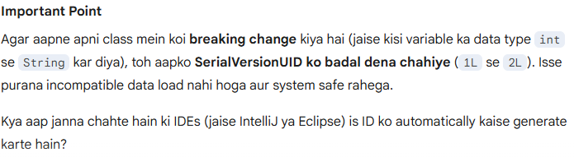

# **Enum:**

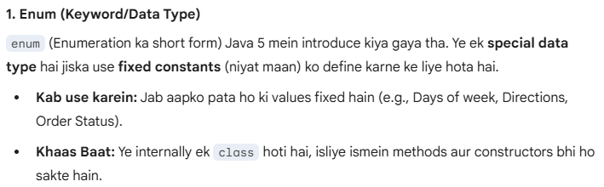

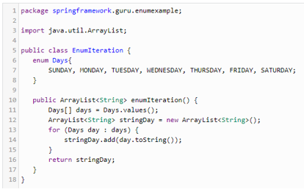

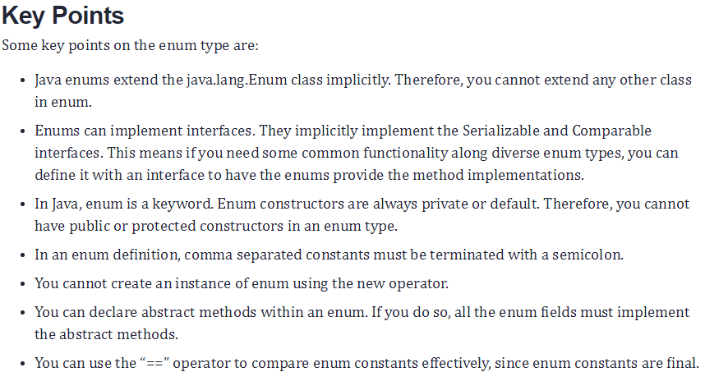

# **Enumeration (Interface):**

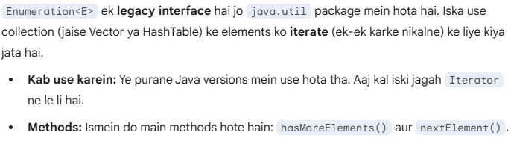

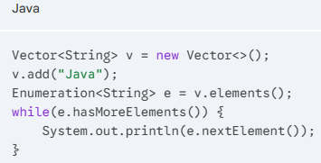

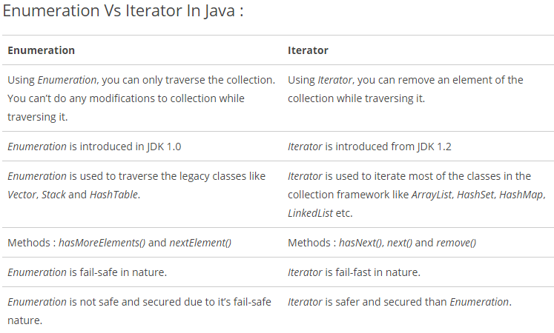

# **Exception Handling:**

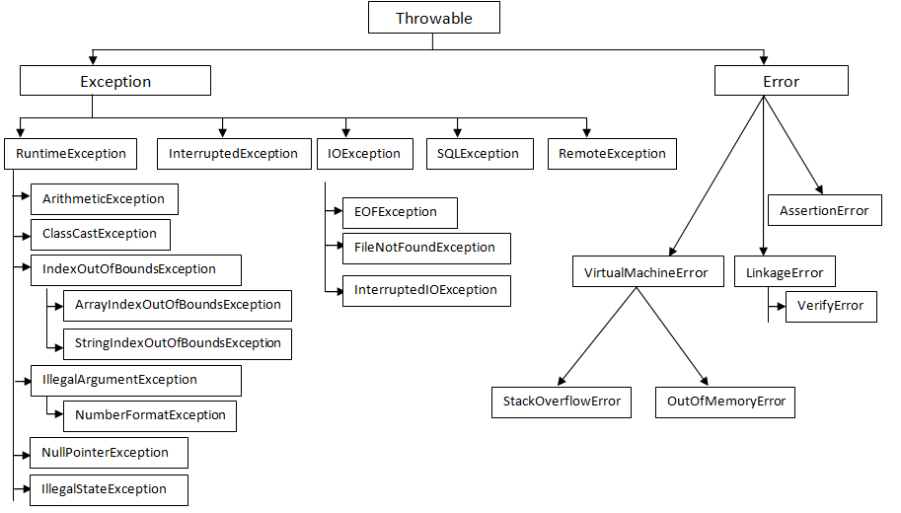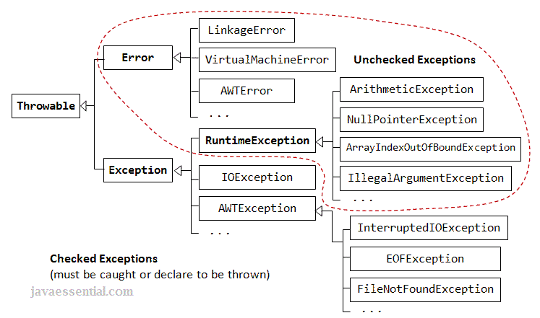

## Exception & Error:

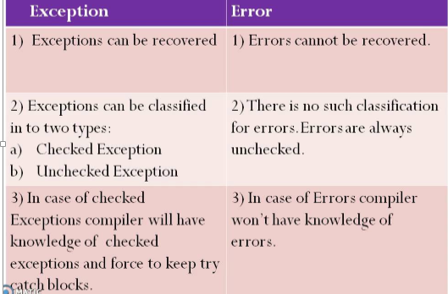

## fully checked exception & Partially checked exception:

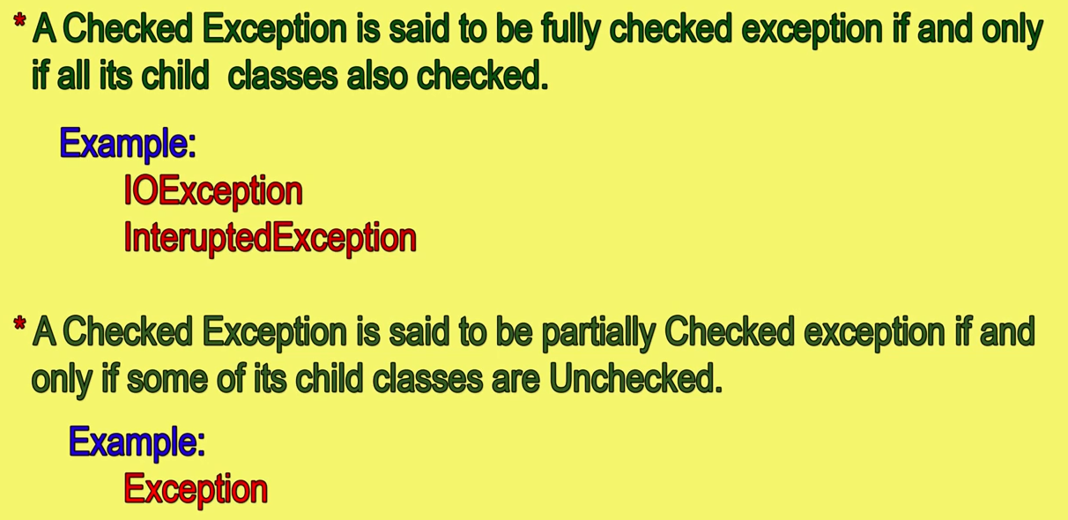

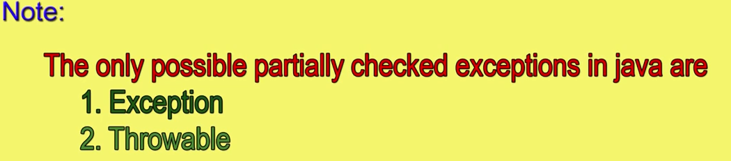

## final, finally & Finalize() :

**final-:**

1. final is an modifier applicable for classes,methods and variables. If a class declare as final then we can not extends that class.i.e., we cannot create child class for that class.

2. If a method declare as a final then we cannot override that method in the child class.

3. If a variable declare as a final then it will become constant and can’t perform re-assignment for that variable.

**finally-:**

finally is a block always associated with try catch to maintain “CleanUp” code.

**Finalize()-:**

Finalize() is a method which is always invoked by “Garbage Collector” just before destroying an object to perform cleanup activities.

**Note:**

* Finally meant for cleanup activities related to try block. Where as finalize() meant for cleanup activities related to object.

## throw & throws:

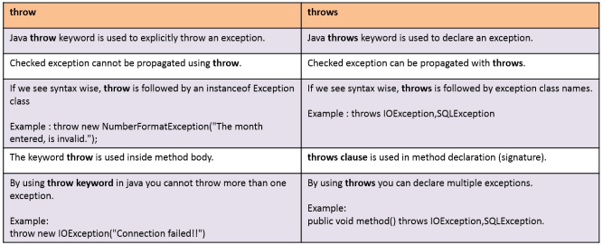

## ClassNotFoundException & NoClassDefFoundError

|  |  |  |
| --- | --- | --- |
| **Difference** | **ClassNotFoundException** | **NoClassDefFoundError** |
| Definition | At the runtime if the corresponding .class file not there then we will get “**ClassNotFoundException**.  If we not set hardcoded class name. | At the runtime if **.class** file is not there to the corresponding .java file then we will get “**NoClassDefFoundError**”  If we hardcoded uses the class then only we well get this error. |
| Example | Object obj=Class.forName(“Test”).newInstance();  If at the runtime Test.class not then we will get this exception.  Note : For Dynamically provided hardcoded class name, at runtime .class file not there then we will get this exception. | Test t=new Test();  If at the runtime Test.class not then we will get this exception.  Note: For hardcoded class name at the runtime .class file not there then only we wil get this error. |
| Which exception | Checked Exceptions | Unchecked Exception |

## CheckedException & UncheckedException:

|  |  |  |
| --- | --- | --- |
| **Difference** | **CheckedException** | **UncheckedException** |
| Definition | The exception which are checked by compiler for smooth execution of the program at runtime are called checkedexception.  Example :  HallticketMissingException  PenNotWorkingException  FileNotFoundException  In the case of checked exceptions compiler will check whether we are handling exception if the programmer not handling then we will get compile time error.  Public static void main(String[] arge){  PrintWriter pw=new PrintWriter(“abc.txt);  pw.write(“hello”);  }  Compiler will tell you :  Exception: Unreported exception java.io.FileNotFoundException; must be caught or declared to be thrown. | RuntimeException and it’s child classes, Error and it’s child classes are unchecked. Except this remaining are checked exceptions.  Example:  Arithmetic Exception  System.out.println(10/0); |
|  | Checked by compiler time | Checked by runtime |
| Extends | Exception | RuntimeException |
|  | Show recoverable condition | Show programming error |

# **Collections Framework**:

Java **Collection Framework** ek single architecture hai jo objects ke group ko store aur manipulate karne ke liye use hota hai.

Pehle (JDK 1.2 se pehle), Java mein data store karne ke liye alag-alag tarike the jaise Vector, Hashtable, aur Array. In sabka apna alag style tha. Collection Framework ne in sabko ek standard interface ke niche la kar kaam aasan kar diya.

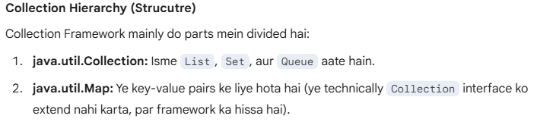

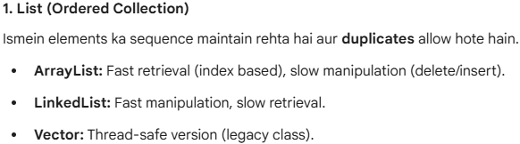

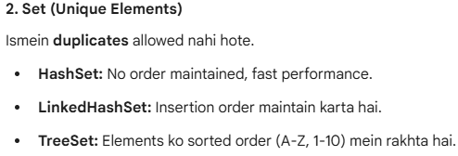

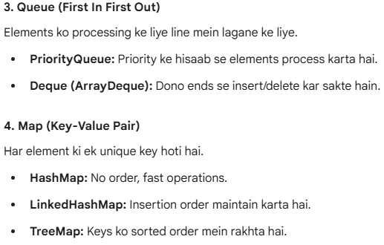

## Comparable & Comparator Interfaces:

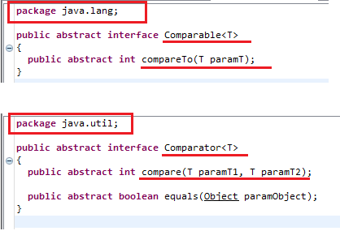

**Comparable Interface Example:**

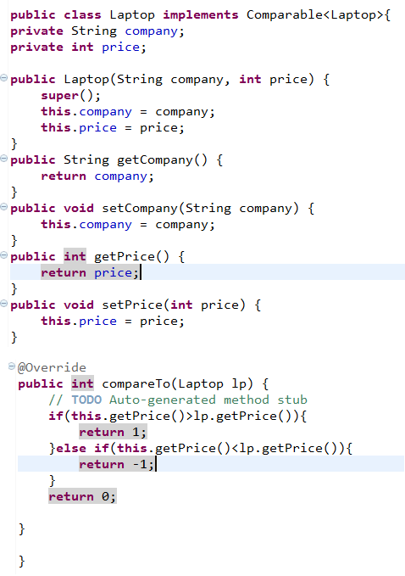

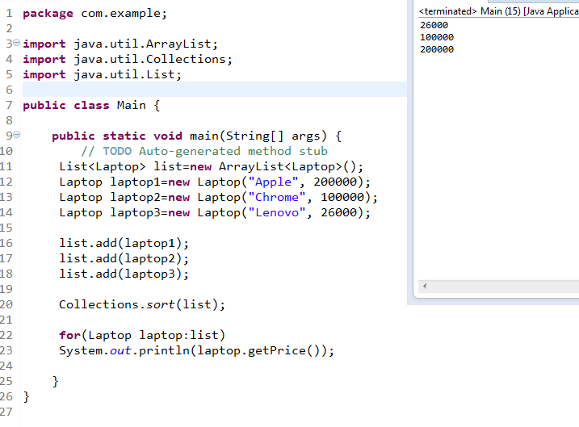

**Comparator Interface Example:**

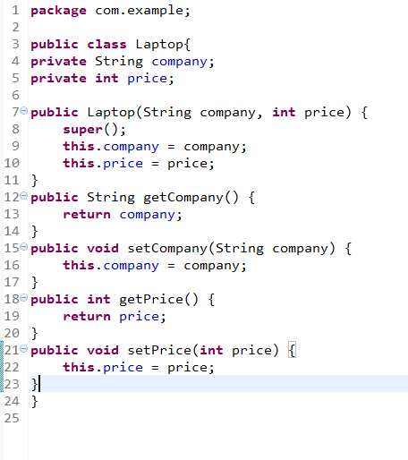

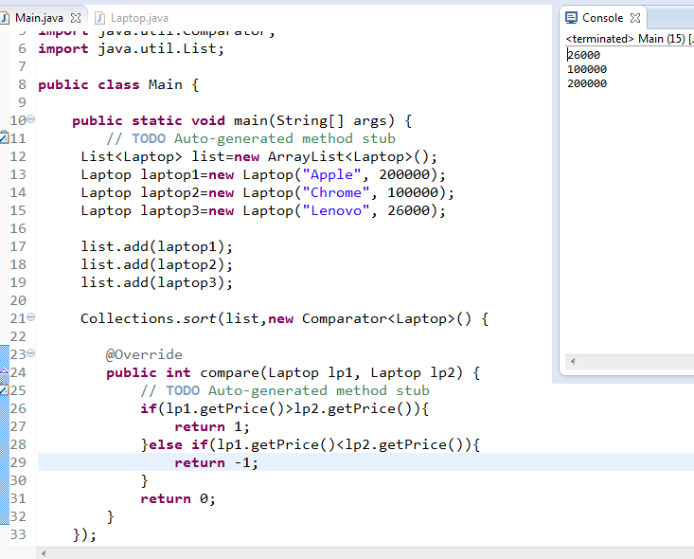

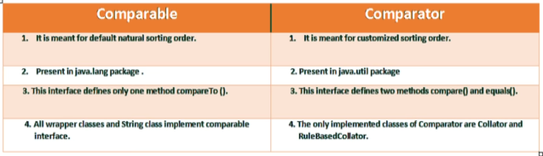

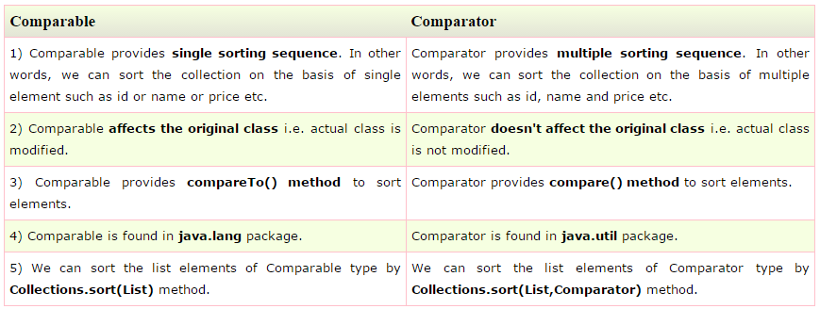

## Map Interface:

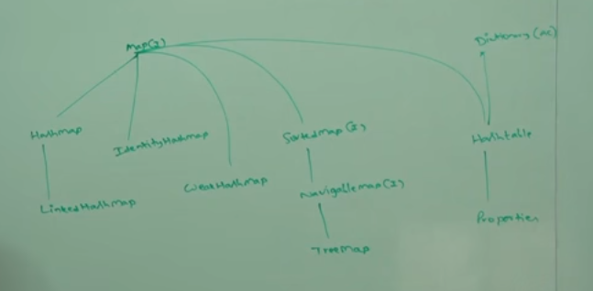

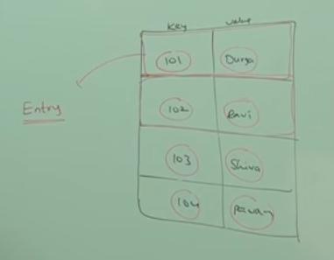

**Map.Put() Method and return type:**

The return type for the put() method is object type.

If we add (map.put(101,’rahul’)) then it will return previous value corresponding to the key(101).

Ex. If we are adding first time then it will return object with null value, but if second time we are adding (map.put(101,’BHATI’)) then it will return object with “rahul” value.

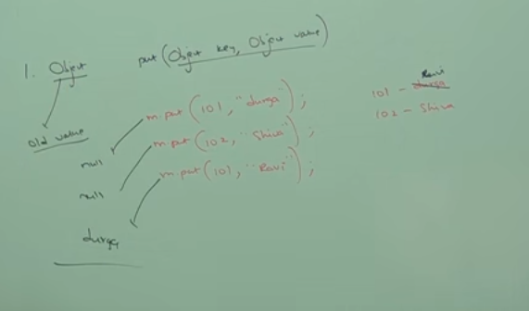

Note:Collections Views Methods are below :

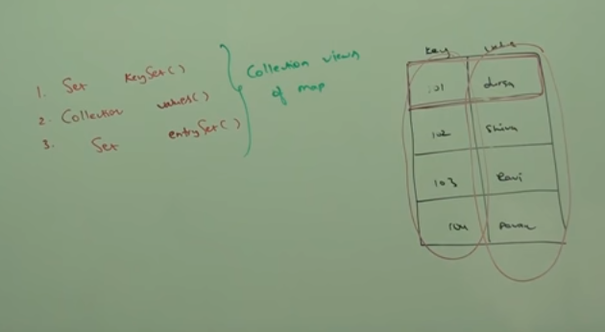

**How hash map internally work?**

In Hashmap collection class we are having put(key,value) and get(key) methods

By calling put(key,value) method, hasmap implementions calls hascode() method on key to get hashcode value ,which will get passed as an input to hashing function to get the bucket location to store the k-v pair in Map.Entry<K,V> in bucket.

Then at the time calling get(key) method ,even if 2 diffrents objects having same hashcode will get

fetched correctly by calling keys .equals() method to get the correct K,V pair to avoid collision.

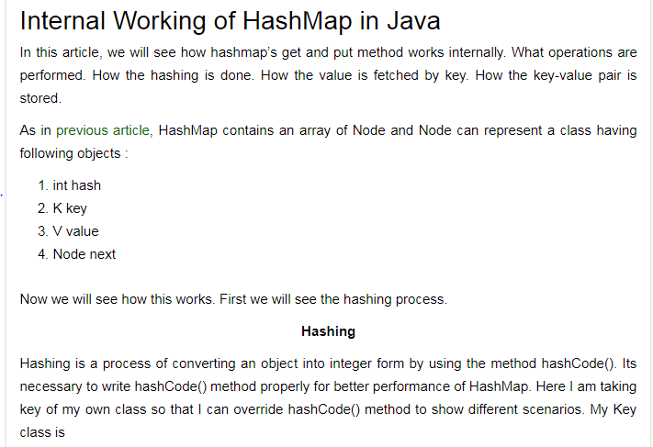

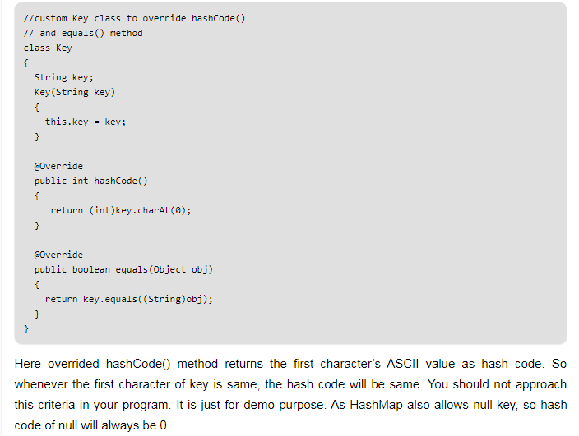

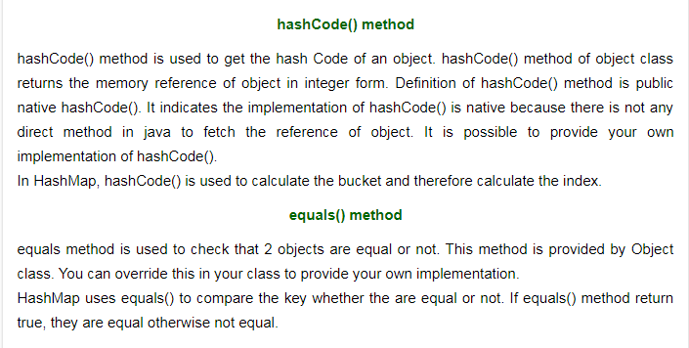

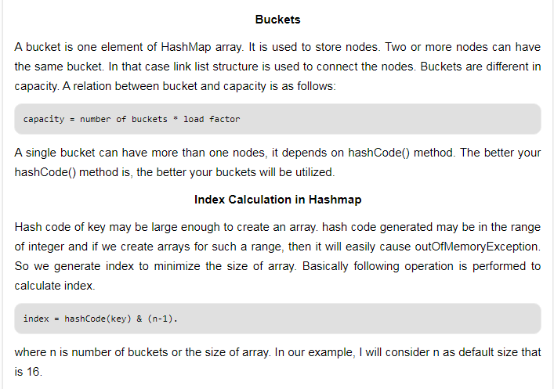

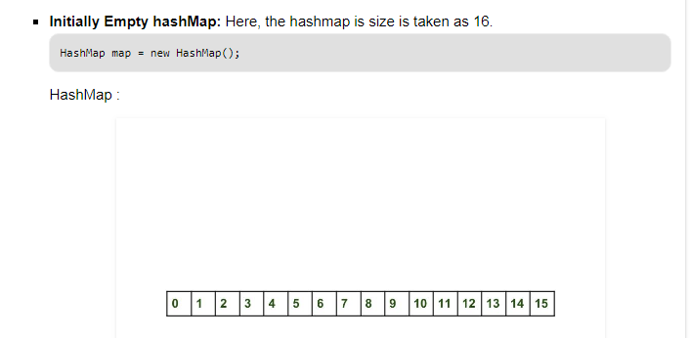

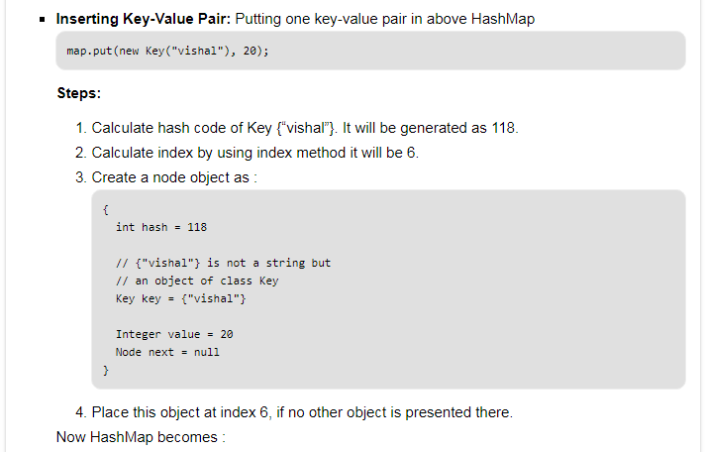

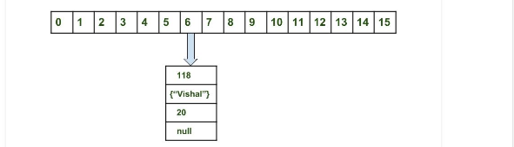

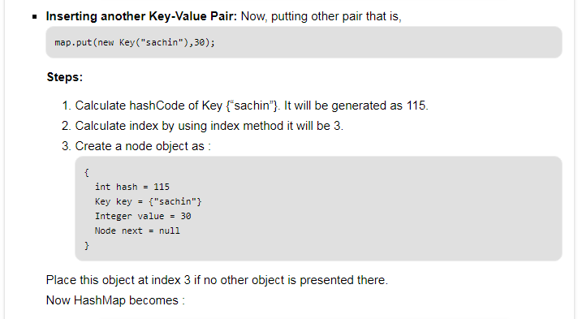

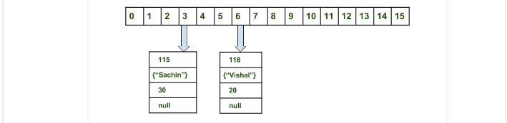

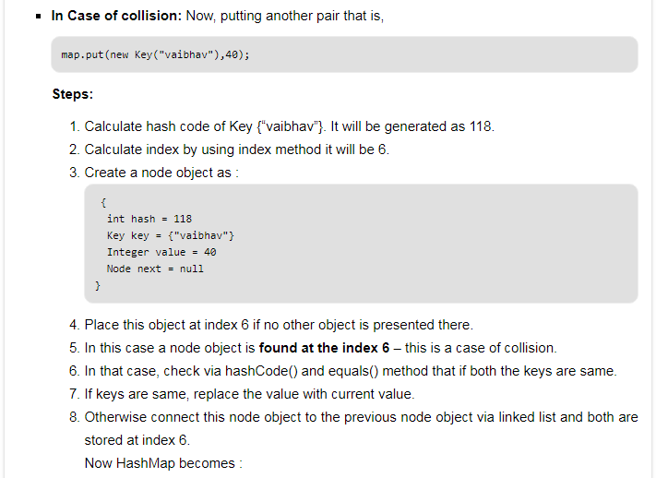

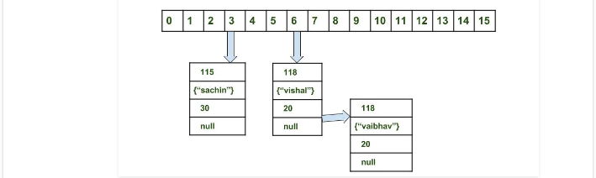

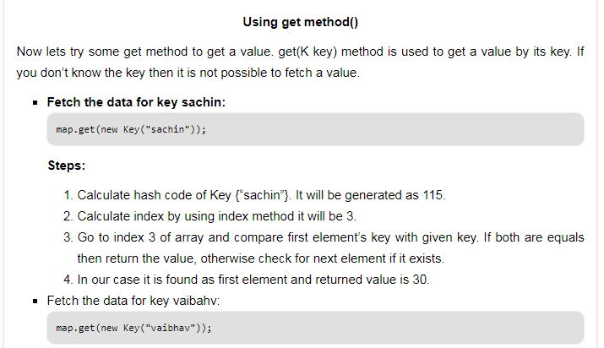

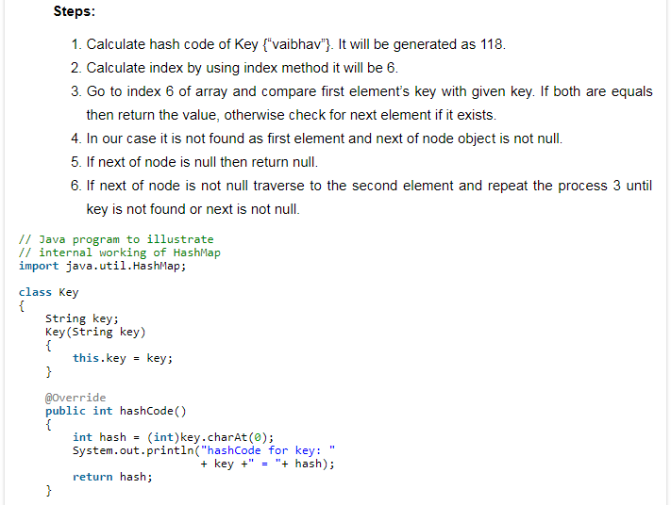

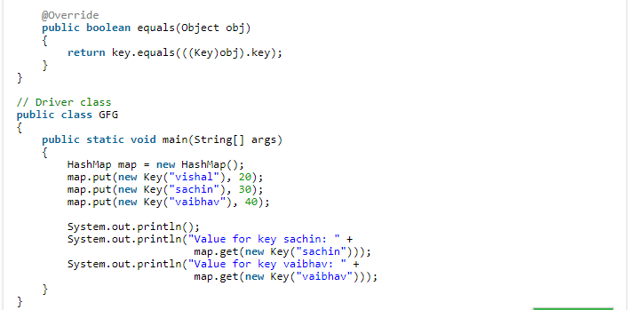

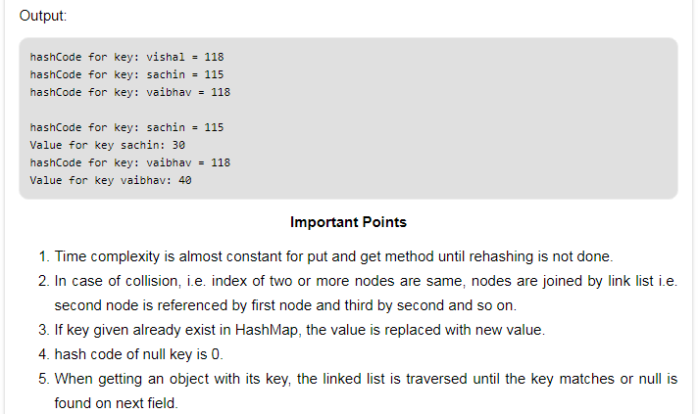

# **Initial Capacity Of HashMap:**

The capacity of an HashMap is the number of buckets in the hash table. The default initial capacity of the HashMap is 24 i.e 16. The capacity of the HashMap is doubled each time it reaches the threshold. i.e the capacity is increased to 25=32, 26=64, 27=128….. **when the threshold is reached.**

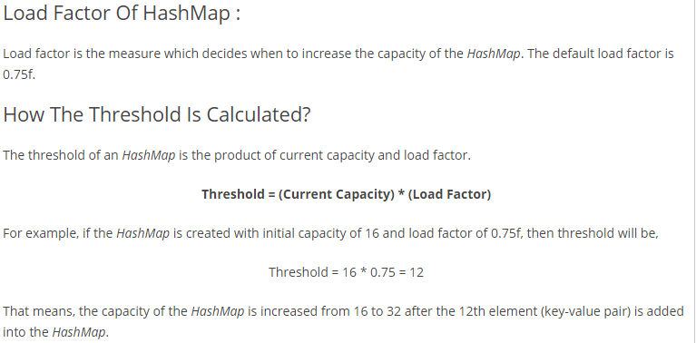

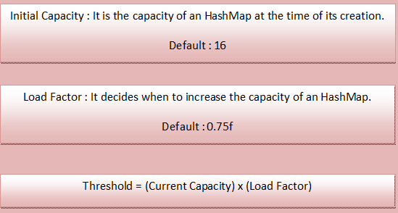

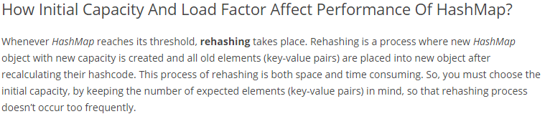

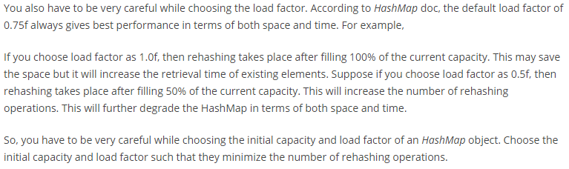

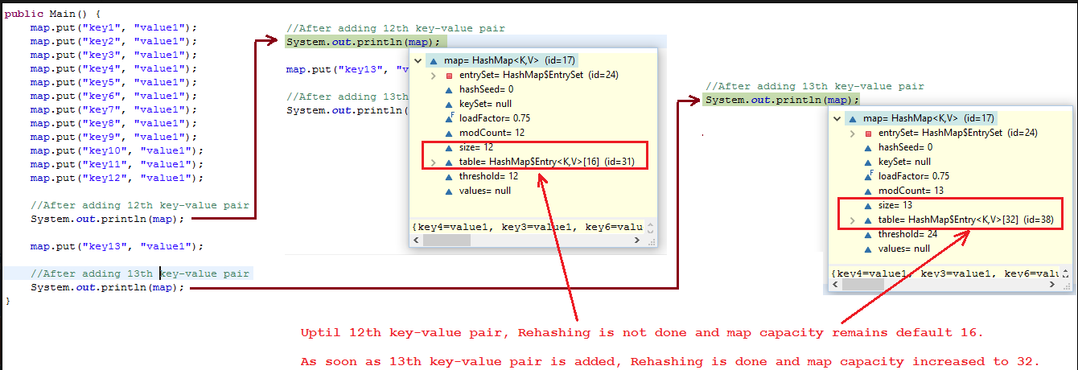

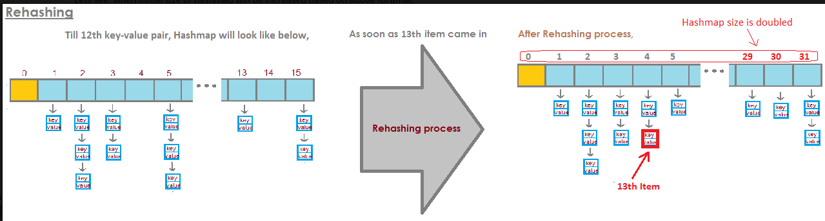

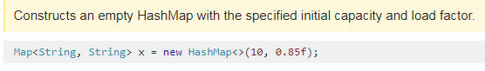

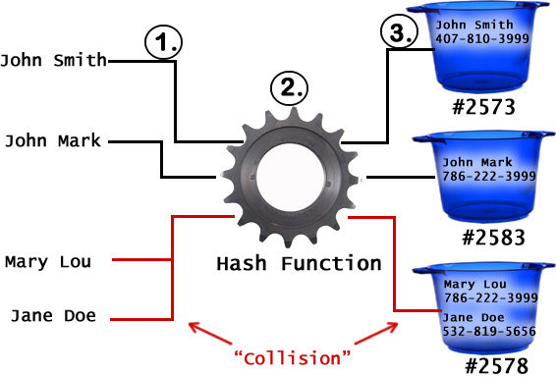

HashMap work on Hashing Principle.

HashMap.Java

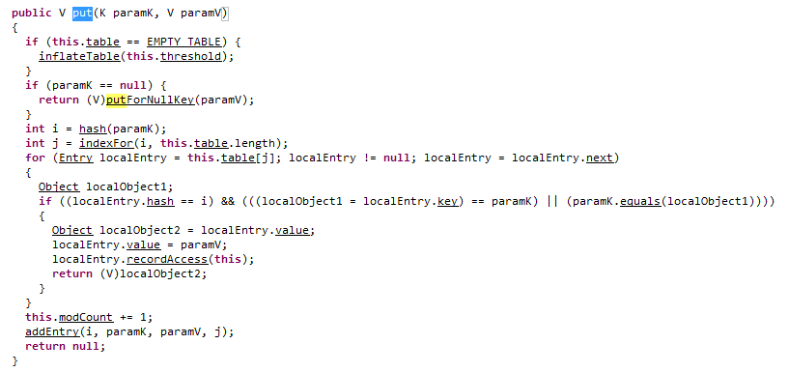

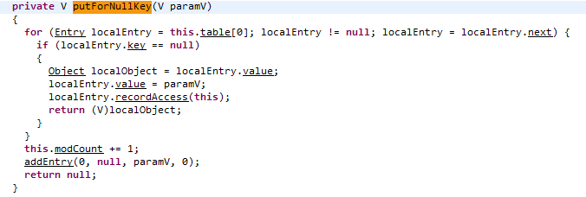

**addEntry(hashcode,key,value,bucket_position)**

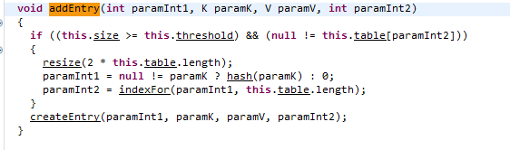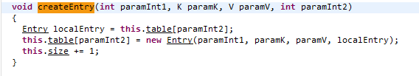

Example:

## Lets override default implemenation of hashcode() and equals():

You don't have to always override these methods, but lets say you want to define equality of country object based on name, then you need to override equals method and if you are overriding equals method, you should override hashcode method too. Below example will make it clear.

Lets see with the help of example.We have a class called Country

**1. Country.java same as above**

[view plainprint?](http://www.java2blog.com/2014/02/hashcode-and-equals-method-in-java.html)

1. **package** org.arpit.java2blog;
3. **public** **class** Country {
5. String name;
6. **long** population;
7. **public** String getName() {
8. **return** name;
9. }
10. **public** **void** setName(String name) {
11. **this**.name = name;
12. }
13. **public** **long** getPopulation() {
14. **return** population;
15. }
16. **public** **void** setPopulation(**long** population) {
17. **this**.population = population;
18. }
20. }

This country class have two basic attributes- name and population.

Now create a class called "EqualityCheckMain.java"

[view plainprint?](http://www.java2blog.com/2014/02/hashcode-and-equals-method-in-java.html)

1. **package** org.arpit.java2blog;
3. **public** **class** EqualityCheckMain {
5. /**
6. * @author arpit mandliya
7. */
8. **public** **static** **void** main(String[] args) {
10. Country india1=**new** Country();
11. india1.setName("India");
12. Country india2=**new** Country();
13. india2.setName("India");
14. System.out.println("Is india1 is equal to india2:" +india1.equals(india2));
15. }
17. }

When you run above program, you will get following output

[view plainprint?](http://www.java2blog.com/2014/02/hashcode-and-equals-method-in-java.html)

1. Is india1 is equal to india2:**false**

In above program, we have created two different objects and set their name attribute to "india".

Because both references india1 and india2 are pointing to different object, as default implementation of equals check for ==,equals method is returning false. In real life, it should have return true because no two countries can have same name.

Now lets override equals and return true if two country's name are same.

Add this method to above country class:

[view plainprint?](http://www.java2blog.com/2014/02/hashcode-and-equals-method-in-java.html)

1. @Override
2. **public** **boolean** equals(Object obj) {
3. **if** (**this** == obj)
4. **return** **true**;
5. **if** (obj == **null**)
6. **return** **false**;
7. **if** (getClass() != obj.getClass())
8. **return** **false**;
9. Country other = (Country) obj;
10. **if** (name == **null**) {
11. **if** (other.name != **null**)
12. **return** **false**;
13. } **else** **if** (!name.equals(other.name))
14. **return** **false**;
15. **return** **true**;
16. }

and now run EqualityCheckMain.java again

You will get following output:

[view plainprint?](http://www.java2blog.com/2014/02/hashcode-and-equals-method-in-java.html)

1. Is india1 is equal to india2:**true**

Now this is because overriden equals method return true if two country have same name.  
One thing to remember here, signature of equals method should be same as above.

## Lets put this Country objects in hashmap:

Here we are going to use Country class object as key and its capital name(string) as value in HashMap.

[view plainprint?](http://www.java2blog.com/2014/02/hashcode-and-equals-method-in-java.html)

1. **package** org.arpit.java2blog;
3. **import** java.util.HashMap;
4. **import** java.util.Iterator;
6. **public** **class** HashMapEqualityCheckMain {
8. /**
9. 3     * @author Arpit Mandliya
10. */
11. **public** **static** **void** main(String[] args) {
12. HashMap<Country,String> countryCapitalMap=**new** HashMap<Country,String>();
13. Country india1=**new** Country();
14. india1.setName("India");
15. Country india2=**new** Country();
16. india2.setName("India");
18. countryCapitalMap.put(india1, "Delhi");
19. countryCapitalMap.put(india2, "Delhi");
21. Iterator<Country> countryCapitalIter=countryCapitalMap.keySet().iterator();
22. **while**(countryCapitalIter.hasNext())
23. {
24. Country countryObj=countryCapitalIter.next();
25. String capital=countryCapitalMap.get(countryObj);
26. System.out.println("Capital of "+ countryObj.getName()+"----"+capital);
28. }
29. }
30. }

When you run above program, you will see following output:

1. Capital of India----Delhi
2. Capital of India----Delhi

Now you must be wondering even through two objects are equal why HashMap contains two key value pair instead of one.This is because First HashMap uses hashcode to find bucket for that key object, if hashcodes are same then only it checks for equals method and because hashcode for above two country objects uses default hashcode method,Both will have different memory address hence different hashcode.

Now lets override hashcode method.Add following method to Country class

[view plainprint?](http://www.java2blog.com/2014/02/hashcode-and-equals-method-in-java.html)

1. @Override
2. **public** **int** hashCode() {
3. **final** **int** prime = 31;
4. **int** result = 1;
5. result = prime * result + ((name == **null**) ? 0 : name.hashCode());
6. **return** result;
7. }

Now run HashMapEqualityCheckMain.java again

You will see following output:

1. Capital of India----Delhi

So now hashcode for above two objects india1 and india2 are same, so Both will be point to same bucket,now equals method will be used to compare them which  will return true.  
This is the reason java doc says "if you override equals() method then you must override hashCode() method"

# **What happened if hascode() returning same has code(means returning 1):**

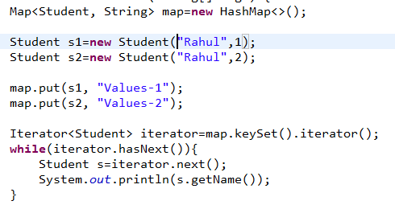

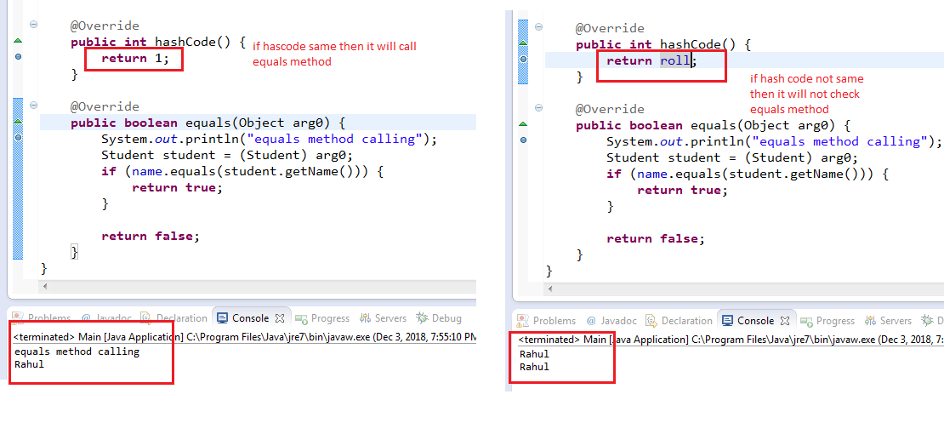

# Concurrent Collections

## Difference between “**Traditional**” & “**Concurrent**” Collections

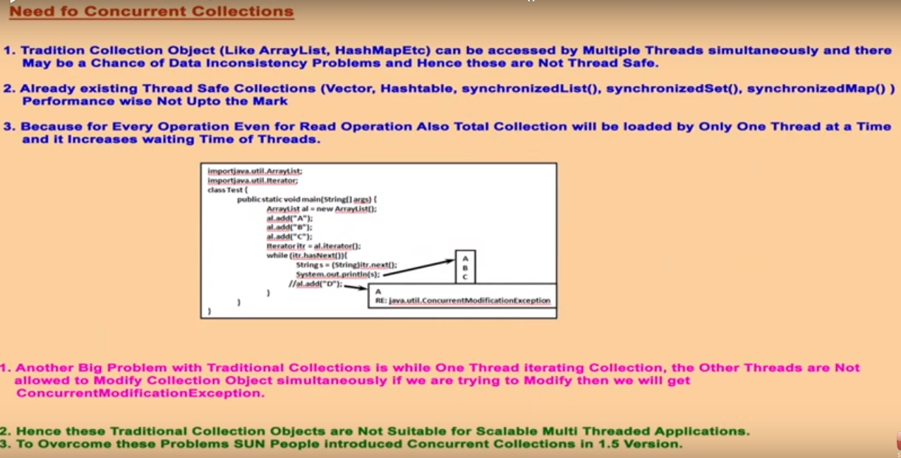

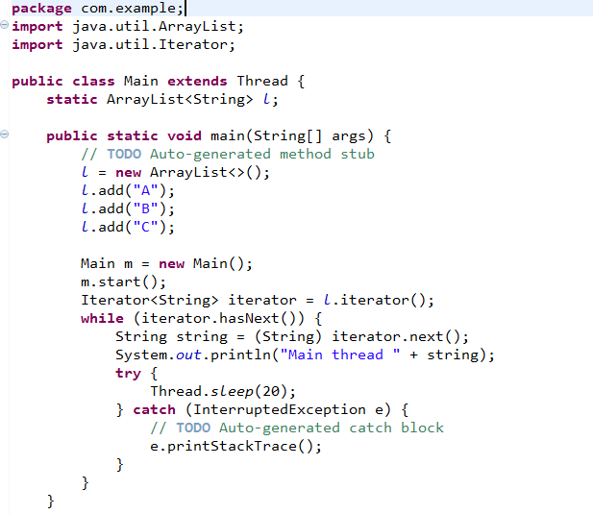

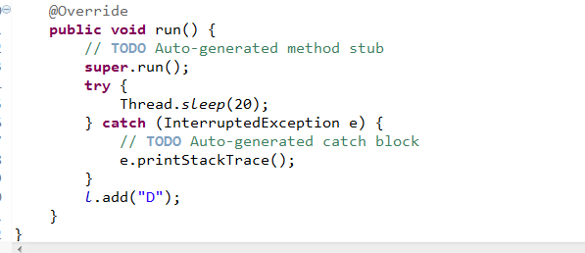

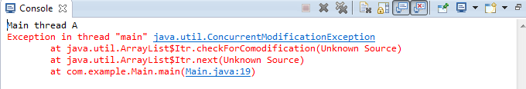

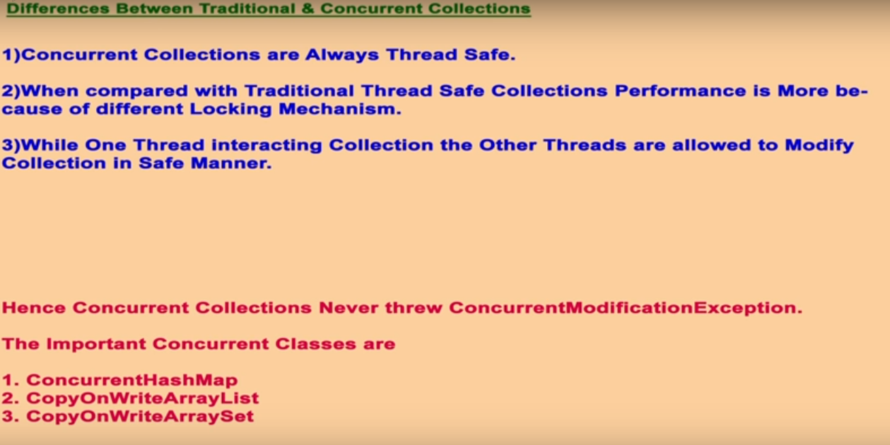

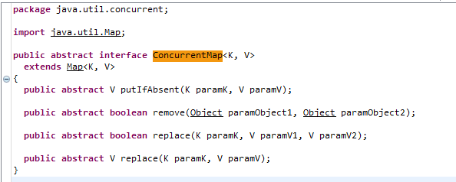

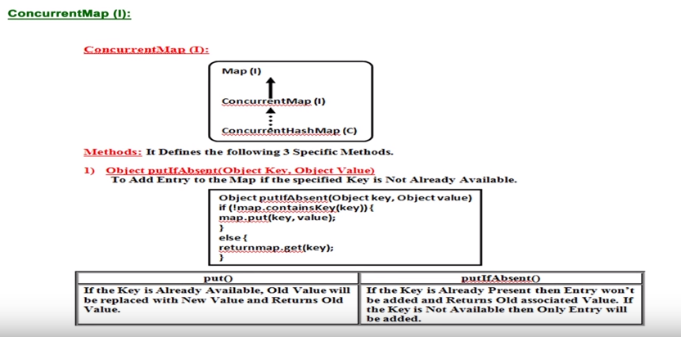

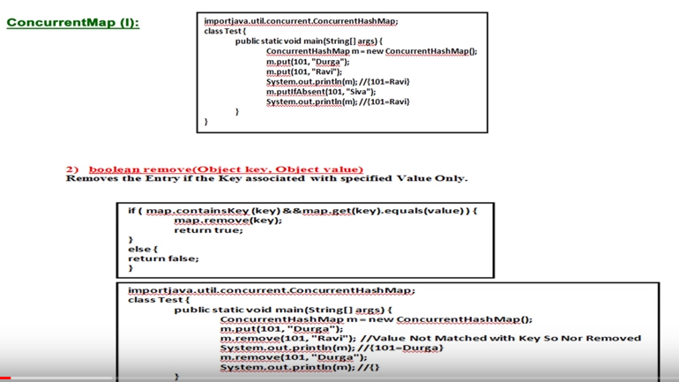

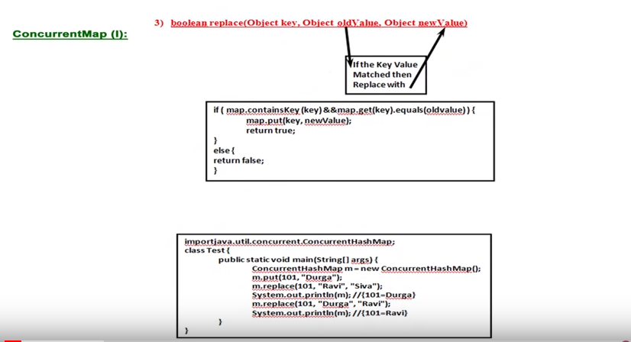

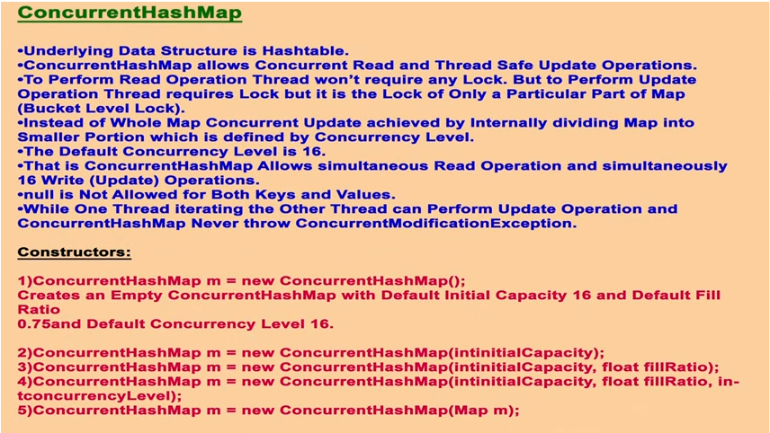

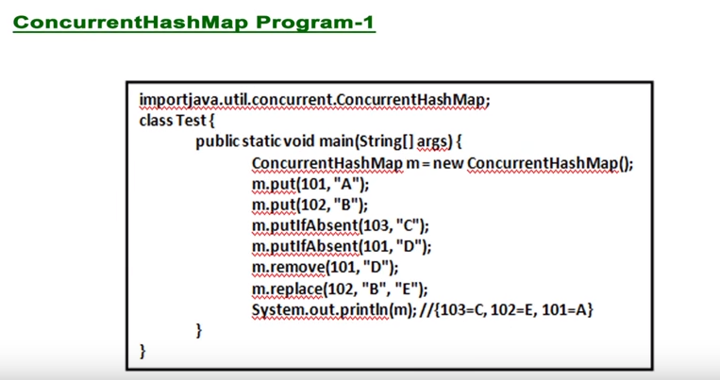

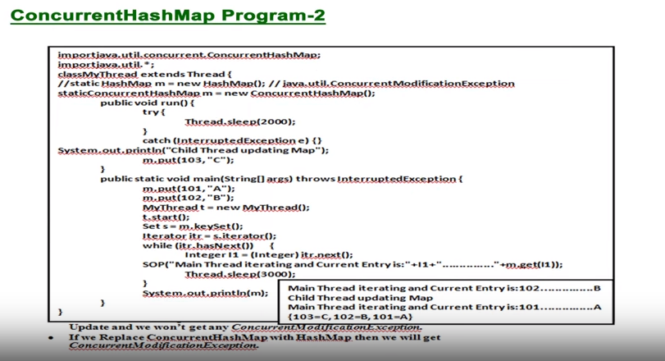

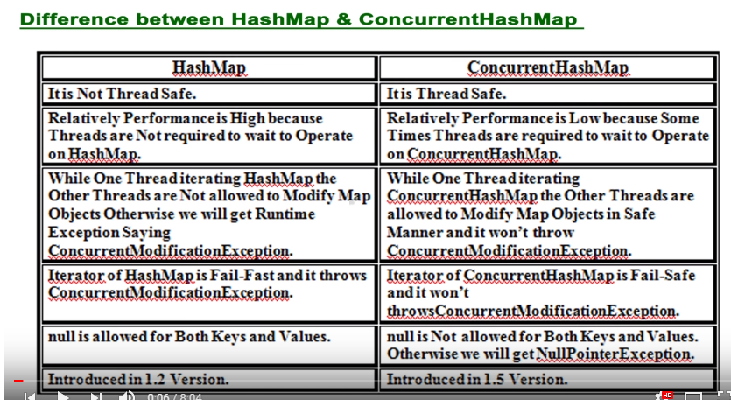

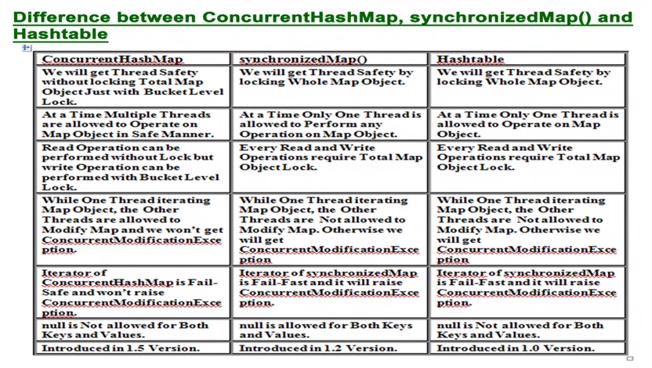

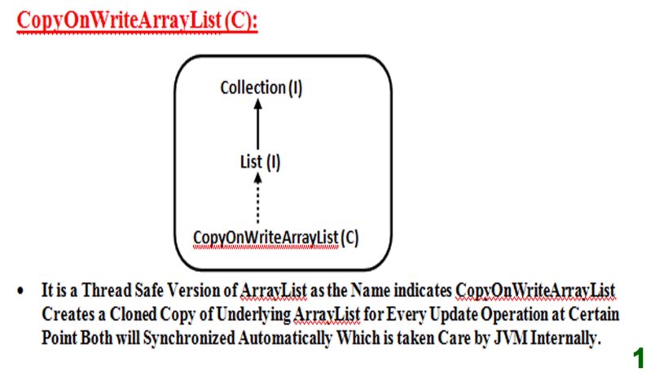 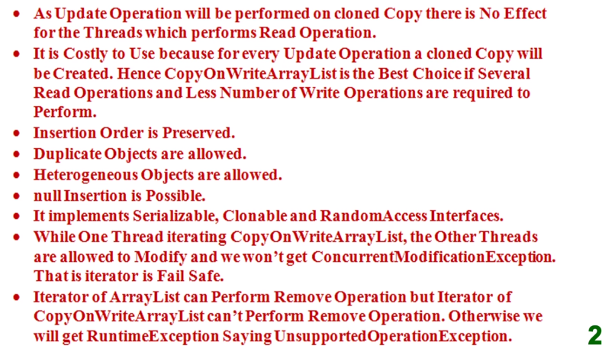

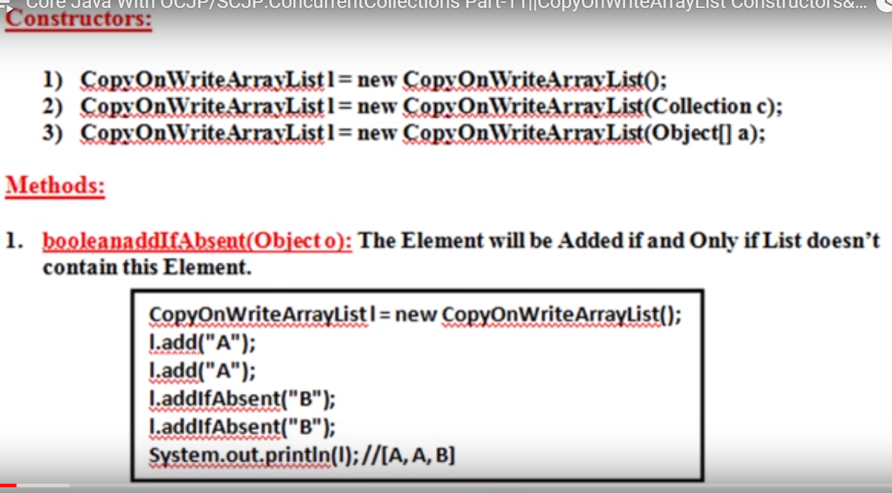

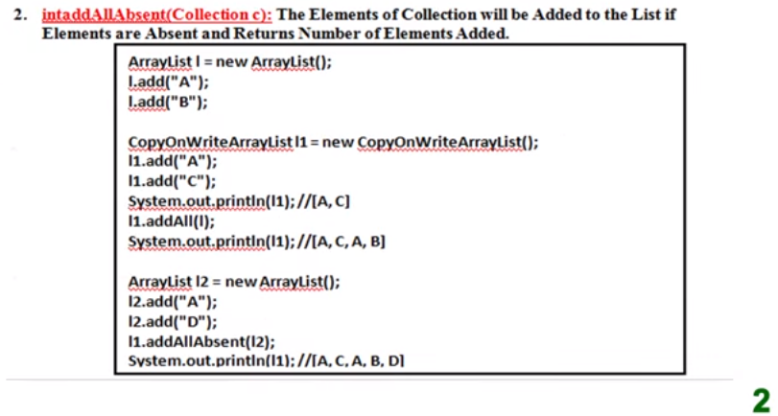

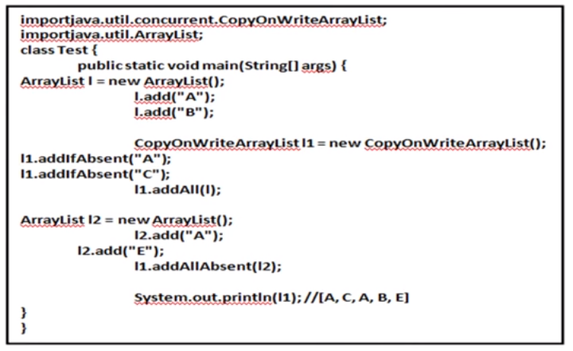

Note: In above example l1.addAll(l)----------is the normal arraylist method that’s why it will not check already added elements. Means it will directly addAll elements of the “l” into “l1” object.

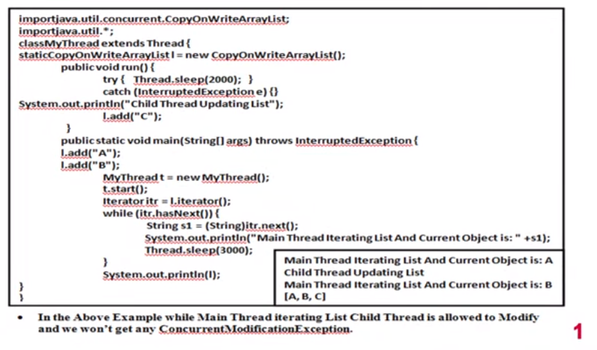

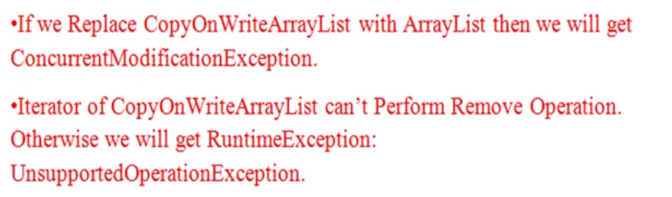

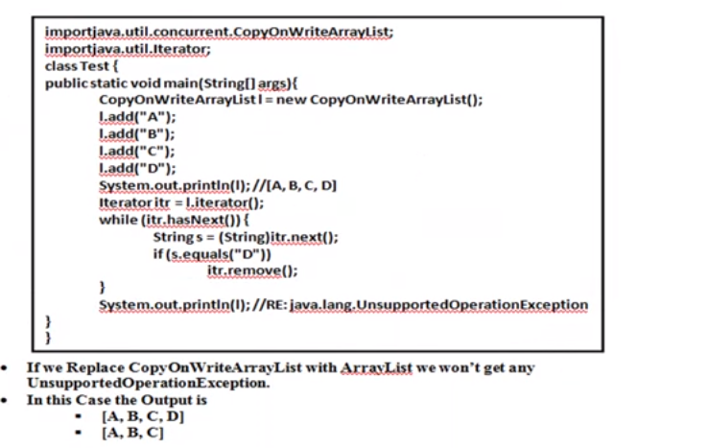

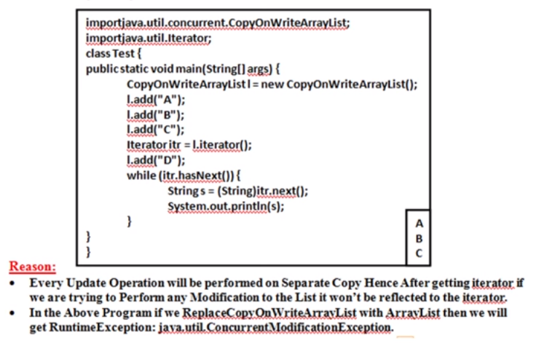

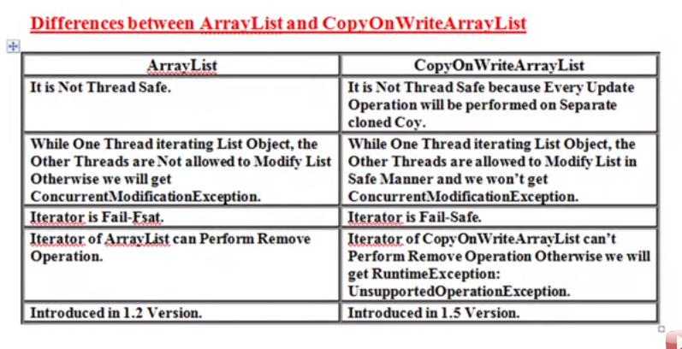

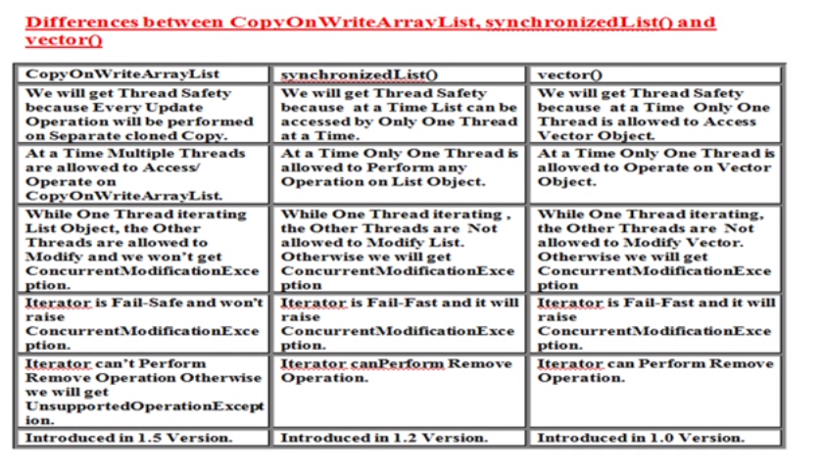

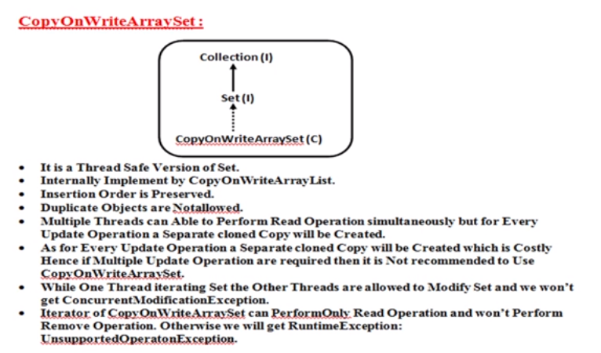 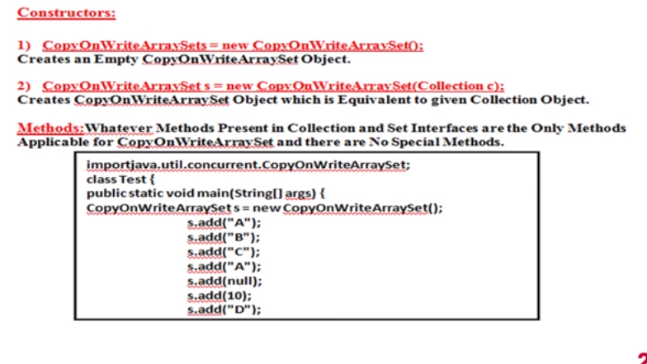 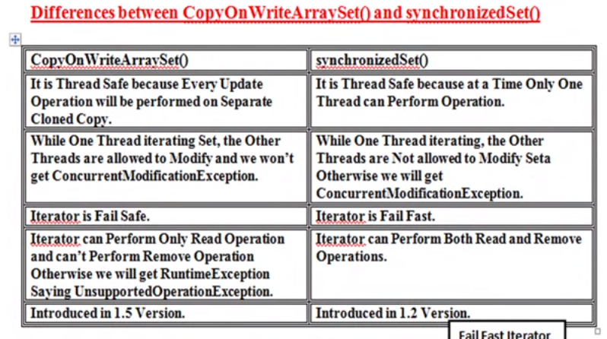

# Multithreading:

**Multithreading** is a process of executing two or more parts of a program simultaneously to maximum utilization of the CPU. Each part of such a program is called a **thread**.

## Synchronization:

In Java, **synchronization** is the mechanism that controls the access of multiple threads to shared resources. Without it, you might encounter "**Race Conditions**," where two threads modify the same data simultaneously, leading to unpredictable results.

Think of it like a **single-person restroom**: the lock on the door ensures that only one person can enter at a time. In Java, this "lock" is known as a **Monitor**.

**Race Condition:**

Race Condition ek aisi situation hai jaha do ya do se zyada threads ek hi shared data par kaam karne ki koshish karte hain, aur final result is baat par depend karta hai ki kaunsa thread pehle execute hua.

Isse program mein unpredictable bugs aate hain kyunki result hamesha "race" (kaun jeeta) par nirbhar karta hai.

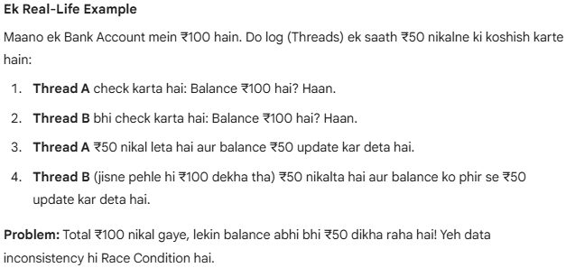

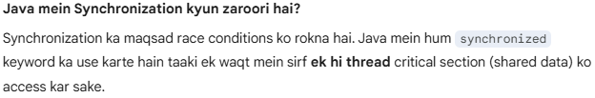

**Method Level Synchronization:**

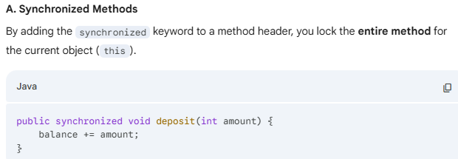

**Block Level Synchronization:**

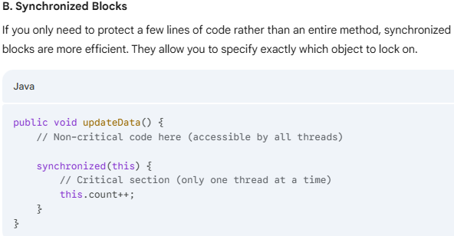

## Volatile keyword:

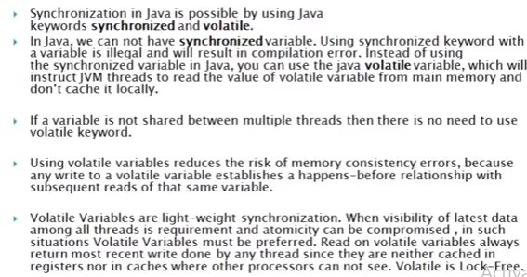

**Note: In volatile first priority is to always write after read operation.**

[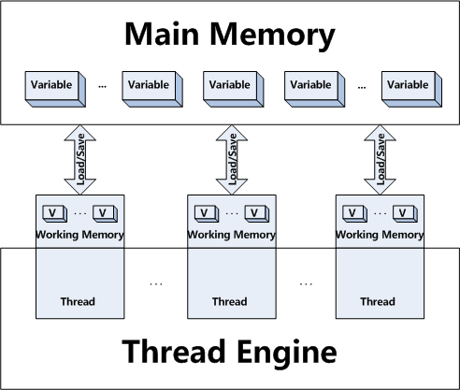](https://click.linksynergy.com/fs-bin/click?id=JVFxdTr9V80&subid=0&offerid=323058.1&type=10&tmpid=14538&RD_PARM1=https://www.udemy.com/multithreading-and-parallel-computing-in-java/)

**Differences Between Synchronized and Volatile:**

1. The volatile keyword in Java is a field modifier while synchronized modifies code blocks and methods.  
  
2. Synchronized obtains and releases the lock on monitor’s Java volatile keyword doesn't require that.  
  
3. Threads in Java can be blocked for waiting for any monitor in case of synchronized, that is not the case with the [volatile keyword](http://java67.blogspot.com/2012/11/difference-between-transient-vs-volatile-modifier-variable-java.html) in Java.  
  
4. Synchronized method affects performance more than a volatile keyword in Java.  
  
5. Since volatile keyword in Java only synchronizes the value of one variable between Thread memory and "main" memory while synchronized synchronizes the value of all variable between thread memory and "main" memory and locks and releases a monitor to boot. Due to this reason synchronized keyword in Java is likely to have more overhead than volatile.  
  
6. You can not synchronize on the null object but your volatile variable in Java could be null.  
  
7. From Java 5 writing into a volatile field has the same memory effect as a monitor release, and reading from a volatile field has the same memory effect as a monitor acquire

**Example Singleton Class in case of Multithreading:**

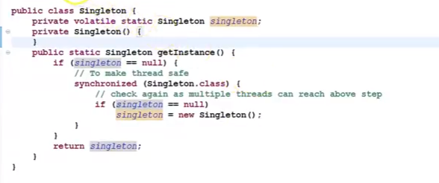

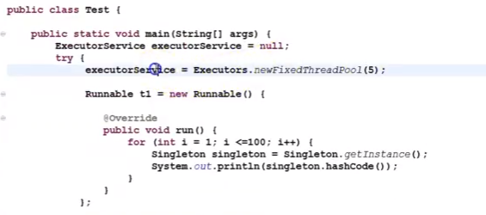

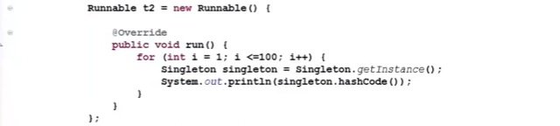

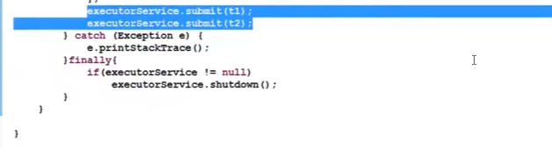

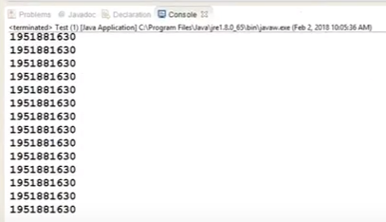

The hashcode will be the same because instance create only once.

Note: Volatile gives a visibility but not the atomicity.

## Atomic Variable:

**Atomic variables** are classes provided in the java.util.concurrent.atomic package that allow you to perform thread-safe operations on single variables without using locks (like synchronized or ReentrantLock).

**Example-#1**

**Problem:**

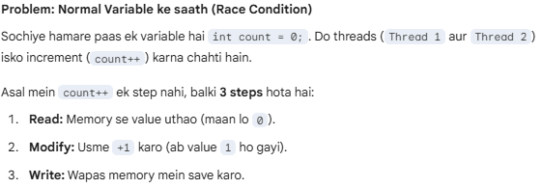

**Solution:**

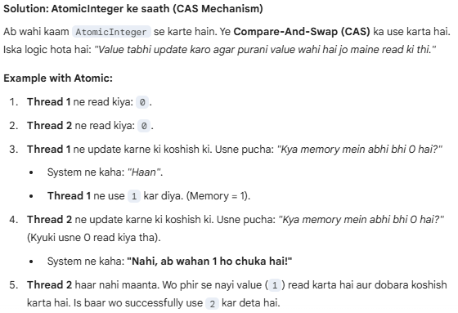

**AtomicInteger**

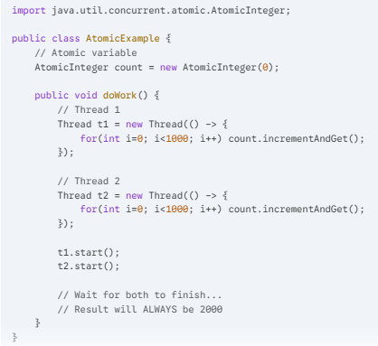

## Thread Pool:

Most of the executor implementations use thread pools to execute tasks, A thread pool is nothing but a bunch of worker threads that exist separately from the runnable or Callable tasks and is managed by the executor.

Creating a thread is an expensive operation and it should be minimized. Having worker threads minimizes the overhead due to thread creation because executor service has to create the thread pool only once and then it can reuse the threads for executing any tasks.

Tasks are submitted to a thread pool via an internal queue called the Blocking queue. If there are more tasks then for waiting until any thread becomes available. If the blocking queue is full than new tasks are rejected

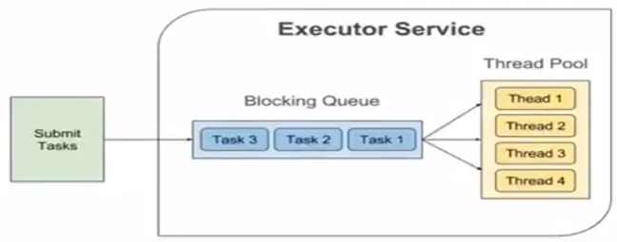

## java.util.concurrent:

The java.util.concurrent (J.U.C) package is organized into several distinct sub-hierarchies. Rather than one single tree, it is a collection of frameworks designed to handle specific threading problems like task scheduling, synchronization, and thread-safe data storage.

It was introduced in JDK 1.5 release as an alternative of synchronized keyword. As I told you Lock is an interface, so we cannot use it directly, instead we need to use its implementation class

## Future and Callable Concurrency:

java.util.concurrent.Callable object can return the computed result done by a thread in contrast to runnable interface which can only run the thread. The Callable object returns Future object which provides methods to monitor the progress of a task being executed by a thread. Future object can be used to check the status of a Callable and then retrieve the result from the Callable once the thread is done. It also provides timeout functionality.

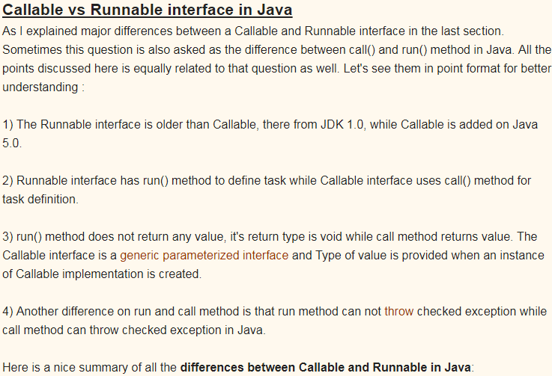

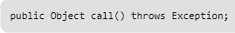

Both callable and runnable interface are the Functional Interface(annotation of the java 7(functionalinteface)).

**Runnable interfaces belong to java.lang package**.

1. In this runnable run method don’t throws any exception.
2. Does not return any value.

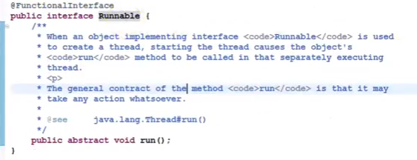

**Callable interface belong to java.util.concurrent. package**.

1. In this callable call() method throws Exeption.
2. It return future value means return object.
3. Return type “v” represent Future Interace.

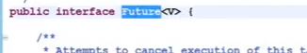

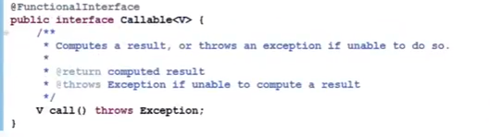

Example:

Output: Future Result : My Callable Interface Task

## 1. The Executor Framework (Task Execution):

Managing thread pools and asynchronous tasks. It separates task submission from task execution.

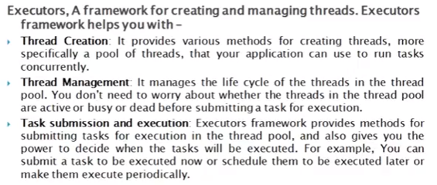

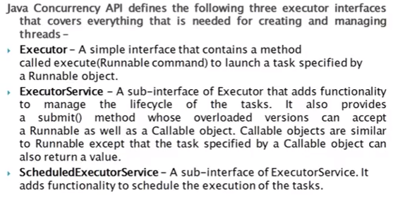

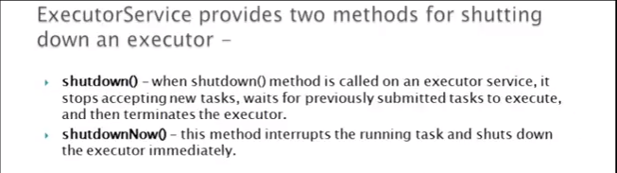

## 2.Executor Interface:

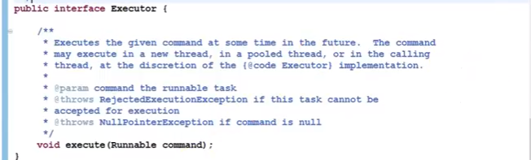

## 3.ExecutorService Interface:

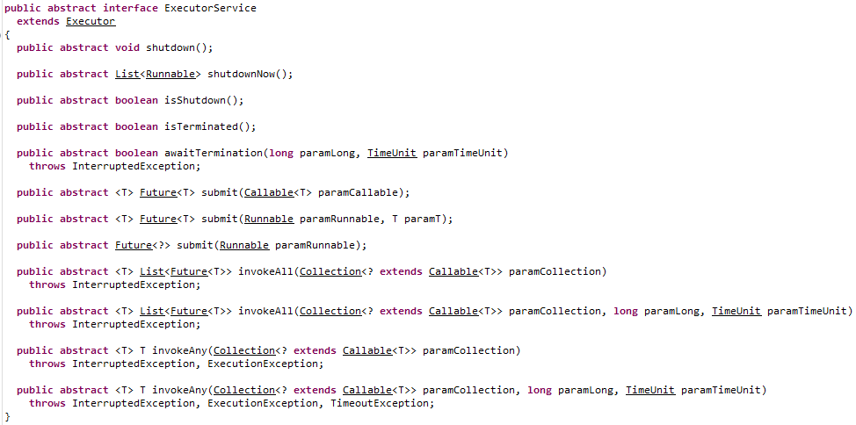



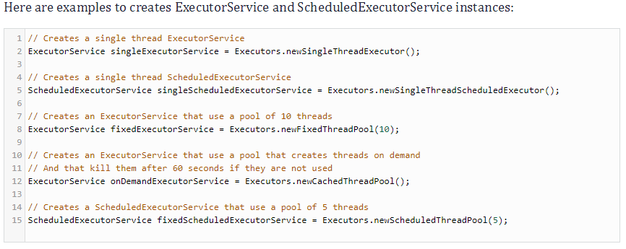

## 4.ScheduledExecutorService Interface:

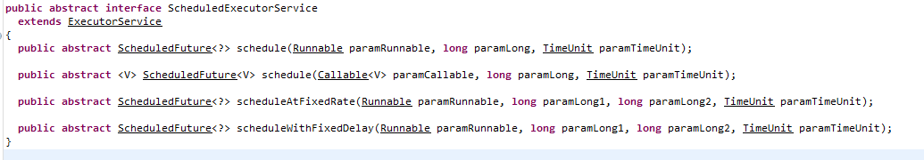

## Executors Utility Class:

Apart from the above three interfaces, the API also provides an Executors class that contains factory methods for creating different kinds of executor services.

**Example #1.**

Store all threads into the thread pool.

Here we are using single thread only. So it will create single thread only into the thread pool.

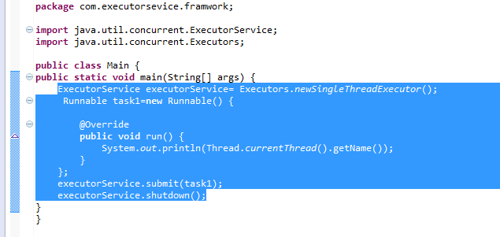

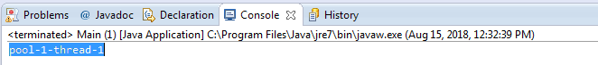

**Example #2:**

Java ExecutorService with a pool of threads for executing multiple tasks:

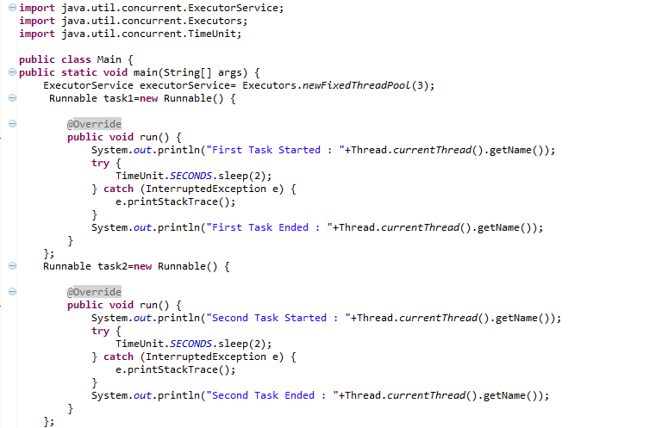

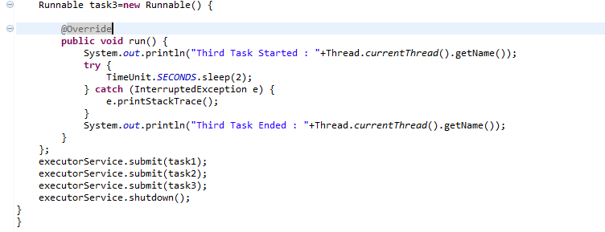

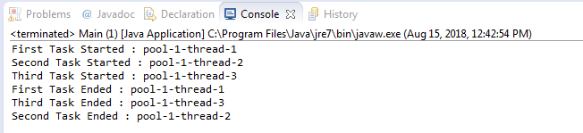

## Java Concurrency - Lock Interface:

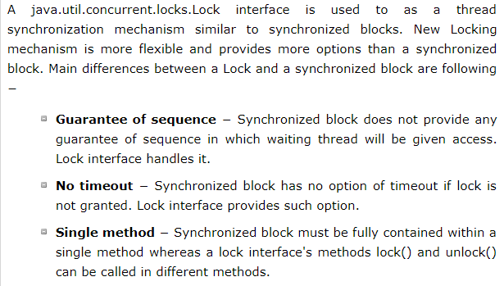

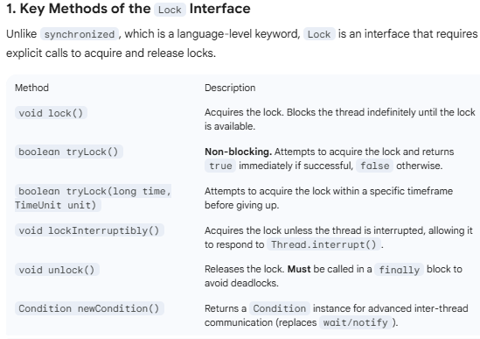

## ReentrantLock

ReentrantLock is the most common implementation. "Reentrant" means a thread can re-acquire the same lock it already holds without deadlocking itself (it simply increments a "hold count").

A **ReentrantLock** is a concrete implementation of the Lock interface in the java.util.concurrent.locks package. It is called "reentrant" because it allows a thread to acquire the same lock multiple times without deadlocking itself.

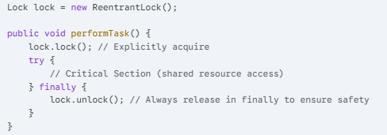

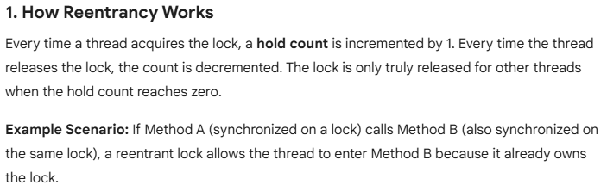

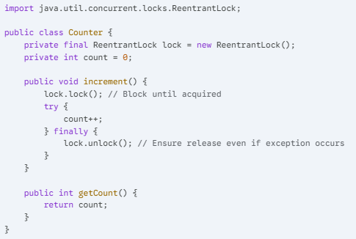

## Blocking Queues (Data Transfer):

Before BlockingQueue, you had to manually use synchronized, wait(), and notifyAll() to manage buffers, which is extremely error-prone and leads to bugs like **Lost Wakeups** or **Spurious Wakeups**. BlockingQueue encapsulates all that complexity into a single, thread-safe class.

**Blocking Queues** are the primary tool for solving the **Producer-Consumer** problem. They act as a thread-safe "buffer" that handles the coordination of data transfer between threads automatically.

What makes them "Blocking" is their behavior when the queue is full or empty:

* **When Empty:** A thread trying to **take**() an element will block (wait) until a producer adds something.
* **When Full:** A thread trying to **put**() an element will block (wait) until a consumer removes something (for bounded queues).

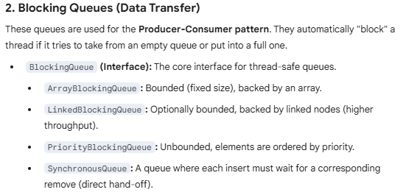

## Synchronizers:

**Synchronizers** are high-level coordination utilities that facilitate common interaction patterns between threads. They allow threads to wait for each other, communicate state changes, or manage access to shared resources without the complexity of low-level wait() and notify() calls.

Here is the breakdown of the primary synchronizers found in java.util.concurrent.

### 1.CountDownLatch:

Real-life example aisa samajhiye: **Ek race tabhi start hogi jab saare (N) runners starting line par pahunch jayenge.**

CountDownLatch in Java is a kind of synchronizer which allows one Thread to wait for one or more Threads before starts processing. This is very crucial requirement and often needed in server side core Java application and having this functionality built-in as CountDownLatch greatly simplifies the development. CountDownLatch in Java is introduced on Java 5.

**When should we use CountDownLatch in Java :**

Use CountDownLatch when one of Thread like main thread, require to wait for one or more thread to complete, before its start doing processing. Classical example of using CountDownLatch in Java is any server side core Java application which uses services architecture, where multiple services is provided by multiple threads and application cannot start processing until all services have started successfully as shown in our CountDownLatch example.**countDownLatch in Java – Things to remember:**

Few points about Java CountDownLatch which is worth remembering:

1. You can not reuse CountDownLatch once count is reaches to zero, this is the main difference between CountDownLatch and CyclicBarrier, which is frequently asked in core Java interviews and multi-threading interviews.

2. Main Thread wait on Latch by calling CountDownLatch.await() method while other thread calls CountDownLatch.countDown() to inform that they have completed.

Example: IT and BA task.

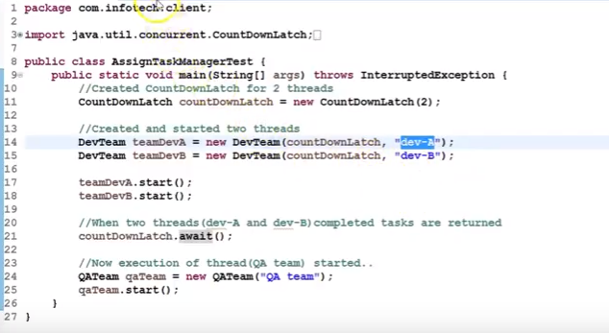

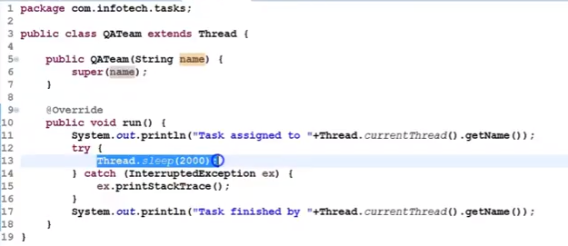

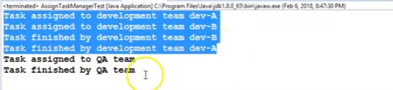

### 2.CyclicBarrier:

CyclicBarrier in Java is a synchronizer introduced in JDK 5 on java.util.Concurrent package along with other concurrent utility like Counting Semaphore, BlockingQueue, ConcurrentHashMap etc. CyclicBarrier is similar to CountDownLatch and allows multiple threads to wait for each other (barrier) before proceeding. The difference between CountDownLatch . CyclicBarrier is a natural requirement for a concurrent program because it can be used to perform final part of the task once individual tasks are completed. All threads which wait for each other to reach barrier are called parties, CyclicBarrier is initialized with a number of parties to wait and threads wait for each other by calling CyclicBarrier.await() method which is a blocking method in Java and blocks until all Thread or parties call await(). In general calling await() is shout out that Thread is waiting on the barrier. await() is a blocking call but can be timed out or Interrupted by other thread.

**Difference between CountDownLatch and CyclicBarrier in Java:**

If you look at CyclicBarrier it also the does the same thing but there is different you can not reuse CountDownLatch once the count reaches zero while you can reuse CyclicBarrier by calling reset() method which resets Barrier to its initial State. What it implies that CountDownLatch is a good for one-time events like application start-up time and CyclicBarrier can be used to in case of the recurrent event e.g. concurrently calculating a solution of the big problem etc.

**Important point of CyclicBarrier in Java:**

1. CyclicBarrier can perform a completion task once all thread reaches to the barrier, This can be provided while creating CyclicBarrier.

2. If CyclicBarrier is initialized with 3 parties means 3 thread needs to call await method to break the barrier.

3. The thread will block on await() until all parties reach to the barrier, another thread interrupt or await timed out.

4. If another thread interrupts the thread which is waiting on barrier it will throw BrokernBarrierException as shown below:

java.util.concurrent.BrokenBarrierException

at java.util.concurrent.CyclicBarrier.dowait(CyclicBarrier.java:172)

at java.util.concurrent.CyclicBarrier.await(CyclicBarrier.java:327)

5.CyclicBarrier.reset() put Barrier on its initial state, other thread which is waiting or not yet reached barrier will terminate with java.util.concurrent.BrokenBarrierException.

Example:

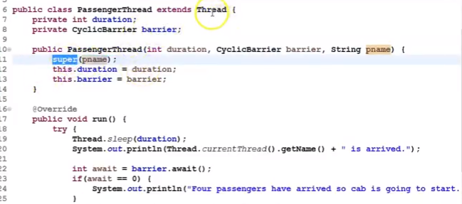

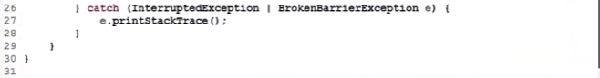

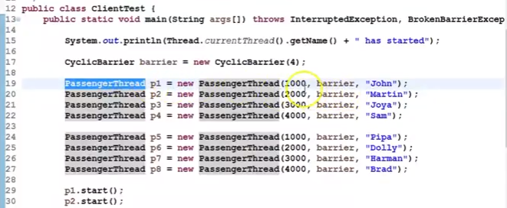

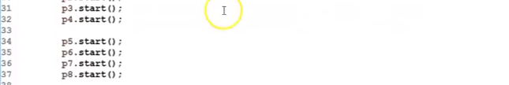

} }

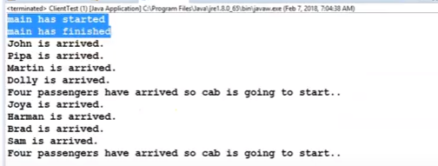

### 3. Semaphore:

**Semaphore** multithreading mein ek aisi utility hai jo **"Permits" (Ijazat/Tokens)** ke concept par kaam karti hai. Iska asali maqsad ye control karna hota hai ki ek waqt mein kitne threads kisi specific resource (jaise Database connection, File, ya Network socket) ko access kar sakte hain.

Ise aap ek **Parking Lot** ki tarah samajh sakte hain:

* Agar parking mein 10 jagah (permits) hain, toh 10 gaadiyan (threads) andar ja sakti hain.
* 11वीं gaadi ko tab tak bahar wait karna padega jab tak koi ek gaadi nikal na jaye.

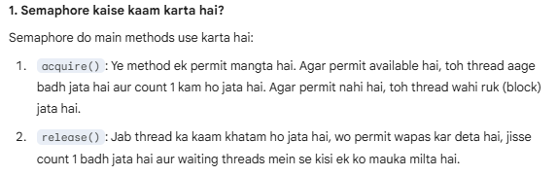

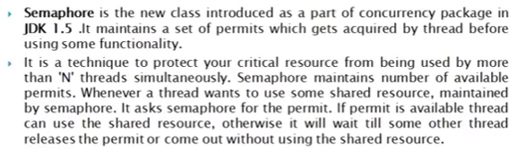

**Example:**

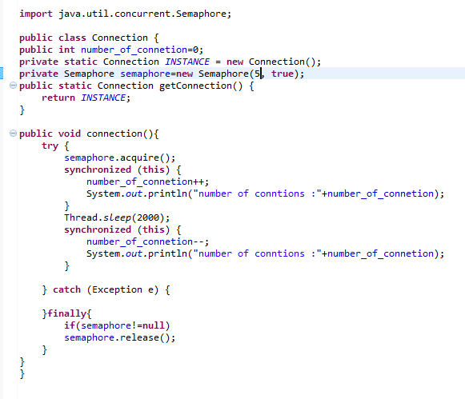

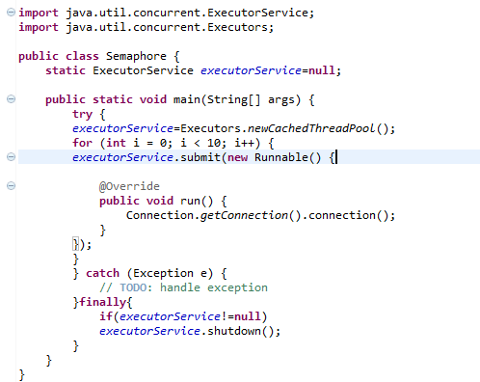

Before Semaphore implement it will create number of connections that we are using in loop(50)

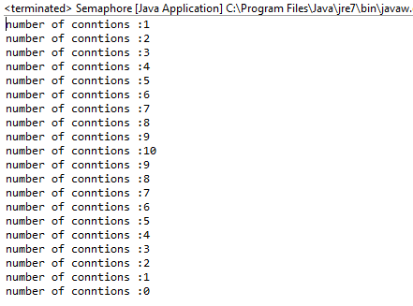

After Semaphore Implement: it will create only connection pool.

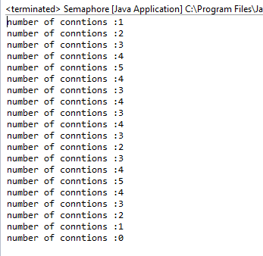

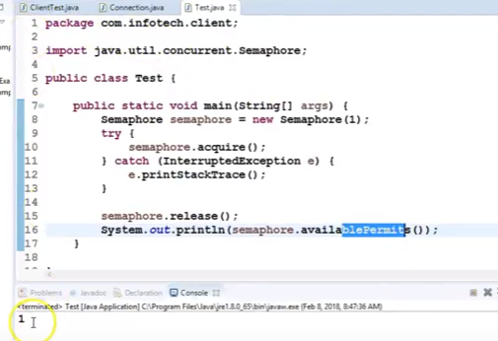

# **Coupling and Cohesion**

(A program should have – Loose coupling and High Cohesion)

**Coupling**

In order to create an effective application that is easy to develop, easy to maintain and easy to update, we need to know the concept of **coupling and cohesion**. **Coupling** refers to the extent to which a class knows about the other class. 

There are two types of coupling -

* **Tight Coupling**(*bad programming design*)
* **Loose Coupling**(*good programming design*)
* **Tight Coupling**

If a class A is able to access data members/instance variables of a class B **directly by dot operator**(because they were declared **public**), the two classes are said to be **tightly coupled** and it leads to *bad designing*, because all the checks made to ensure the valid access to data members of class B are bypassed by their direct access. Let's understand this by an example -

***//Tight coupling***

**class Names**

**{**

**public String name;**

**public String getName()**

**{**

***//some code to check valid access to name***

**return name;**

**}**

**public void setName(String s)**

**{**

***//some code to check valid setting to name***

**name=s;**

**}**

**}**

**class ModifyData**

**{**

**public void updateName()**

**{**

**Name ob= new Name();**

**ob.name="Hello"; *//Directly accessing name with dot operator shows tight coupling between two classes***

**System.out.println(ob.name); *//Tight coupling because of bad encapsulation***

**}**

**}**

* **Loose Coupling**

A good application designing is creating an application with loosely coupled classes by following proper **encapsulation**, i.e. by declaring data members of a class with **private** access and forcing other classes to access them only through **public getter, setter methods**. Let's understand this by an example -

**class Names**

**{**

**private String name;**

**public String getName()**

**{**

***//some code to check valid access to name***

**return name;**

**}**

**public void setName(String s)**

**{**

***//some code to check valid setting to name***

**name=s;**

**}**

**}**

**class ModifyData**

**{**

**public void updateName()**

**{**

**C ob= new C();**

**ob.setName("Howard");**

**ob.getName();**

**}**

**}**

**Cohesion**

**Cohesion** refers to the extent to which a class is defined to do a **specific specialized task**. A class created with high cohesion is targeted towards a single specific purpose, rather than performing many different specific purposes.

There are two types of cohesion -

* + **Low cohesion**(*bad programming design*)
  + **High Cohesion**(*good programming design*)

* **Low Cohesion**

When a class is designed to do many different tasks rather than focussing on a **single specialized task**, this class is said to be a "*low cohesive*" class. Low cohesive class are said to be *badly designed* leading to a hard time at creating, maintaining and updating them. Let's understand this by an example -

**class PlayerDatabase**

**{**

**public void connectDatabase();**

**public void printAllPlayersInfo();**

**public void printSinglePlayerInfo();**

**public void printRankings()**

**public void closeDatabase();**

**}**

* **High Cohesion**

A good application design is creating an application with *high cohesive* classes, which are targeted towards a *specific specialized task* and such class is easy not only easy to create, but also easy to maintain and update.

**class PlayerDatabase**

**{**

**ConnectDatabase connectD= new connectDatabase();**

**PrintAllPlayersInfo allPlayer= new PrintAllPlayersInfo();**

**PrintRankings rankings = new PrintRankings();**

**CloseDatabase closeD= new CloseDatabase();**

**PrintSinglePlayerInfo singlePlayer = PrintSinglePlayerInfo();**

**}**

**class ConnectDatabase**

**{**

***//connecting to database.***

**}**

**class CloseDatabase**

**{**

***//closing the database connection.***

**}**

**class PrintRankings**

**{**

***//printing the players current rankings.***

**}**

**class PrintAllPlayersInfo**

**{**

***//printing all the players information.***

**}**

**class PrintSinglePlayerInfo**

**{**

***//printing a single player information.***

**}**

# **SQL Injection in Java Code:**

Preventing SQL Injection in Java is primarily about ensuring that user input is never treated as part of the SQL command itself. When you concatenate strings to build a query, the database cannot distinguish between your code and the data provided by a user.

Here are the most effective ways to secure your Java application:

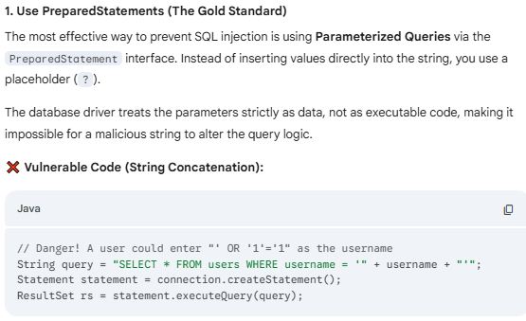 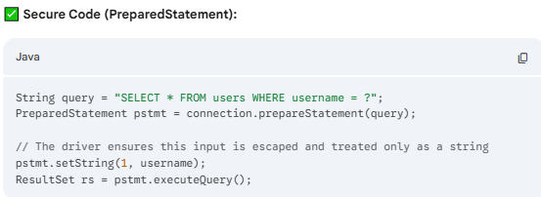 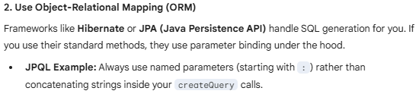

Query query = entityManager.createQuery("SELECT u FROM User u WHERE u.username = :name");

query.setParameter("name", username);

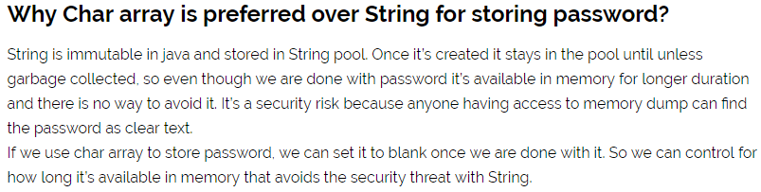

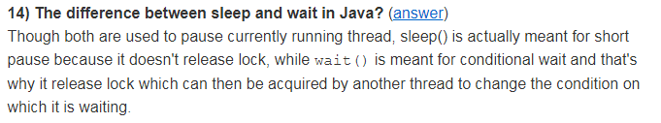

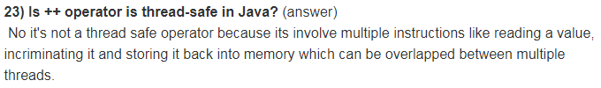

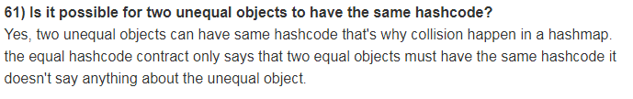

# Java 8 New Features:

**java 8 release -18th March 2014**

## List of new features:

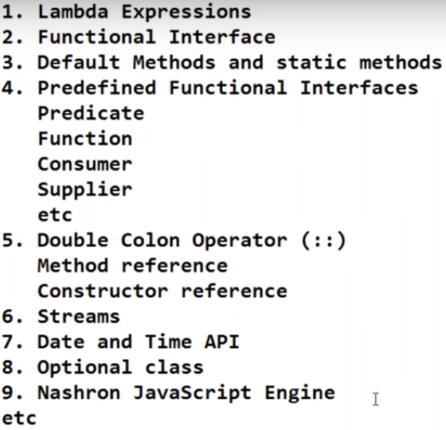

## 1.Lambda Expressions:

The main objective of the lambda expression is bring benefits of functional programming into Java.

**Note:** wherever functional interface there only we can using Lambda expression only.

i.e., If the functional interface concept is not there, then you can not using Lambda expression concept.

Lambda expression concept always associate with Functional interface only.

Lambda expression is not generalized concept, it’s only specific concept which is applicable with functional interface.

***What is Lambda Expression*** - :

* 1. It is an anonymous function means jiska koi naam nhhi hota, NameLess
  2. Without return type – Jo kuchh bhi return nhi krta
  3. Without Modifiers – Means no private,public,default,protected .

***How to write Lambda Expression (With and Without Example):***

***Example-#1:***

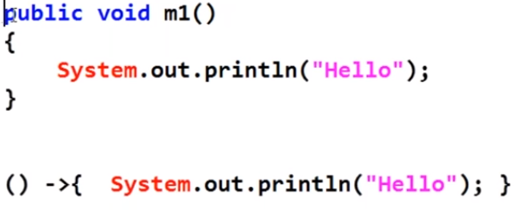

***Example-#2: By passing parameters***

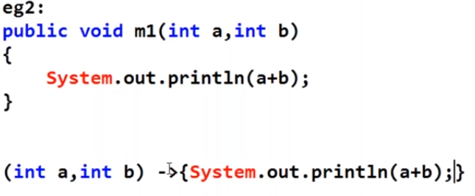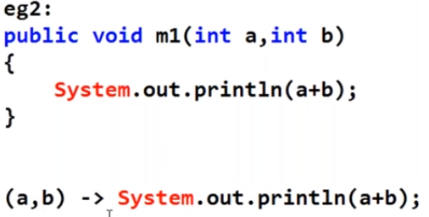

***Example-#3: Just add code and return:***

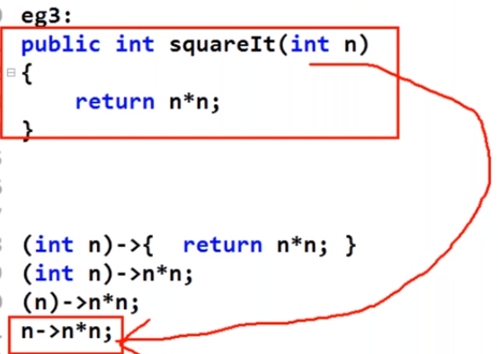

Note: if you use return keyword you have to write inside the “ { } ”,

Note: If only one parameter then prentices “ () ” are optional.

Note:

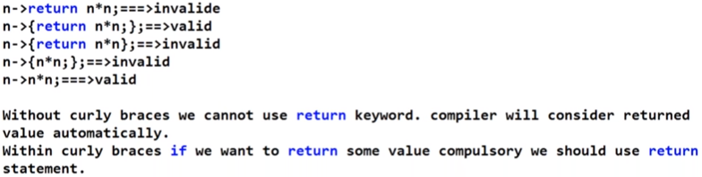

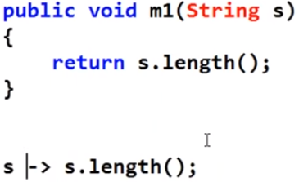

## 2.Functional Interface:

Functional Interface rule should contains only single abstract method.

It can contain default and static methods but should contain only one single abstract method.

Existing functional interface what we know:

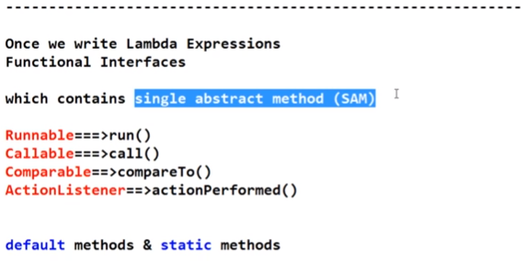

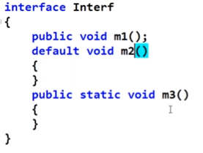

### @FunctionalInterface Annotation:

This annotation came in java 8 to specify this interface is Functional Interface.

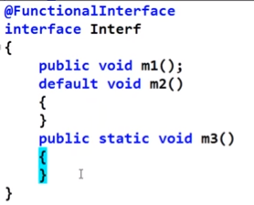

If the compile time you have specify interface as a functional interface(annotation) but is not follow the rule then it will give you error at compile time-

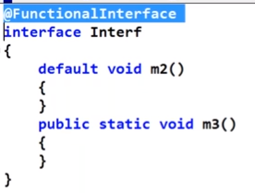

Compile Test.java-

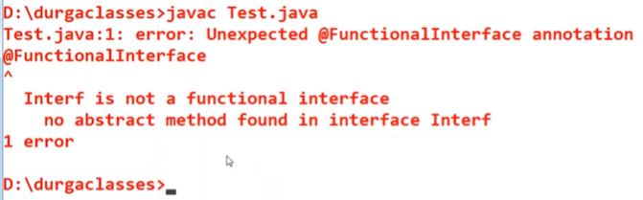

Example 2-

Compile Test.java-

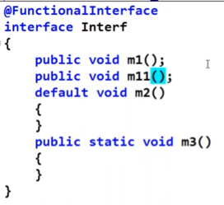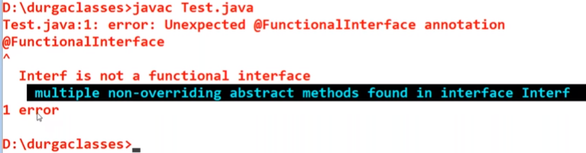

### Functional Interface with respect to inheritance-:

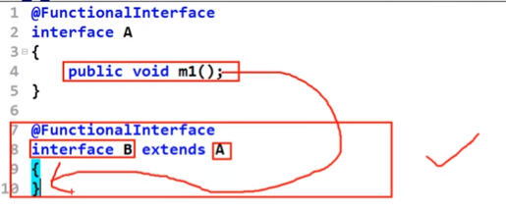

Above example is valid because m1() by default to available for B interface.

Compile Test.java-

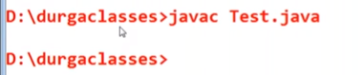

Example 2- also Valid

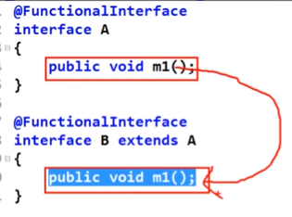

Example 3- Invalid

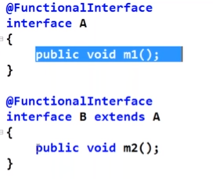

Compile Test.java ( because Functional interface contains only simple abstract method – one is coming from parent interface (m1) and second you have specify in B (m2)).

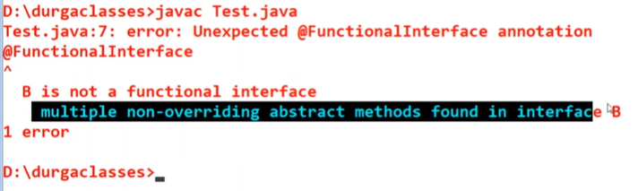

Example 4- Valid

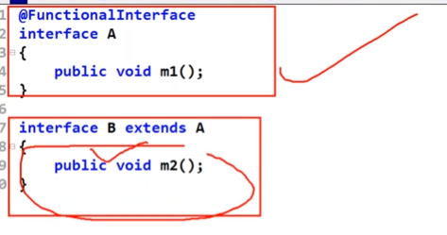

Note – above case is valid because here we are not using annotation e.i, B interface is a normal interface not the functionalInterface (missing annotation).

Compile Test.java

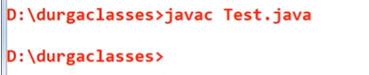

### Lambda Expression with Functional Interface-:

**without Lambda Expression:**

Specification for above - Demo.java class is implementations for parent interface(InterF)

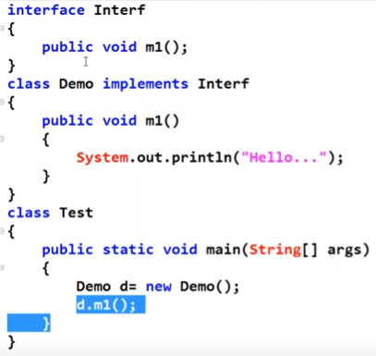

Output:

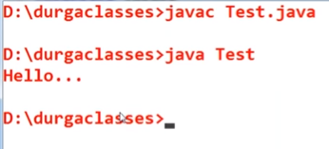

**With Lambda Expression**- you can implement m1() methods of InterF interace using Lambda Expression, we do not need to implement top level separate class(Demo.java)-

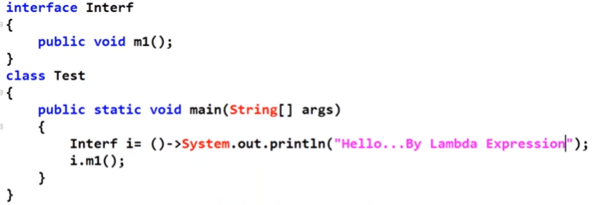

Output-

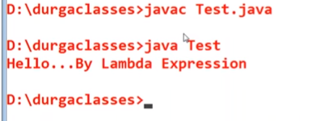

Note: lines of the code reduced

**Example-#2** – calling m1() multiple times

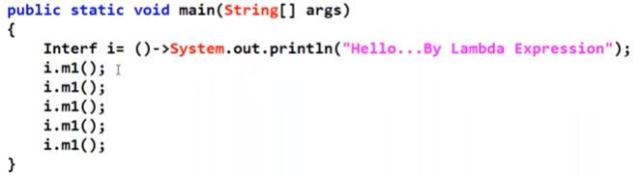

Output-

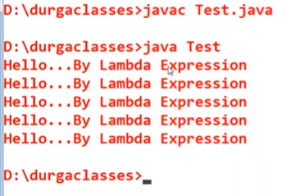

**Example-#3: just returning then**

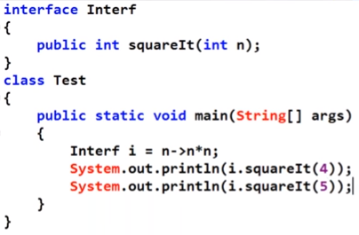

### Lambda Expression in Collection Concept:

**Example-#1:**

**Without lambda expression:**

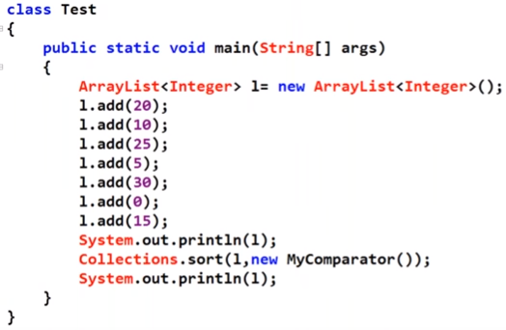

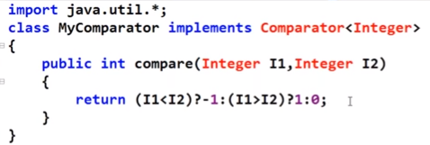

**With Lambda Expression:**

Comparator(functional interface) contain only single abstract method(compare()).

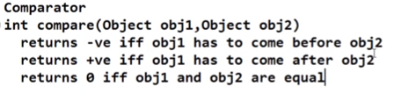

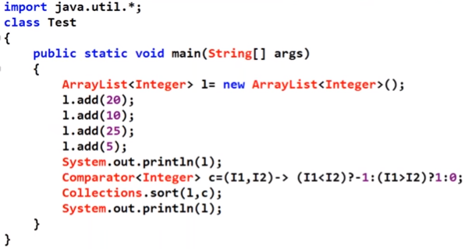

Output:

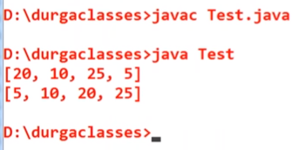

### Anonymous inner Class vs Lambda expression:

Note: lambda expression is not the replacement of anonymous inner class.

Anonymous inner class- the class without having name such type of inner class are called anonymous inner class.

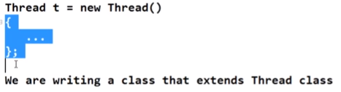

Similarly:

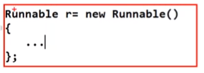

Anonymous inner class example:

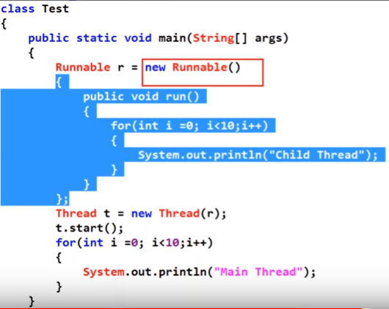

Anonymous inner class with Lambda Expression:

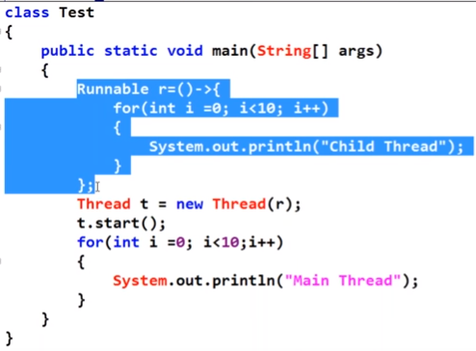

Note: Lambda expression we can not use for every anonymous inner class:

Like – normal anonymous inner class – below case possible for this but not possible with lambda expression , because lambda expression only applicable for single abstract class.

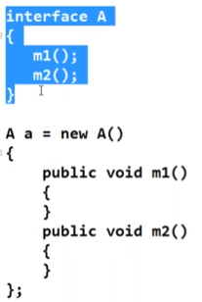



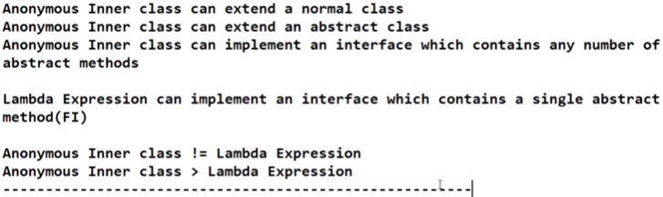

## 3.Default method and Static Method:

Default method (virtual extension method or defender method)and Static Method:

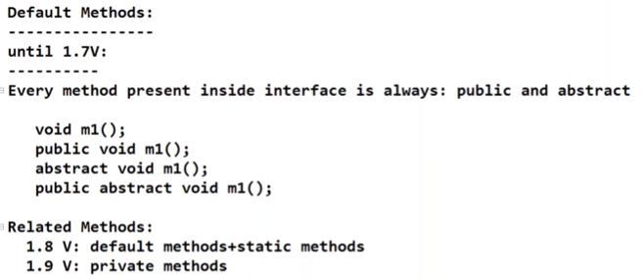

**Note: 1.8 v we can declare default implementation of a method.**



Example-1:

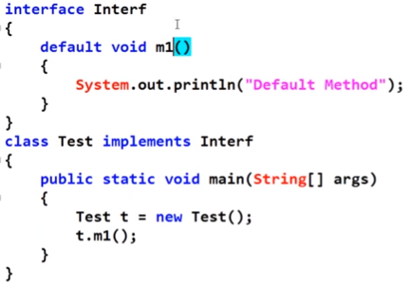

Output:

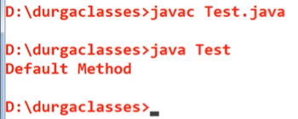

### Static Methods inside interface:

From java 1.8 onward you can declare static methods inside interface.

Note: interface static methods only call using interface name only.

Example 1 :

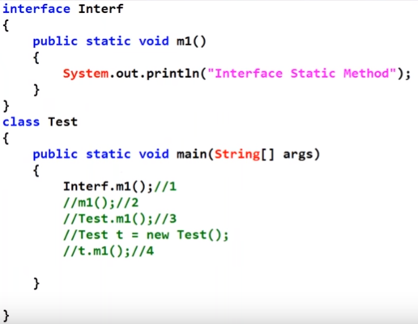

Output:

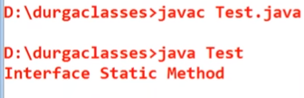

## 4. Predefined functional interface:

Introduced in java 1.8 to make the lambda expression as the common coding activity.

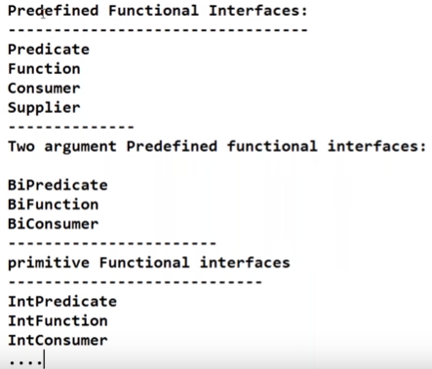

### Predicate Interface:

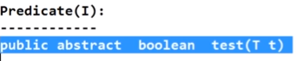

Note: predicate function is use for conditional checking. Predicate function return type always be Boolean-



Note: Predicate always take input type and return Boolean result.

Example with and without lambda expression.

**Example-#1 – Integer**

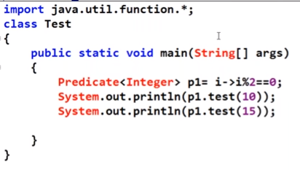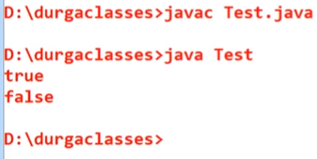

**Example-#2 – String**

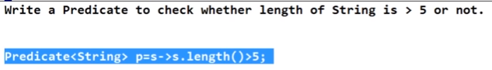

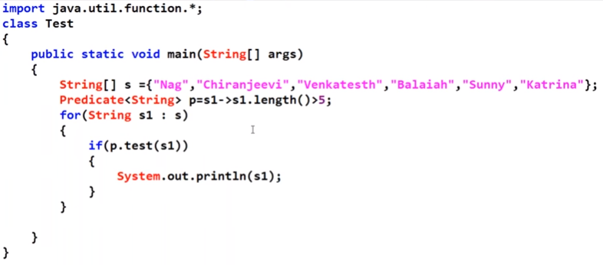

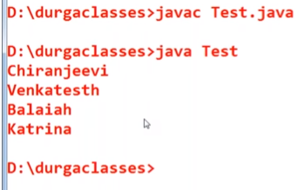

**Example-#3 – Custom Class (Employee)**

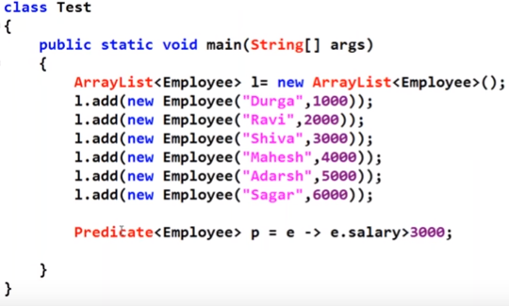

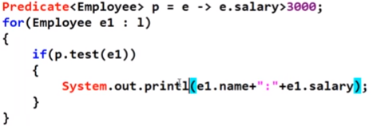

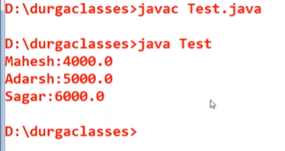

**Predicate Join:**

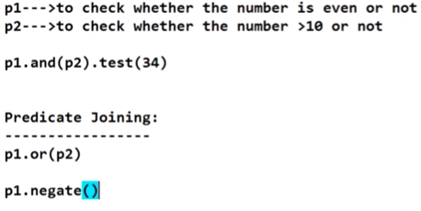

Example 1:

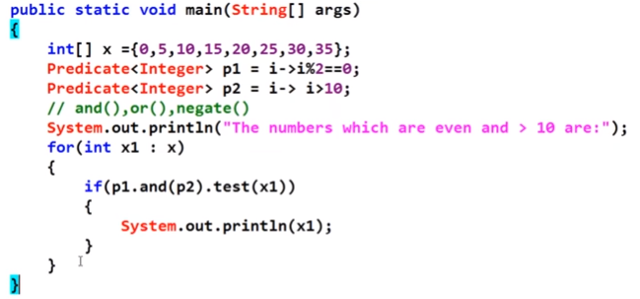

Output:

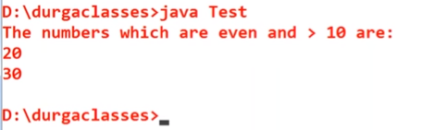

Example -2 : to check or condition.

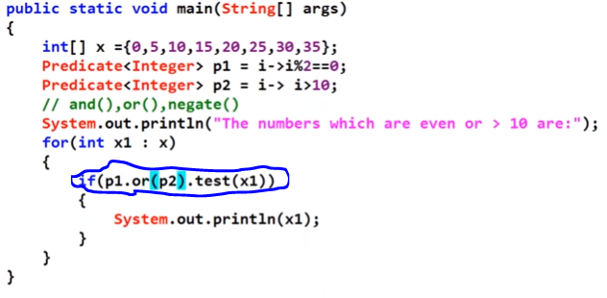

Output:

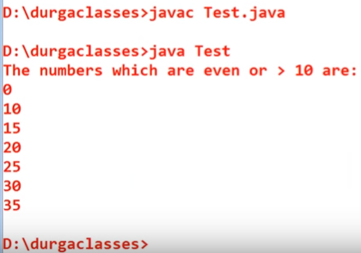

Example 4: to check negative

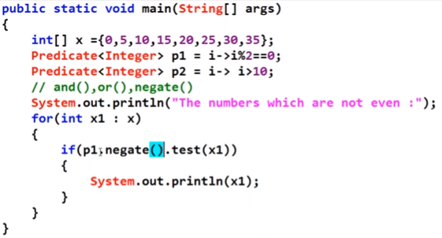

Output:

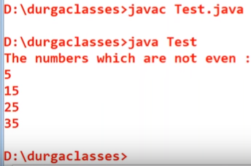

### Function Functional Interface:

Input (T) and return (R) with any type.

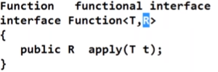

**Example-#1 – Take input(Integer) and return integer:**

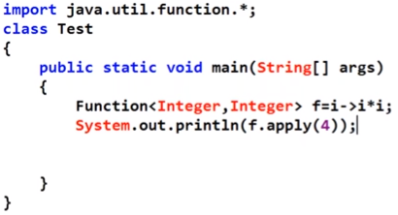

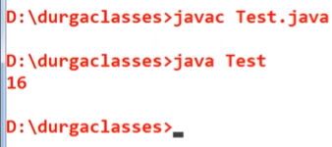

**Example-#2 – Input String and return Integer:**

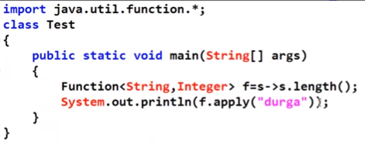

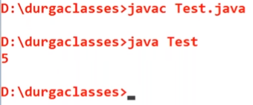

**Example-#3 – Input String and return String:**

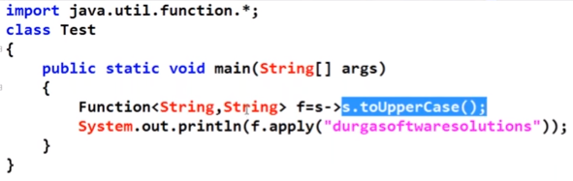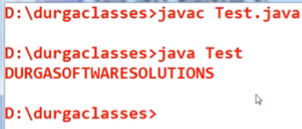

**Function Chaining:**

Two function can be combine to form more complex functions.

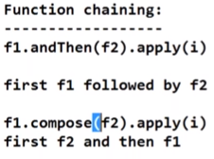

Example 1: first f1 and then f2:

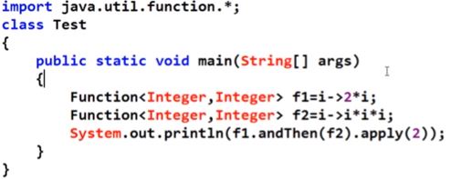

Output:

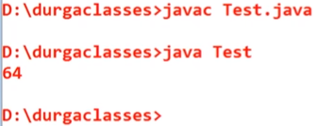

Example 2: first calculate f2 and then compose result with f1:

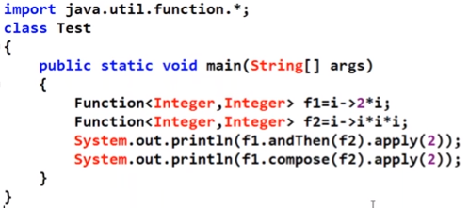

Output:

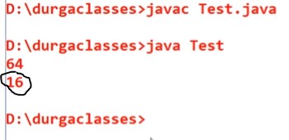

### Consumer Functional Interface:

Consumer always take some input type but do not return any values means it’s void type.



That is :

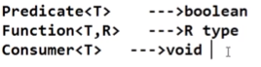

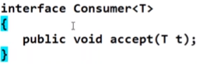

Example 1-

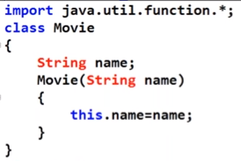

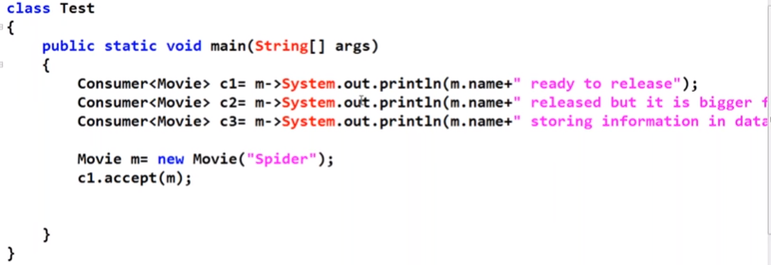

Output:

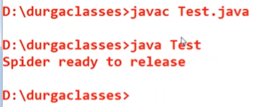

### Supplier Functional Interface:

Supplier will not take any input.



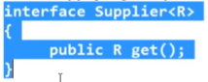

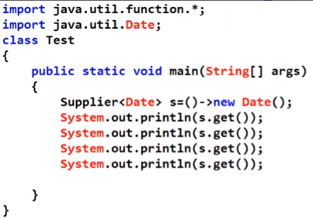

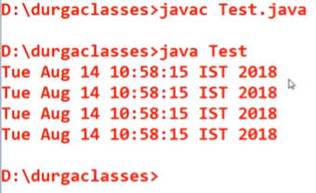

## 5.Double Colon Operator(::) :

**Method and Constructor Reference(::):**

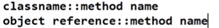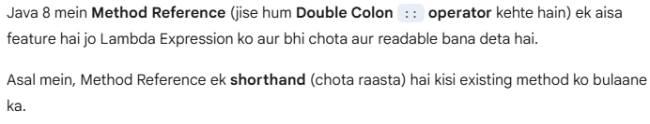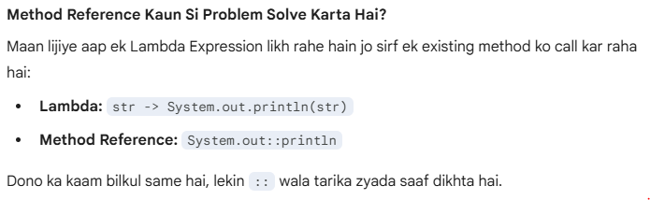

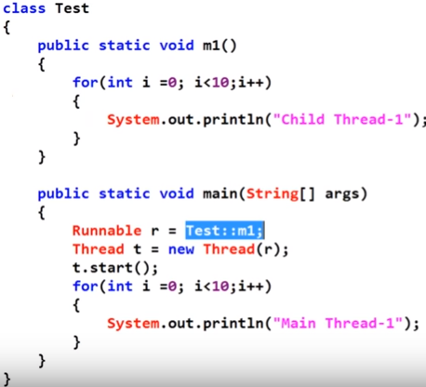

Notes: above example is for static method.

Example 2: for non-static method-

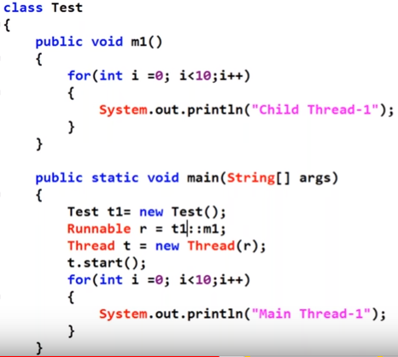

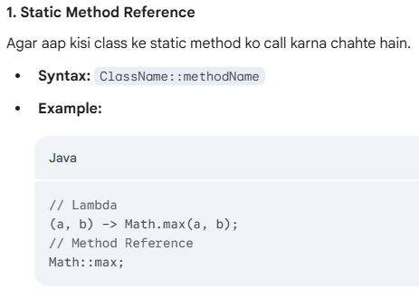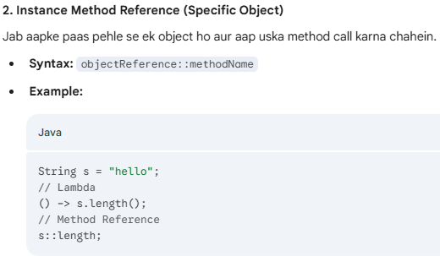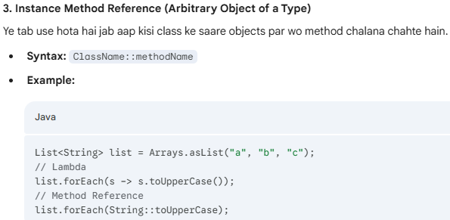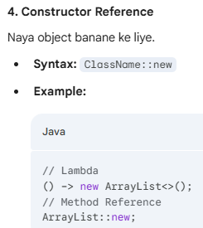

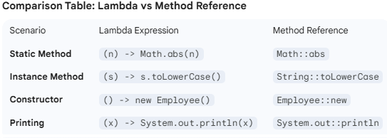

## 6. Stream API:

If you want process of the object from collection then you can use Steams concept.

It’s an Interface present in java.util.steam package.

***Below method we will discuss:***

1. ***Steam()***
2. ***Filter()***
3. ***Map()***
4. ***Collect()***
5. ***Count()***
6. ***Sorted()***
7. ***Min()***
8. ***Max()***
9. ***ForEach()***
10. ***toArray()***

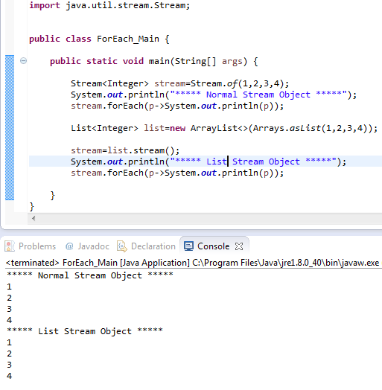

### Stream Intermediate Operator:

Intermediate operations return the stream itself so you can chain multiple method calls in a row. Let’s learn important ones.

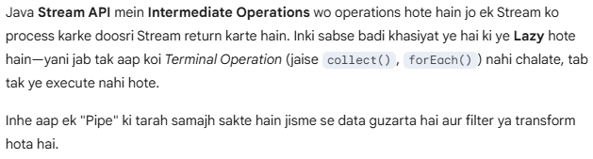

### filter(Predicate):

Filter accepts a predicate to filter all elements of the stream. This operation is intermediate which enables us to call another stream operation (e.g. forEach) on the result.

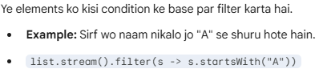

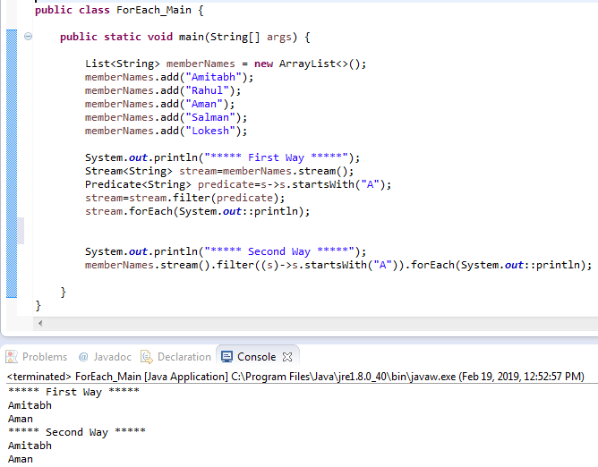

***With Stream Concept: filter() method of streams. -> filter(predicate) means getting input and returning Boolean value.***

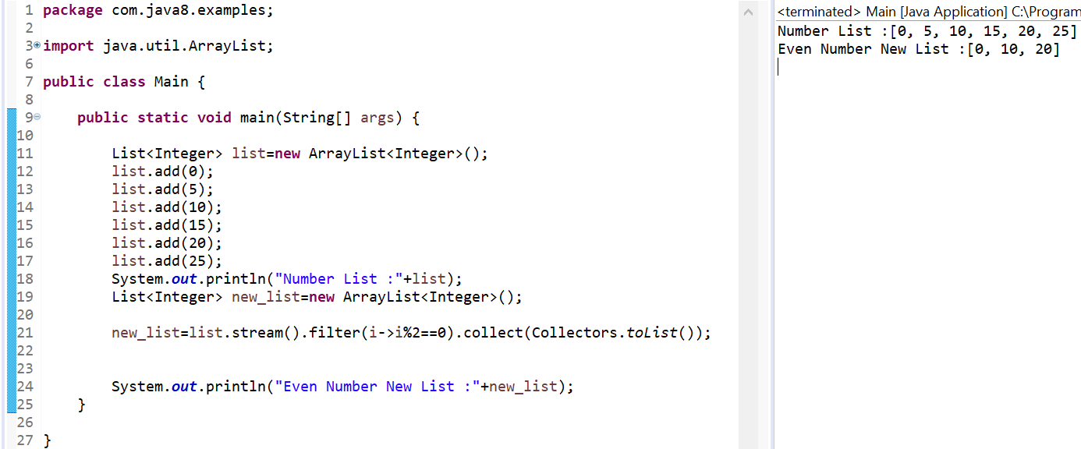

***Example-2: write a program to make double of all elements in a list and insert into another New list.***

***Without Streams Concept:***

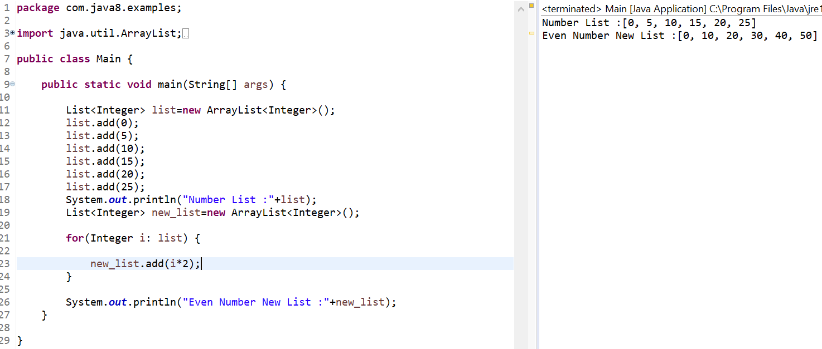

***With Steams Concept: map() method -> map(function) means getting input and retuning output***

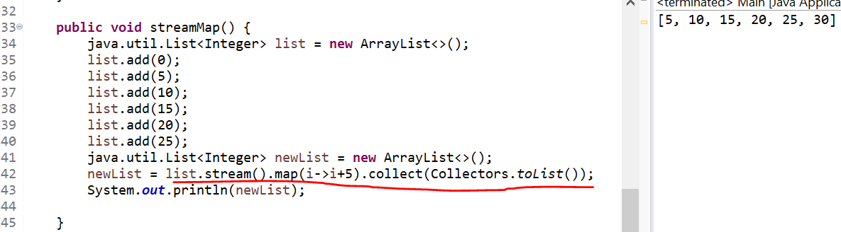

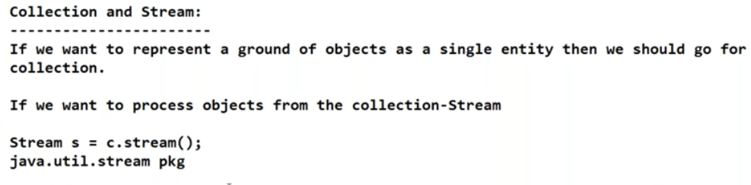

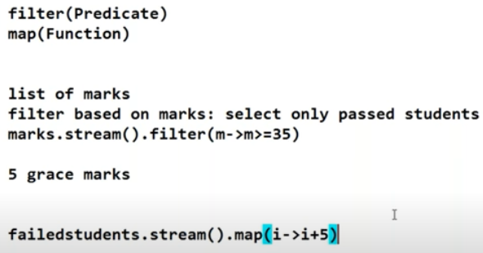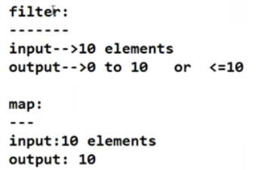

***In above screenshot if filter have 10 input elements then output will be 0 to 10 or equal to 10.***

***But in map() if input 10 element then output compulsory will be 10,because for every element will***

### map(Function):

Java Stream API mein map() ek bahut hi powerful intermediate operation hai. Iska kaam hota hai Transformation.

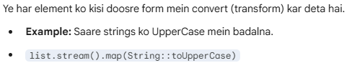

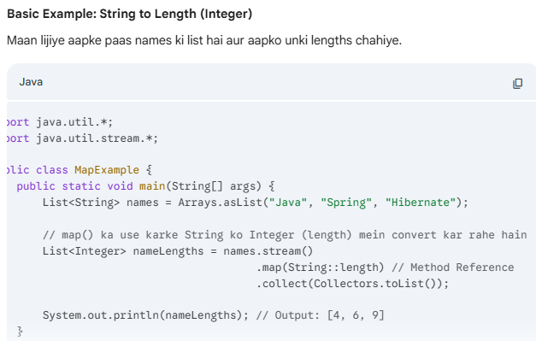

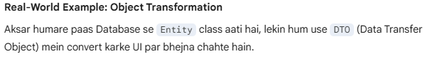

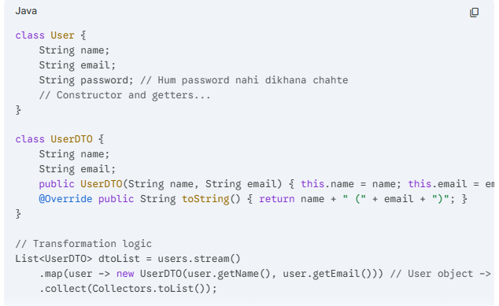

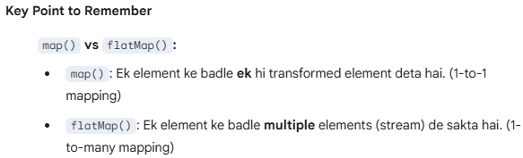

### sorted():

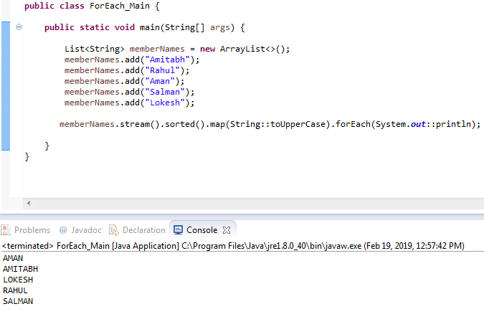

***Example-4: sorted() method***

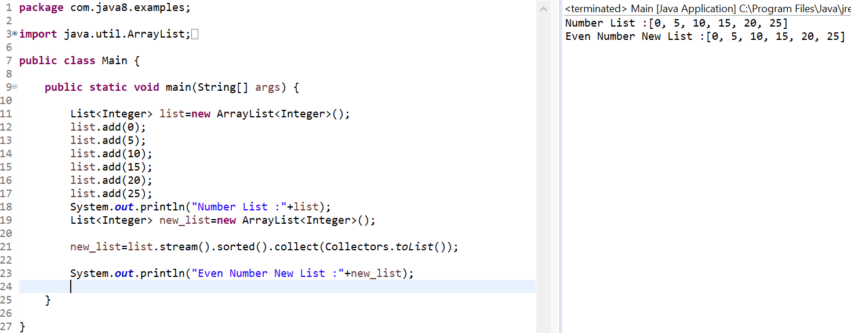

***Example-5: manually sorting: using comparator:***

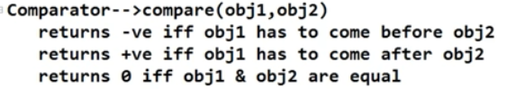

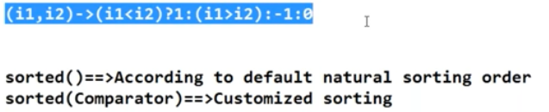

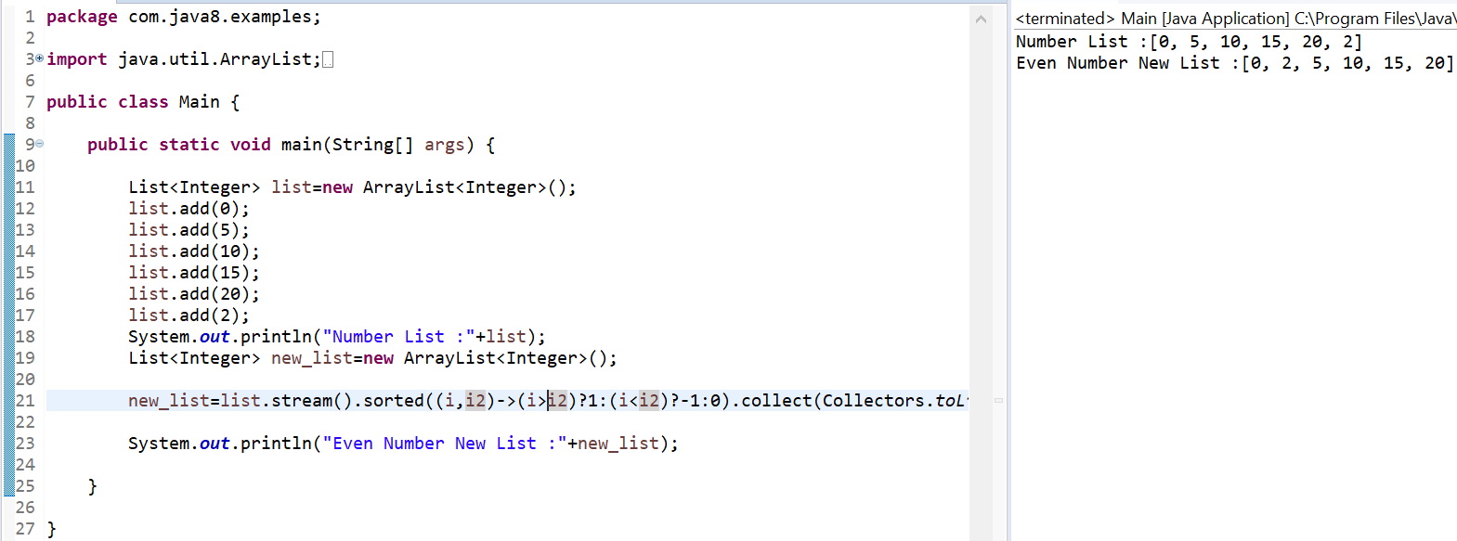

***Example-6: For string compare:***

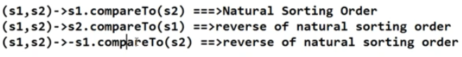

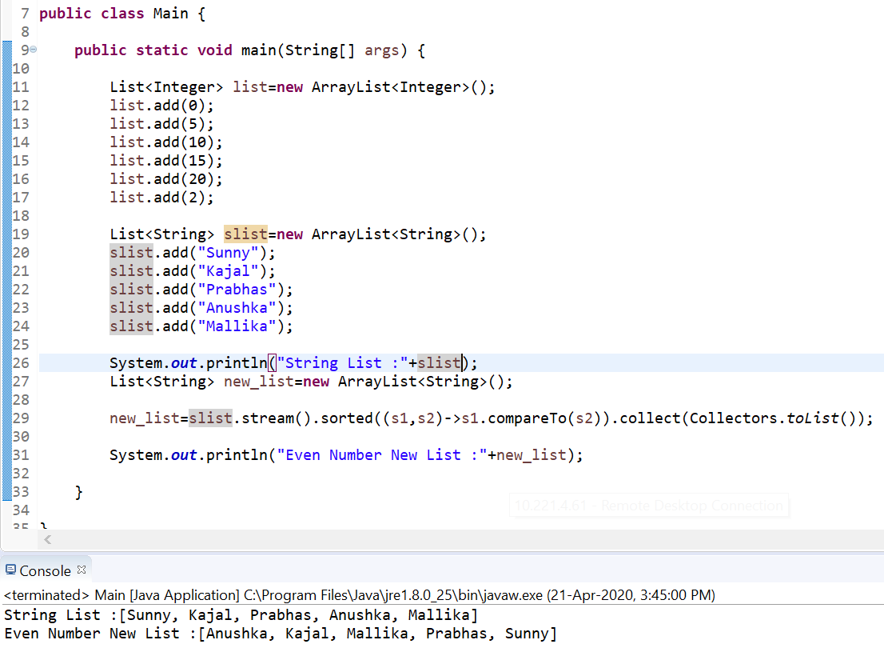

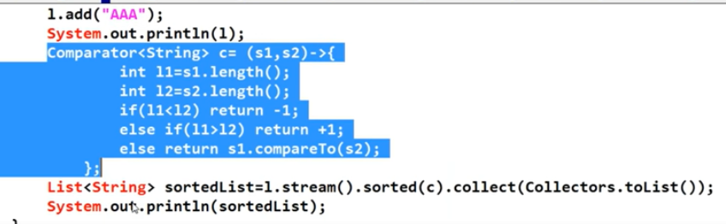

### Min() & max():

***Exampl-7:min() and max() :***

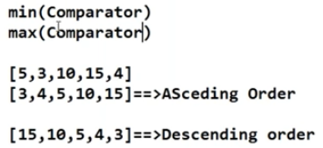

***Min() example:***

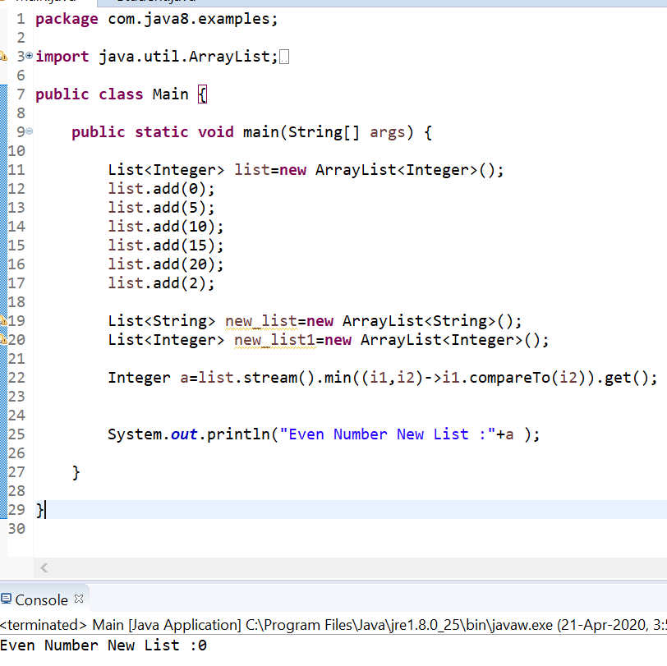

***Max() example:***

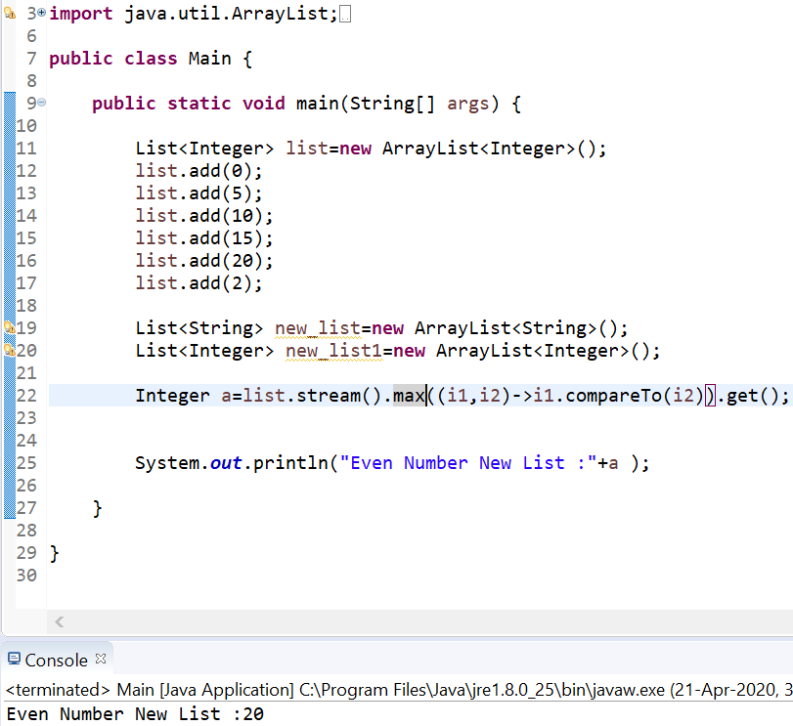

***Example-8: Iterate collection elements using Streams concept:***

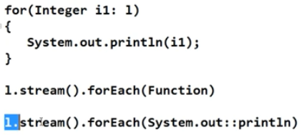

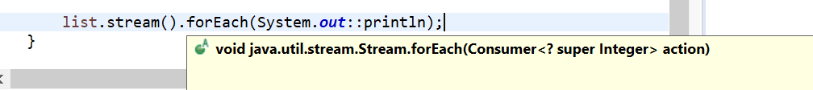

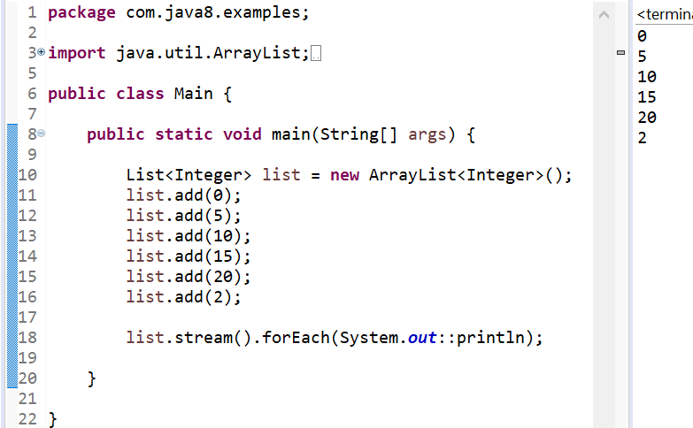

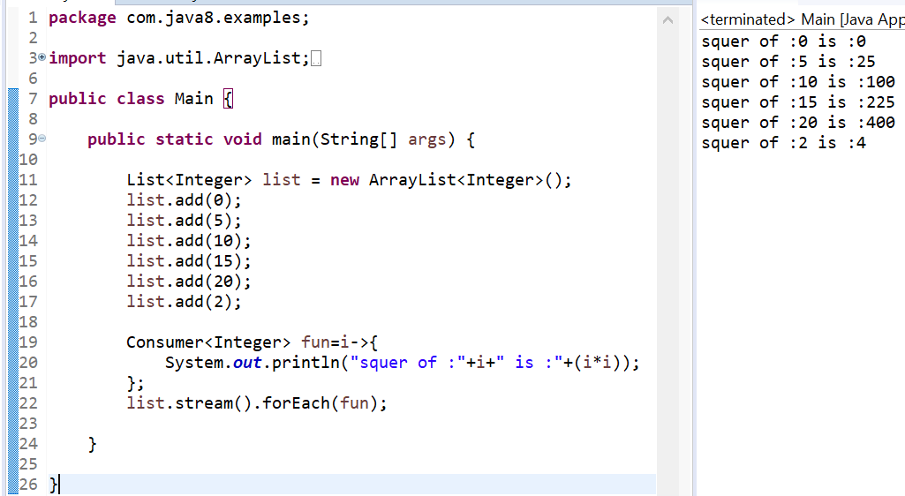

### toArray():

***Example-9: toArray():***

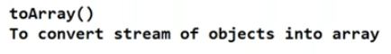

***Method and constructor reference:*** 

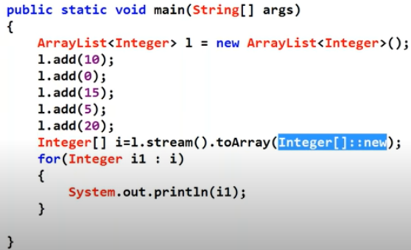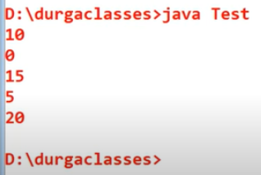

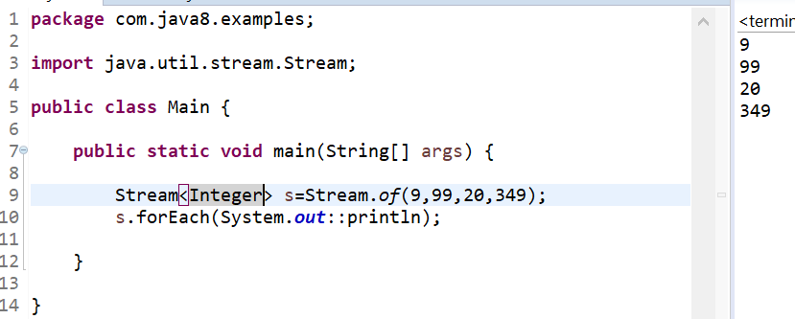

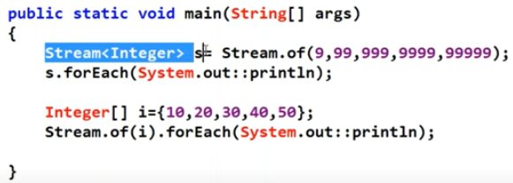

## 7.Date and Time API:

it is also called Joda Time API because it’s developed by Joda.org.

With respect to conventions and performance wise it’s good.

Package name for this API is – java.time*

Example-1:

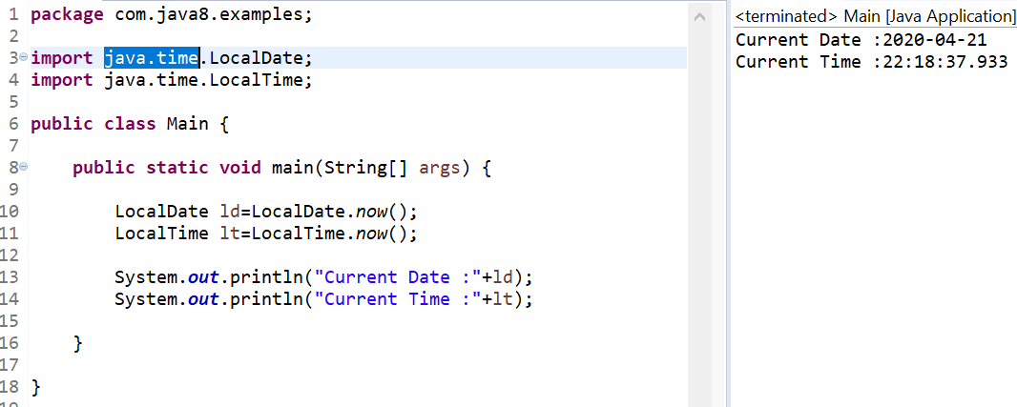

Example-2: print date according our requirement.

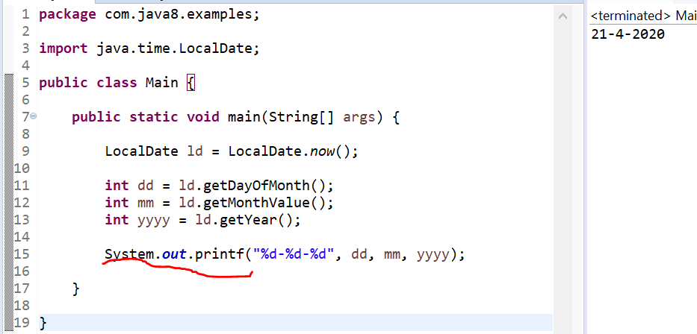

***Example-3:*** print time according our requirement:

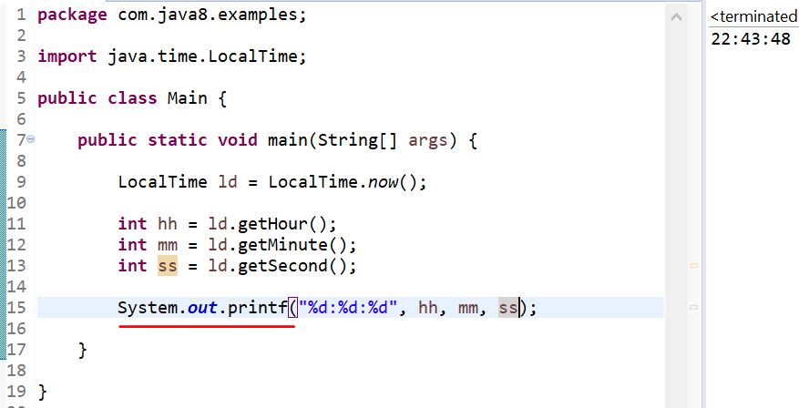

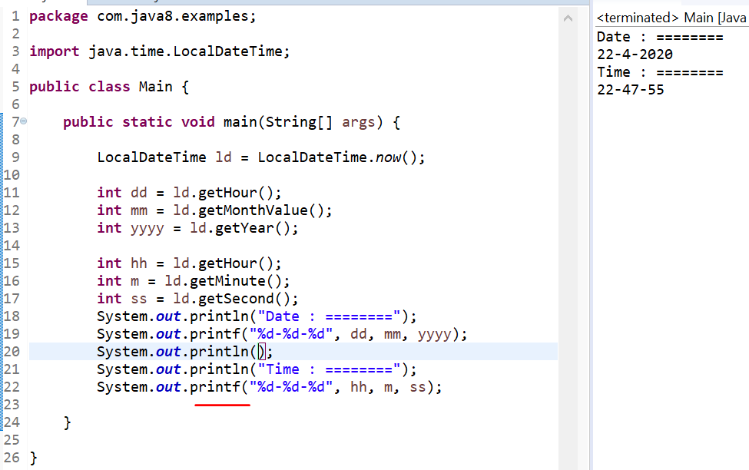

***Example-4: How to represent both date and time by providing date:***

***There are may method for date and time, like after 6month or before 6months.***

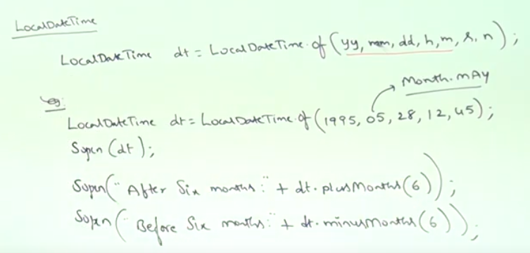

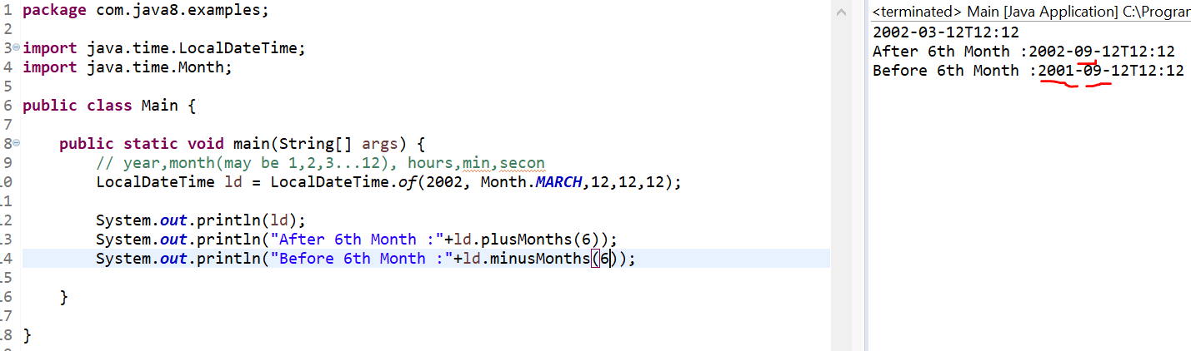

***Example-5: To find age of a person(period):***

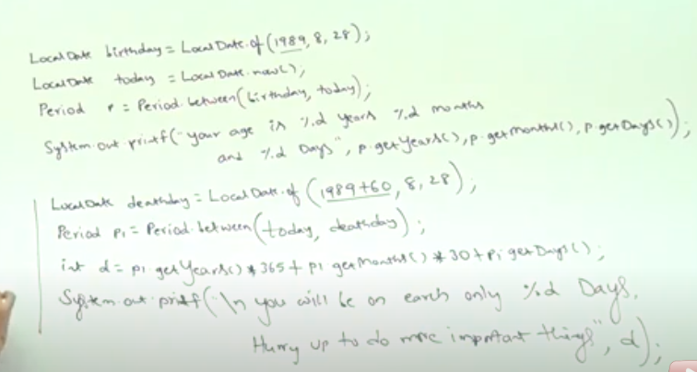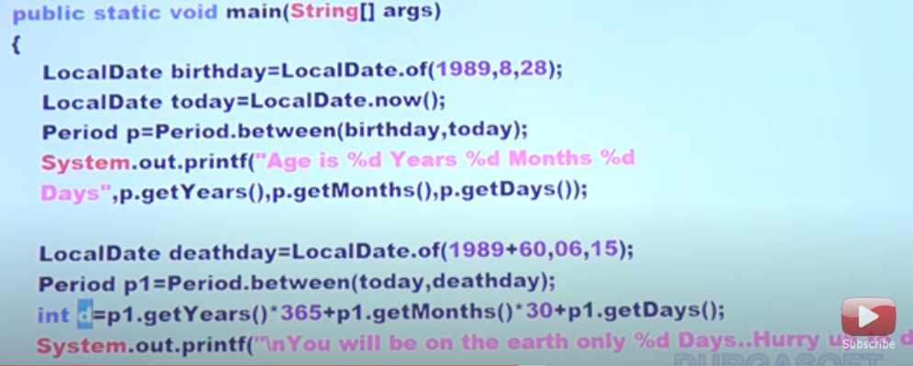

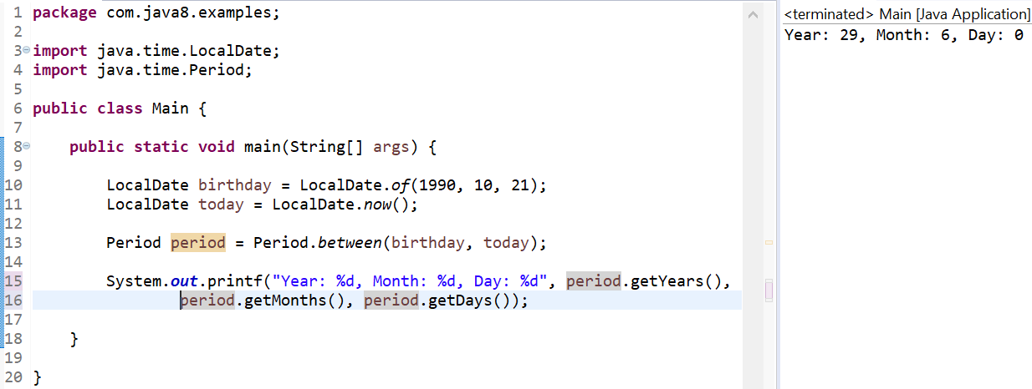

***Example-6: To write a program to find given Year is leap year or not by using Year Class:***

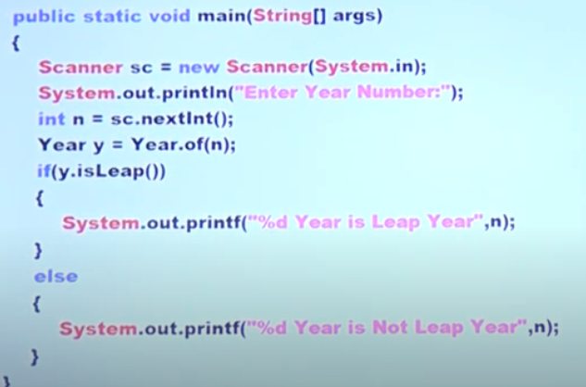

***Example-7: ZoneId Class – for all over the world date and time example.***

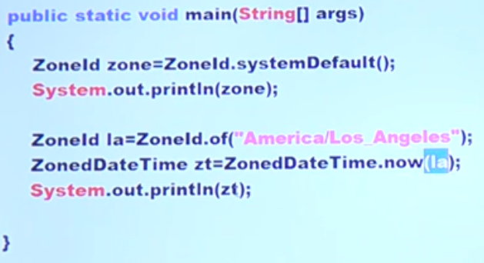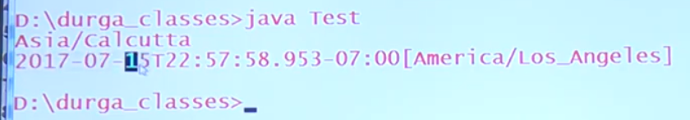

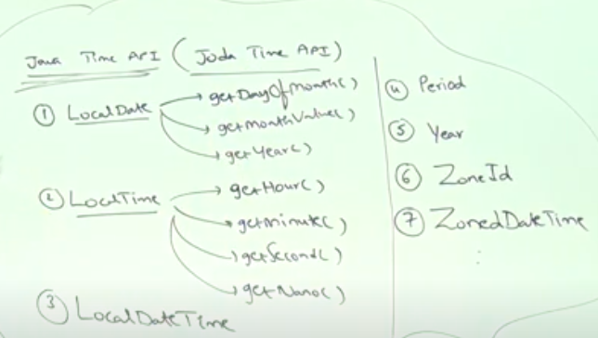

## 8.Optional Class:

It is a public final class and used to deal with NullPointerException in Java application. You must import java.util package to use this class. It provides methods which are used to check the presence of value for particular variable.

Optional object is used to represent null with absent value. This class has various utility methods to facilitate code to handle values as ‘available’ or ‘not available’ instead of checking null values. It is introduced in Java 8 and is similar to what Optional is in Guava.

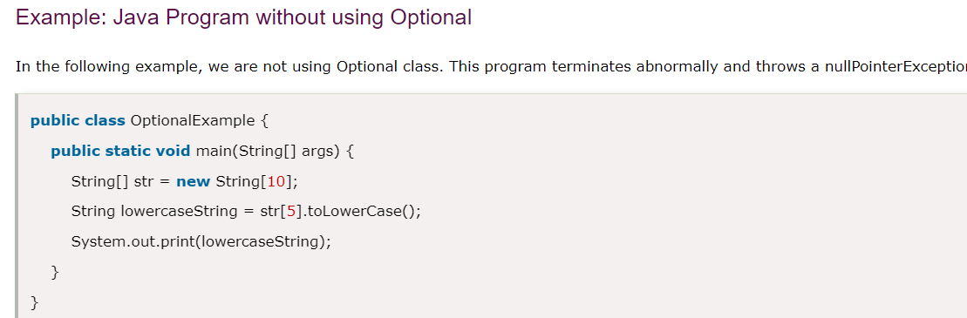

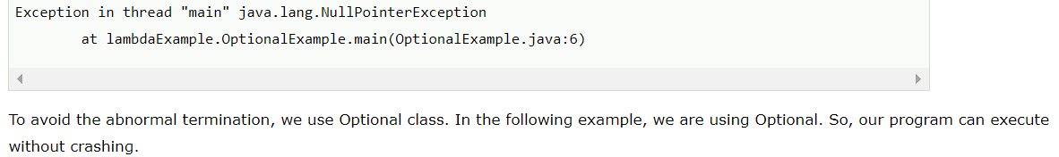

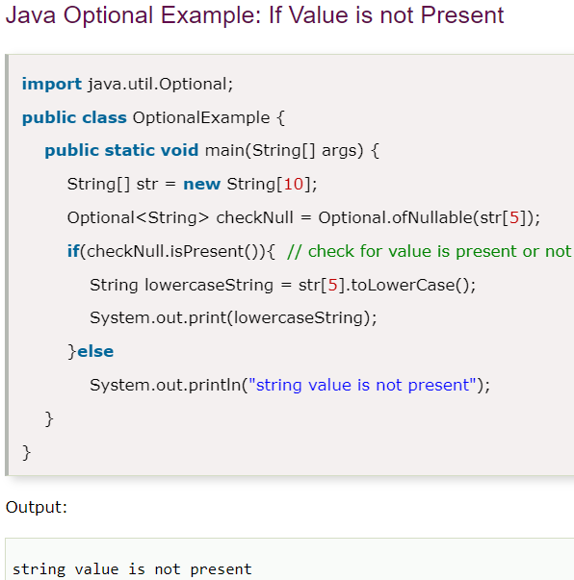

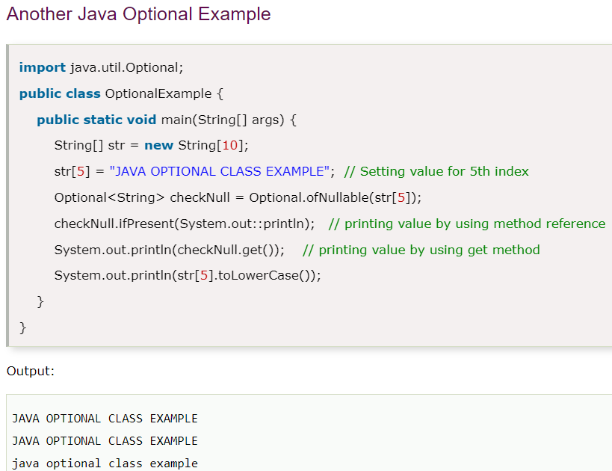

## String.join():

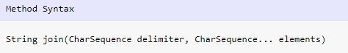

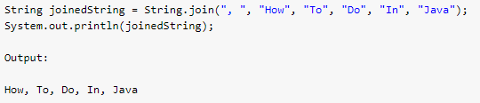

## Convert Stream to List:

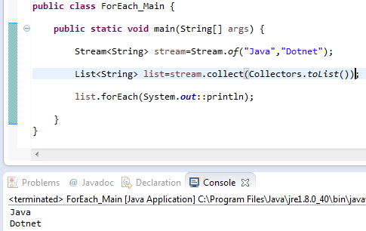

## Java 8 forEach loop:

The Java forEach is a utility method to iterate over a collection or stream and perform a certain action on each element of it.

**Example 1**: List collection-

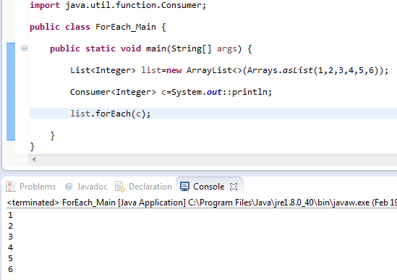

**Example 2**: Map collection Iteration using java 8 for Each loop.

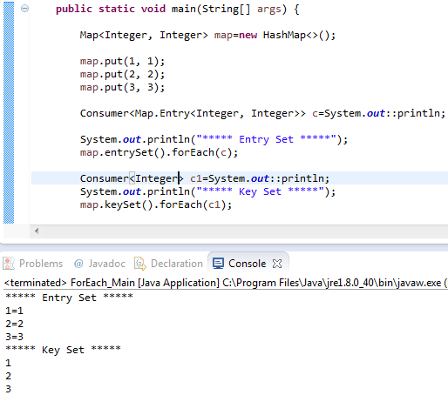

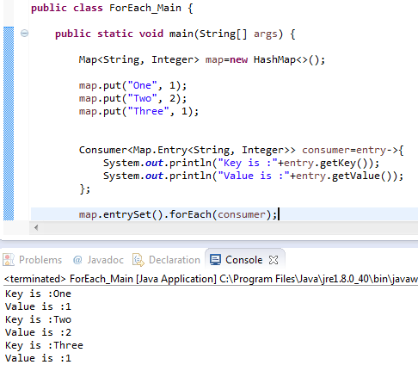

# ==Interview Java-8==

## 1. What are some of the important features that are introduced in Java 8?

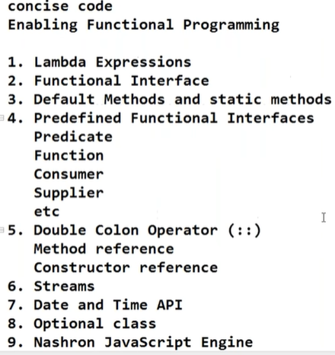

## 2.What is a lambda expression?

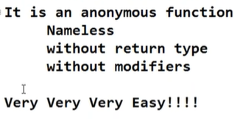

## 3. What are the most important advantages of using Java 8?

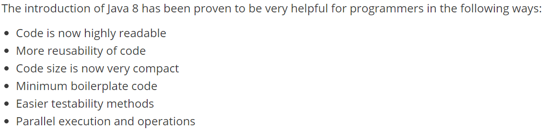

## 4. What is the meaning of functional interfaces in Java 8?

Functional interface should contain only one abstract method is called functional interface. It may be or may not be contain non-abstract method but I should contain one Abstract method.

In use annotation(@FunctionalInterface) to declare it’s an functional interface

Function Interfaces are like:

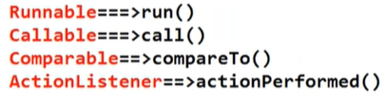

Above we have examples.

## 5. What is the meaning of method reference in Java 8?

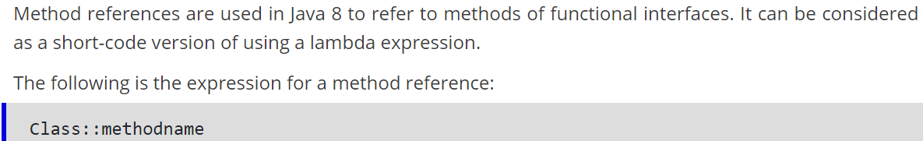

## 6. Differentiate between a predicate and a function in Java 8.

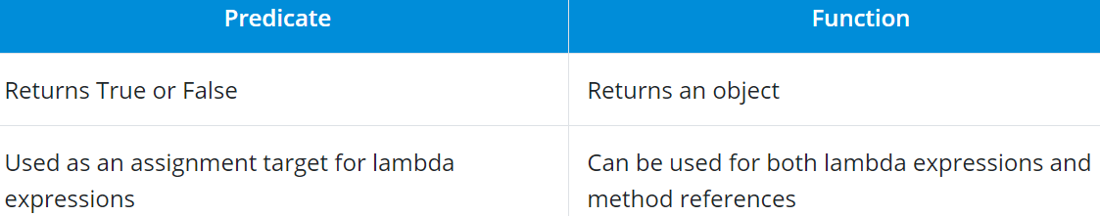

## 7.What are default methods in Java 8?

Above we have default method details and examples.

## 8. What are the core API classes for date and time in Java 8?

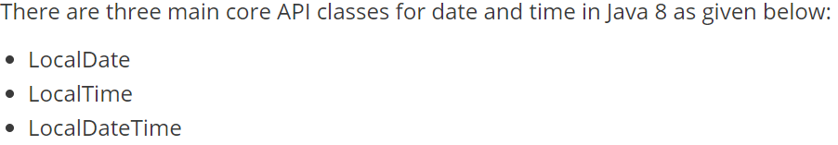

## 9. What were the issues that were fixed with the new Date and Time API of Java 8?

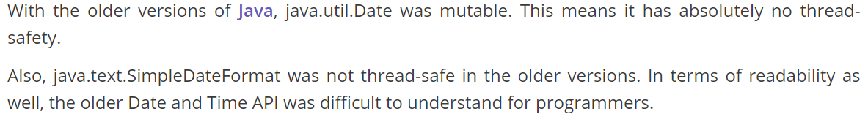

## 10.What is Nashorn in Java 8?

## 11.What is the use of the optional keyword in Java 8?

## 12.What is JJS in Java 8?

JJS is the common line tool that comes packaged with Java 8. It is used to run JavaScript code seamlessly using just the console.

## 13. What are collectors in Java 8?

Collectors are mainly used to combine the final result after the processing of elements in a stream. They are used to return lists or strings.

The following piece of code denotes how collectors work:

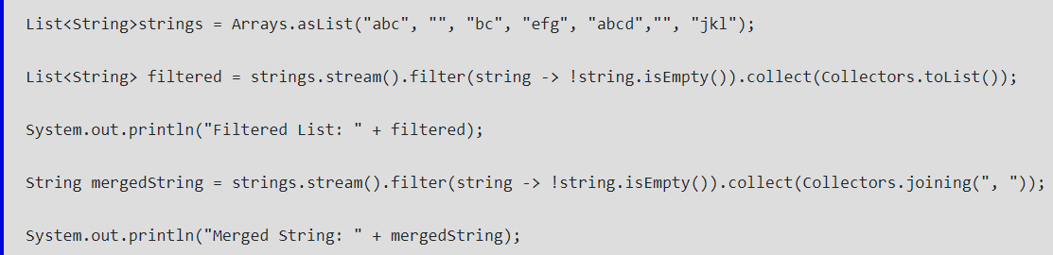

## 14.When is an ideal situation to use the Stream API in Java 8?

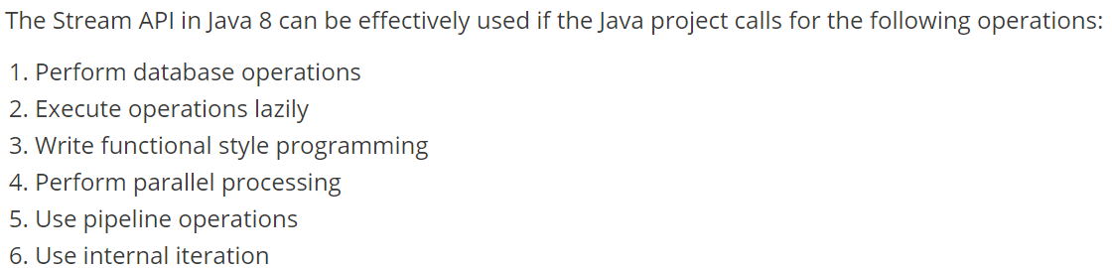

## 15. What is a supplier in Java 8?

Above explanation.

## 16. Differentiate between findFirst() and findAny() in the Stream API of Java 8.

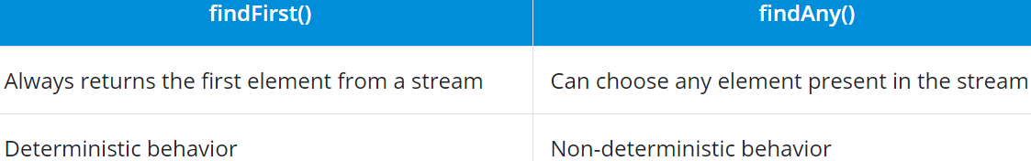

## 17. Differentiate between Collection API and Stream API in Java 8.

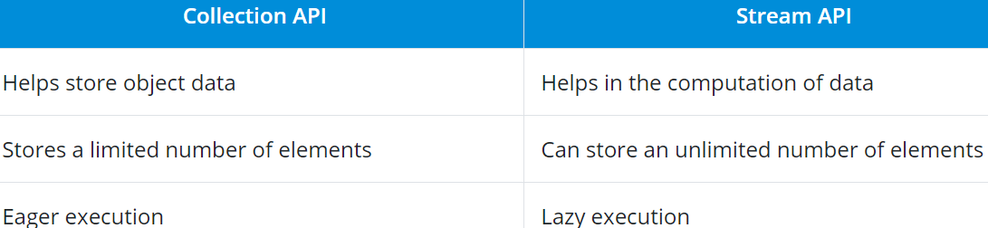

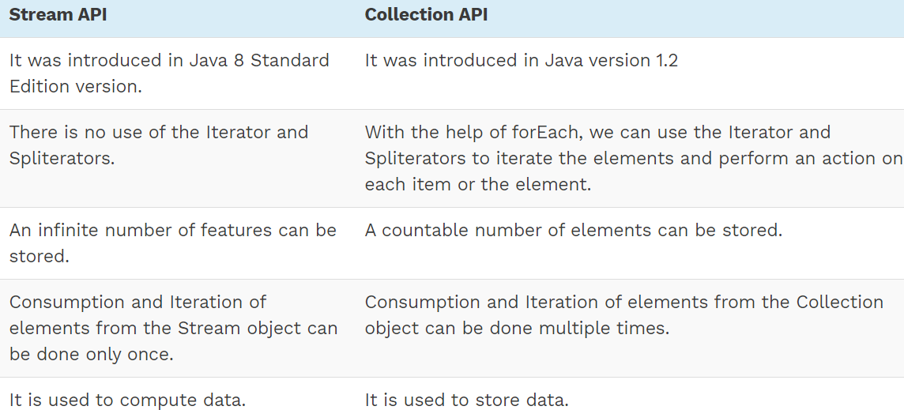

## 18. What is the meaning of a Spliterator in Java 8?

Spliterator is a newly introduced iterator interface for Java 8. It is very efficient and handles API-related operations seamlessly across the runtime environment.

## 19. Differentiate between Spliterator and a regular iterator in Java 8.

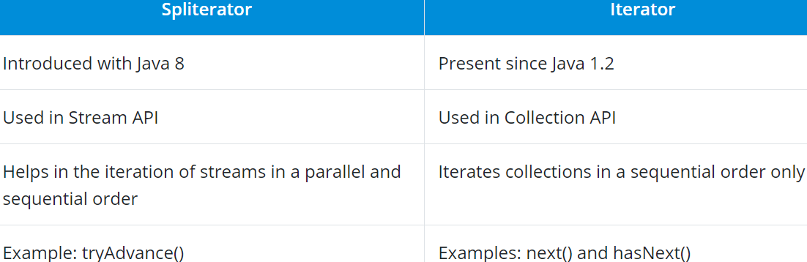

## 20. Can you name the common types of functional interfaces in the standard library?

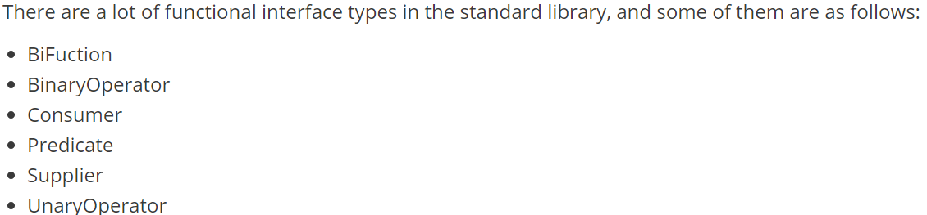

## 21. What is the easiest way to find and remove duplicate elements from a list using Java 8?

Duplicate elements can be listed and removed easily by applying stream operations and performing a collection later using the Collections.toSet() method. This should remove all of the duplicate elements present in the list.

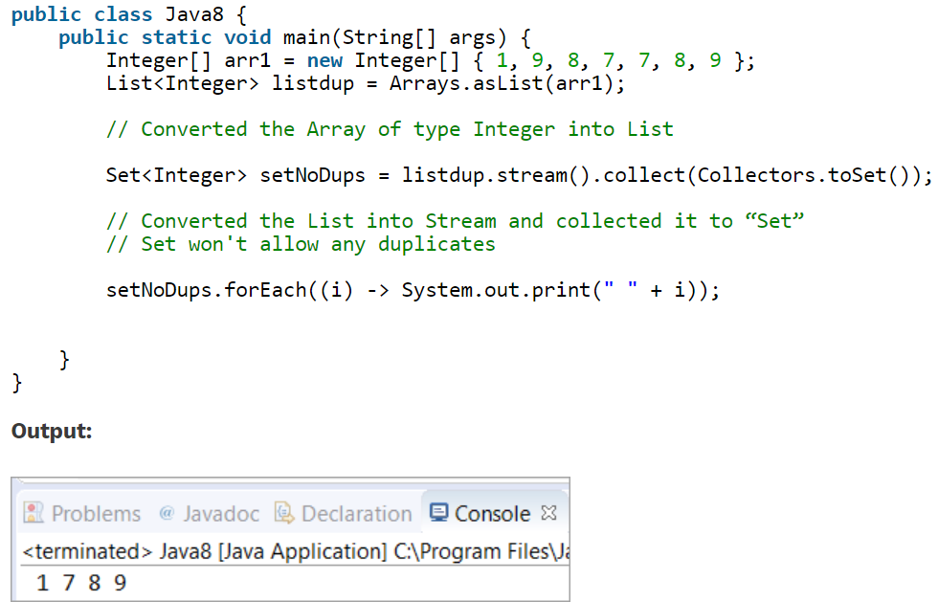

## 22. What is the easiest way to convert an array into a stream in Java 8?

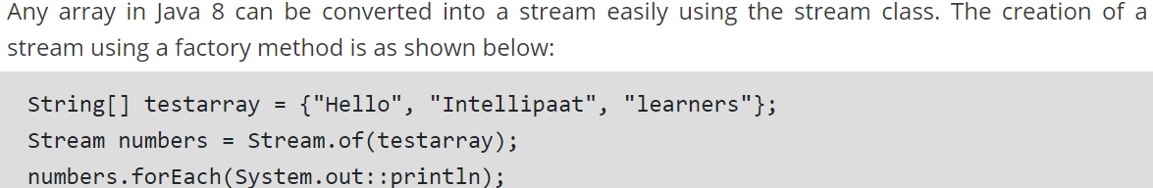

## 23. What is a SAM Interface?

Java 8 has introduced the concept of FunctionalInterface that can have only one abstract method. Since these Interfaces specify only one abstract method, they are sometimes called as SAM Interfaces. SAM stands for “Single Abstract Method”.

## 24. String:: Valueof Expression

It is a static method reference to the **ValueOf**method of the **String** class. System.out::println is a static method reference to println method of out object of System class.

It returns the corresponding string representation of the argument that is passed. The argument can be Character, Integer, Boolean, and so on.

## 25. What is the difference between limit and skip?

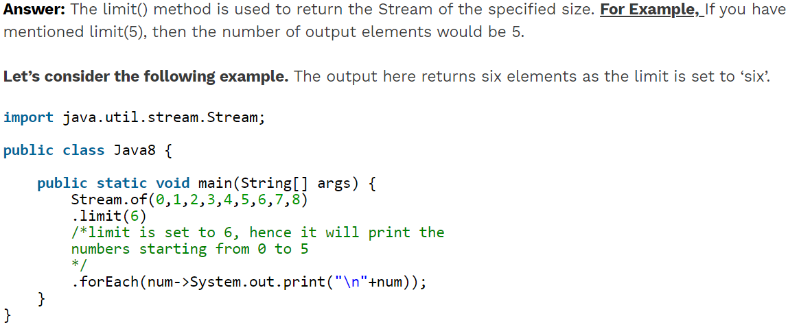

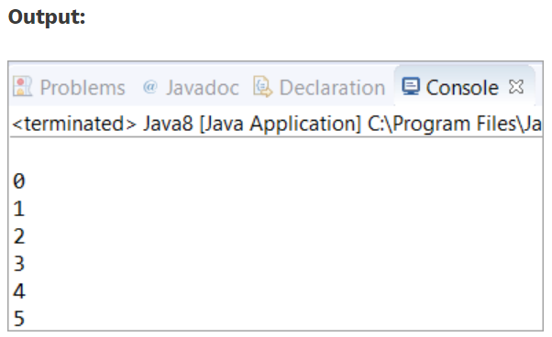

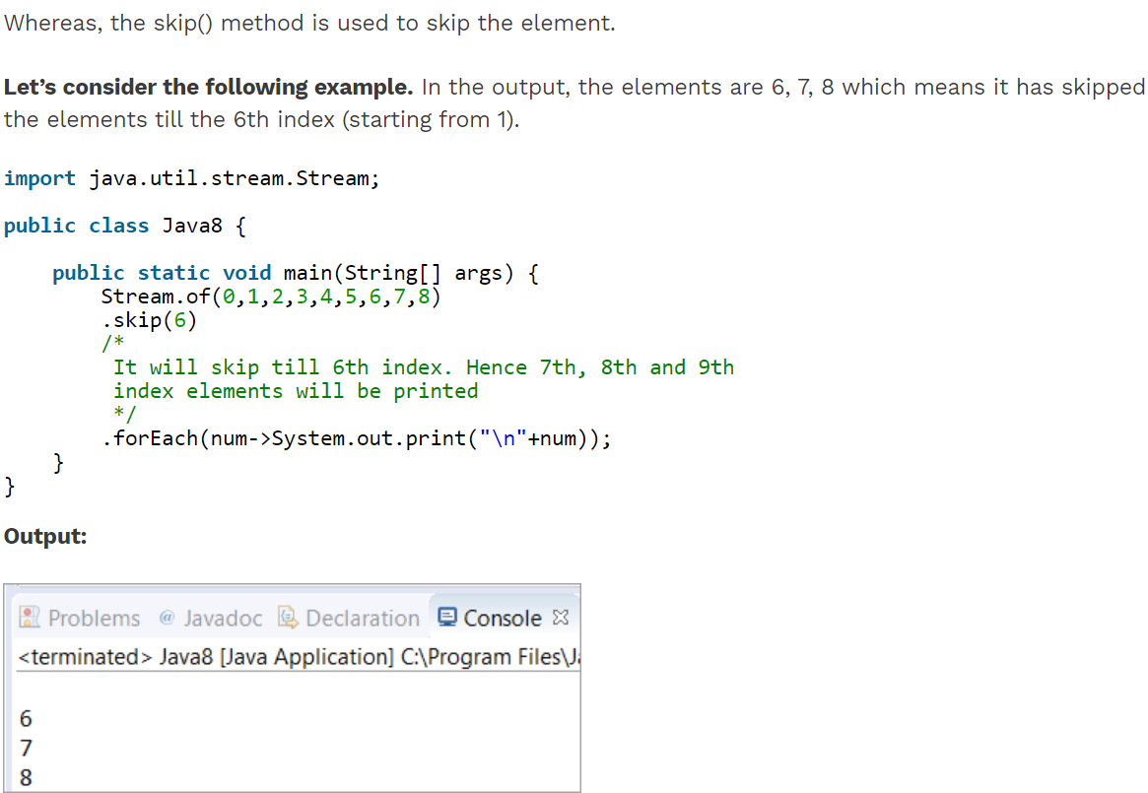

## 26. Write a program to print 5 random numbers using forEach in Java 8?

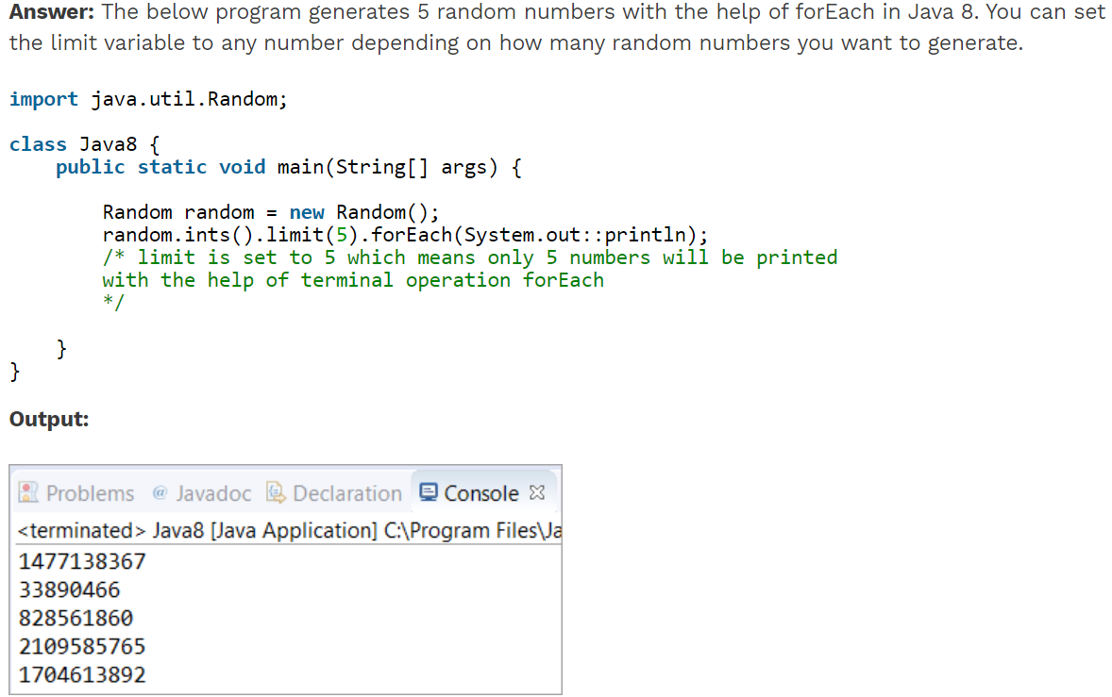

## 27. Write a Java 8 program to get the sum of all numbers present in a list?

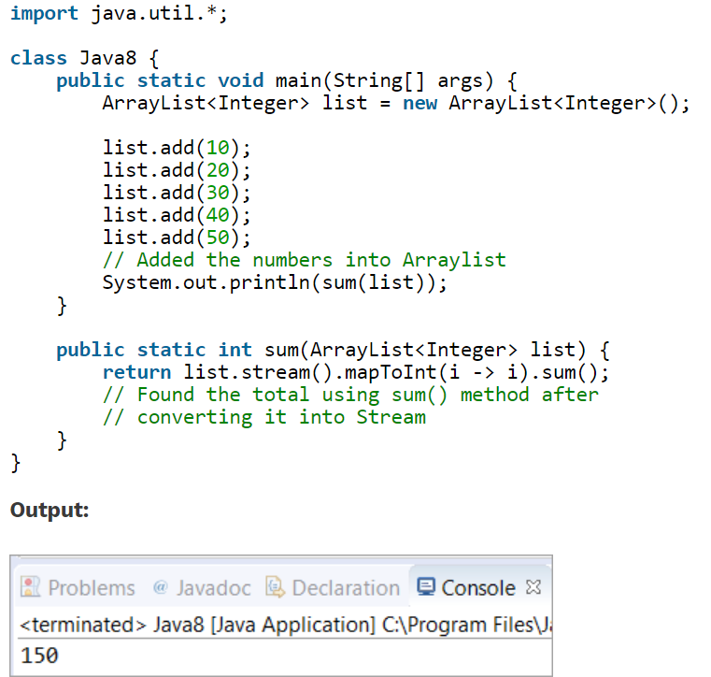

## 28.Write a program - Given a list of employees, you need to filter all the employee whose age is greater than 20 and print the employee names.(Java 8 APIs only)

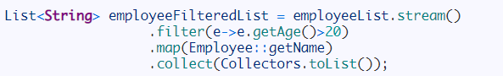

## 29. Given the list of employees, find the employee with name “Mary”.

